


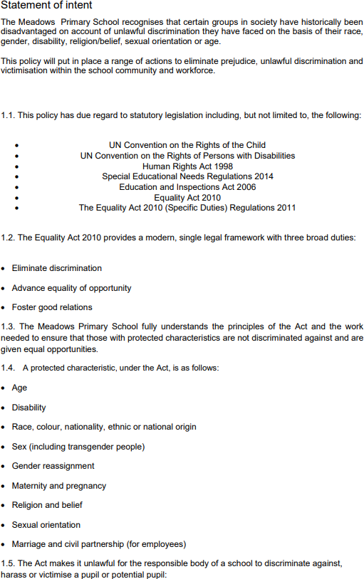

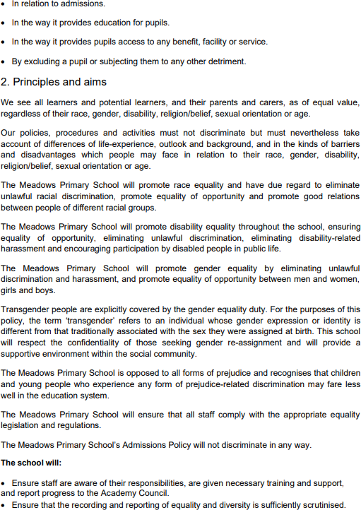

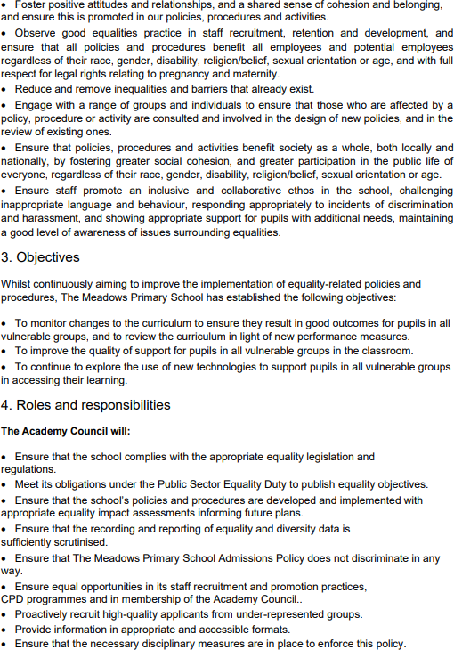

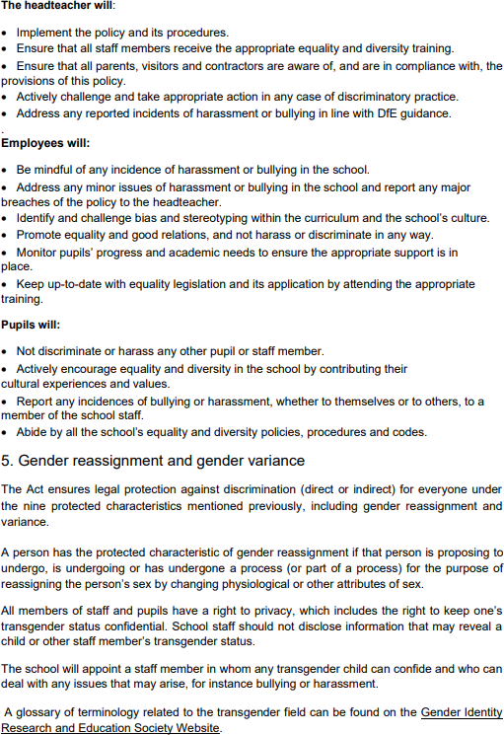

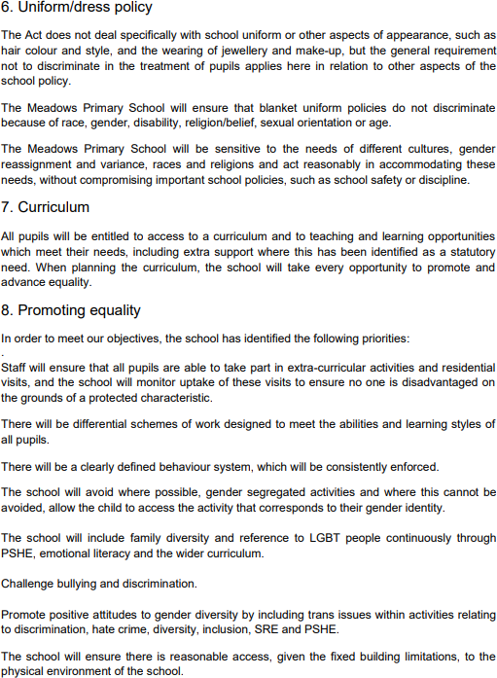

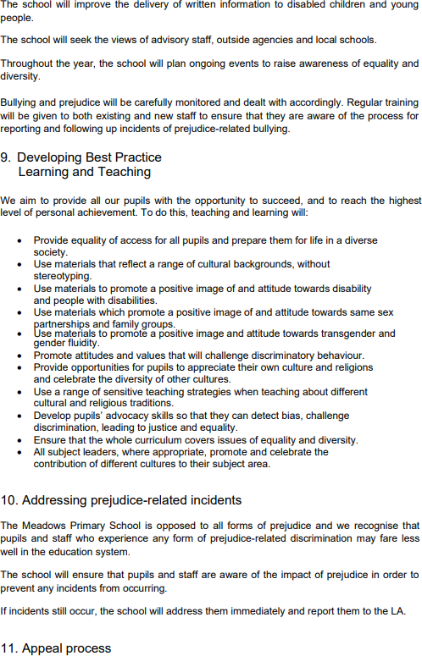

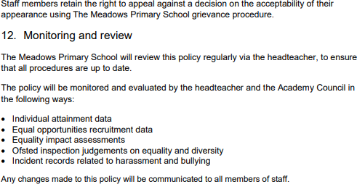

Reviewed | October 2025
Document Owner | N. Parry
Approved By | G. Taylor
Review Period | 2 years





Shaw Education Trust Head Office, Kidsgrove Secondary School, Gloucester Road,  Kidsgrove,  ST7 4DL | Twitter LinkedIn Call Email  Visit | @ShawEduTrust @ShawEducationTrust 01782 948259  info@shaw-education.org.uk  shaw-education.org.uk

