
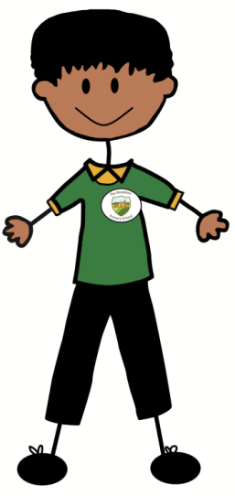
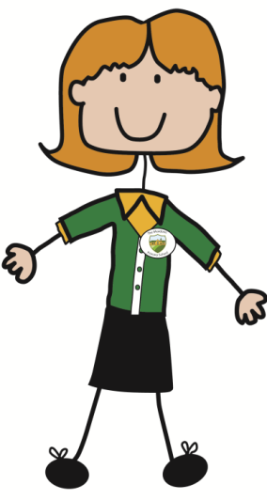
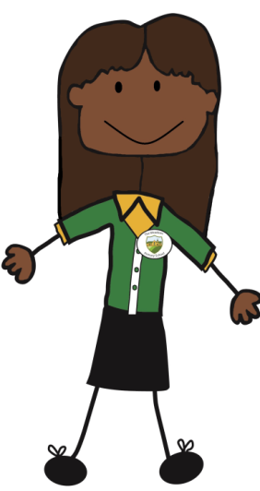
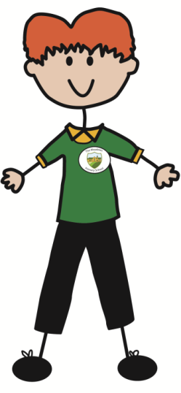
‘Learning by Caring and Sharing’
Jewellery Policy
Information regarding our school uniform can be found here: School Uniform | The Meadows School Within this page, it details that the only acceptable jewellery that can be worn to school are:
- a single pair of stud earing
- an analogue watch (no smart watches please)
The Wearing of Jewellery in PE Policy
Parents and carers can find out about our uniform and jewellery rules on the school prospectus and on visits to the school. By sending a child to our school, parents and carers have implied their acceptance of the rules. The wearing of jewellery, earrings and ear-studs (metal or plastic) is not permitted on safety grounds during physical education lessons and other sporting activities such as out of hours school learning or competitive fixtures. This includes body piercings such as tongue studs or belly button jewellery. These items represent a potential hazard not only to the wearer but also to other children.
Medical advice confirms that any jewellery worn in physical education lessons is an unnecessary risk and should be avoided at all times. Serious accidents have occurred as a result of contact between pupils wearing earrings or studs and other pupils or equipment, thus damaging the ear, or where items of jewellery have caught in apparatus and torn the ear lobe.
The Meadows prohibits the wearing of jewellery, earrings and ear-studs in all aspects of physical activity as these could present a hazard to the wearer and to others. Pupils are encouraged to leave items of jewellery and earrings at home on days when they have physical education lessons. Children who do wear earrings to school on PE days will be expected to remove them by themselves. Staff are unable to help with this.
Parents cannot withdraw his/her child from PE lessons, as PE is a statutory subject in maintained schools until the end of Key Stage (KS) 4 and all pupils are required to attend.
The only exception to this is if the child has a statement of special educational needs that explicitly states that the child is unable to participate in PE lessons.
Newly pierced ears can take a period of up to six weeks before sleepers and studs can be removed. We do remind parents and carers that ears should be pierced at the start of the summer holidays to allow sufficient time for earrings to be safely removed. This is communicated via the school newsletter. Pupils who are not able to remove earrings (as these may be newly pierced) will not actively participate in physical education for their own and others safety. In this circumstance a pupil will be asked to undertake learning in another classroom.
The taping of jewellery can create a perception of safety and is not permitted. Tape can often fall off and does not reduce the risk of compression injury.
Parents are encouraged to actively work with schools in helping to minimise disruption to the physical education curriculum. Parents can help by ensuring that school guidance on jewellery is adhered to and that ears are pierced at the start of the summer holidays to allow maximum healing time.
We will not ask parents to assume responsibility or liability for the outcome of any future injury arising from the wearing of an earring or ear-stud since any such undertaking cannot be legally valid.
Equality Impact Assessment
Under the Equality Act 2010 we have a duty not to discriminate against people on the basis of their age, disability, gender, gender identity, pregnancy or maternity, race, religion or belief and sexual orientation. This policy has been equality impact assessed and we believe that it is in line with the Equality Act 2010 as it is fair, it does not prioritize or disadvantage any pupil and it helps to promote equality at this school.

Reviewed | October 2025
Document Owner | N. Parry
Approved By | G. Taylor
Review Period | 3 years



15

Shaw Education Trust Head Office, Kidsgrove Secondary School, Gloucester Road,  Kidsgrove,  ST7 4DL | Twitter LinkedIn Call Email  Visit | @ShawEduTrust @ShawEducationTrust 01782 948259  info@shaw-education.org.uk  shaw-education.org.uk



