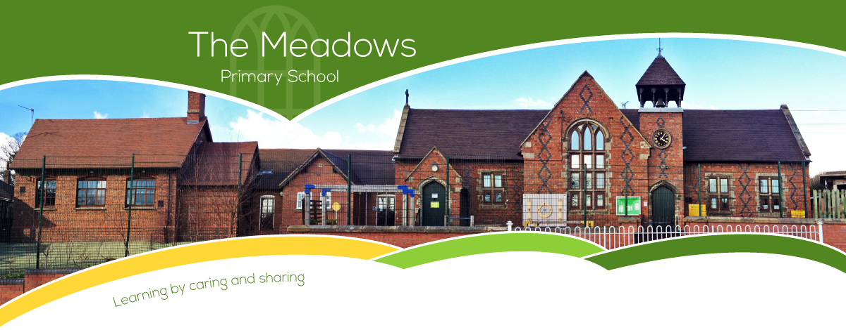

|  |  |  |  |  |  |  |
| --- | --- | --- | --- | --- | --- | --- |
| **Class 3 – Odd Year Planning** | | | | | | |
| **Subject** | **Autumn Term** | | **Spring Term** | | **Summer Term** | |
| **English**  *SMSC link: All* | * Seal Surfer by Michael Foreman * Dance with Me, Autumn- Poem * Winter’s Child by Angela McAllister | | * The Fossil Girl by Catherine Brighton * Mountain Gorilla- Poem * The Silence Seeker by Ben Morley | | * Journey by Aaron Becker * Look Closely- Poem * Zeraffa Giraffa by Dianne Hofmeyr | |
| **Maths**  *SMSC link: Social* | * Number and place value * + - ÷ x methods * Properties of shape * Position and direction | * Fractions * Decimals * Mass * Time | * Number and place value * + - ÷ x methods * Properties of shape * Fractions * Length | * Decimals * Perimeter | * Number and place value * + - ÷ x methods * Properties of shape * Money | * Volume and capacity * Position and direction * Fractions * Area |
| **Science**  *SMSC link:*  *Cultural*  *Social*  *Moral* | * States of matter: In a State (Chemistry) * Sound (Physics) | | * Living things and their habitats (Biology) * Light (Physics) | | * Plants (Biology) | |
| **Computing**  *SMSC link:*  *Cultural*  *Social*  *Moral* | * Online Safety (*Year 3 Unit)* * Programming Scratch (*Year 3 Unit)* | | * Investigating Weather (*Year 4 Unit)* * Networks and the Internet (*Year 4 3 Unit)* | | * Creating media: Video trailers * Website Design | |
| **History**  *SMSC link: All* | * Ancient Egypt * Cradles of Civilisation | | * The Indus Valley * Persia and Greece | | * Arabia & early Islam * Cordoba – The city of light | |

|  |  |  |  |
| --- | --- | --- | --- |
| **Geography**  *SMSC link: All* | * Mountains * Settlements | * Agriculture * The Rhine and the Mediterranean | * Earthquakes * Deserts |
| **Art/DT**  *SMSC link: Social*  *Cultural* | * Constructing a Castle (DT) * Growing artists (Art) | * Ancient Egyptian Scrolls (Art) * Torches (Year 4, DT) | * Mega materials (Art) * Fastening (DT) |
| **Music**  *SMSC link: Social*  *Cultural* | * Ukulele | * Ukulele | * Ukulele |
| **PSHE** | * One World * Safety First | * Think Positive * It's My Body | * Respecting Rights |
| **PE**  *SMSC link: Social* | * Swimming * Hockey * Netball * Gymnastics | * Cricket * Tag rugby * Gymnastics/Dance | * Athletics * Dance |
| **RE** | * A Hindu Story * More Hindu Stories | * Living with Hindu traditions * The Hebrew Bible -Abraham, Isaac and Jacob | * The message of Jesus spreads * Islam 1 Ramadan |
| **Spanish**  *SMSC link: Social*  *Cultural* | * Phonics 1&2 (C) * Shapes (E) | * Vegetables (E) * Ancient Britain (E) | * In Class (I) * Habitats (I) |