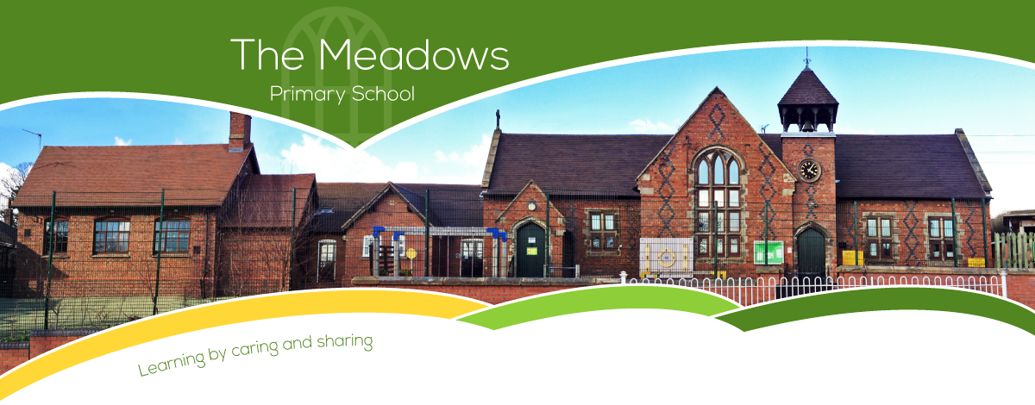

Class 4 – Odd Year Planning
Subject | Autumn Term |  | Spring Term |  | Summer Term
Literacy | - Diary: Queen of the Falls by Chris Van Allsburg; Good Night Stories for Rebel Girls by Elena Favilli and Francesca Cavallo  - Fiction: Beowulf by Michael Morpurgo  - Poetry: The Moon |  | - Fiction: Arthur and the Golden Rope by Joe Todd-Stanton  - Autobiography: Malala’s Magic Pencil by Malal Yousafzai  - Poetry: Viking Kennings and Spells |  | - Persuasion: The Paperbag Prince by Colin Thompson  - Shakespeare: Bold and Brave Women from Shakespeare by Shakespeare  - Poetry: Sonnet Written at the Close of Spring
Maths | - Number and place value  - + - ÷ x methods  - Properties of shape  - Position and direction | - Fractions  - Decimals  - Mass  - Time | - Number and place value  - + - ÷ x methods  - Properties of shape  - Fractions  - Length | - Decimals  - Statistics  - Percentages (FDP)  - Perimeter and area | - Number and place value  - + - ÷ x methods  - Properties of shape  - Money  - Fractions | - Volume and capacity  - Percentages (FDP)  - Position and direction  - Statistics
Science | - Understand movement and forces  - Space |  | - Material Properties |  | - Reproduction in Plants and Animals
Computing | - Y6 - Online safety  - Programming: Microbit |  | - Data handling: Mars rover (1)  - Data handling: Mars rover (2) |  | - Networks: Bletchley Park and the History of Computers  - Creating Media: Stop motion animation
History | - The round city: Baghdad  - The Anglo-Saxons |  | - Vikings 1 – Lady of the Mercians  - Norse Culture |  | - Vikings 2 – Changing rulers, changing worlds  - Local history study
Geography | - Why is California so thirsty?  - Oceans |  | - Migration  - North and South America |  | - The Amazon  - Interconnected Amazon
Art/DT | - Bridges  - I need space |  | - Stuffed Toys  - Portraits |  | - Monitoring Devices  - Photo opportunity
Music | - Looping and remixing  - Blues |  | - Dynamics, pitch and texture  - Compositions to represent the festival of colour |  | - School performance
PE | - Hockey  - Netball  - Gymnastics |  | - Cricket  - Tag rugby  - Gymnastics/Dance |  | - Outdoor adventure  - Athletics  - Dance
PSHE | - Be Yourself  - Britain |  | - Aiming High  - It's My Body |  | - TEAM  - Moving to high school
RE | - Islam 2: Stories of the prophets  - Islam 3: Living Muslim traditions |  | - Christianity 6: Living Christian traditions  - Planning your study of two Christian sites |  | - The prince who became the Buddha  - Buddhist stories and teachings
Spanish | - Phonics 3&4 (C)  - The Date (I)  - My Home (I) |  | - Clothes (I)  - Planets (P) |  | - Healthy Living (P)  - Me in the World (P)

