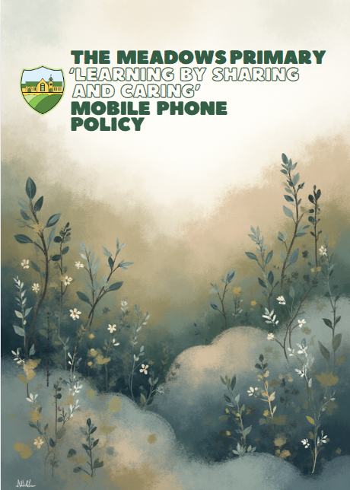
Meadows Primary School is committed to ensuring the welfare and safety of the pupils in our care. The aim of the Mobile Phone Policy is to recognise and guide the appropriate use of such technology through clear user guidelines, acknowledging that the incorrect or inappropriate use of mobile phones and other personal devices could pose a risk to children and adults.
It is recognised that it is the enhanced functions of many mobile phones that cause the most concern and are most susceptible to misuse. Misuse includes taking and distributing indecent images, exploitation and bullying. Mobile phones can also cause unnecessary distraction during the working day and can be intrusive when used in the company of others.
For the purpose of this policy, the term mobile phone also covers any electronic device with the capacity to be used as a form of communication, either via the device itself or through any applications stored on the device.
As it can be very difficult to detect when such devices are present or being used, particularly in relation to enhanced functions such as cameras, the use of all mobile phones is limited, regardless of their capabilities.
This policy is not an exhaustive list of acceptable and unacceptable use of mobile phones. In situations where guidance does not exist in this policy, staff are expected to exercise professional judgement and act in the best interests of the pupils and the academy.
This policy applies to all staff, volunteers (including Academy Councillors), visitors, and anyone onsite through external contracts.
Code of Conduct
The Staff Code of Conduct provides clear reference to the use of mobile phones.
Our aim is to ensure that adults in our setting:
- have a clear understanding of what constitutes misuse;
- know how to minimise risk;
- avoid putting themselves into compromising situations which could be misinterpreted and lead to possible allegations;
- understand the need for professional boundaries and clear guidance regarding acceptable use;
- are responsible for self-moderation of their own behaviours;
- are aware of the importance of reporting concerns to the SLT promptly.
An agreement of trust is therefore promoted regarding the carrying and use of mobile phones within the setting, and this is agreed to by all users.
Personal Mobile Phones
Mobile phones and personally owned devices may not be used during lessons or formal academy time except in emergencies or exceptional circumstances (e.g., an acutely ill relative). In such circumstances, a member of the Senior Leadership Team must be made aware, and this should remain rare. It is important that family members are aware of the school telephone number should an emergency arise.
Mobile phones should be switched off (or on silent) at all times.
Mobile phones and personal devices must not be used in areas such as classrooms, corridors, the playground, the field, or in the vicinity of children. The only areas where mobile phones may be used are offices, the staffroom, and classrooms/corridors before and after school, provided no children are present. They should not be used in classrooms during breaktimes.
Personal mobile phones must never be used to take recordings or photographs of children. Any recordings or photographs taken for school purposes must be taken on a school-owned device.
Personally owned mobile phones and devices are the responsibility of the owner. Meadows Primary School accepts no responsibility for loss, theft or damage. Devices should be kept securely, out of sight, and equipped with security settings.
Mobile Phones for Work-Related Purposes
Staff must ensure that:
- Personal mobile phones are not used to contact parents during school trips; all relevant communication should go via the school office unless an urgent safeguarding situation arises.
- Parents accompanying educational visits are reminded not to contact other parents, and not to take photographs of children (including their own) during the trip, except where directed in an emergency.
Pupils
This applies only to children walking to and from school independently in Years 5 and 6.
Children walking without an adult may carry a mobile phone for safety. Parents must request permission and give written consent.
Once permission is granted, children may bring a phone to school, but it must be turned off before entering the school site and handed into the office. Phones are not permitted in any other areas of the school.
Pupils must not use phones on the school premises at any time. If a phone is used, it will be confiscated and parents/carers contacted.
For school events held out of hours (fayres, discos), phones must be switched off and handed in at the start of the event. Any undisclosed phones will be confiscated and must be collected by parents from the office.
The school accepts no responsibility for theft, loss, damage, or any potential health effects. Phones should be insured, security marked and password protected.
Parents should be aware of risks including theft, bullying, and inappropriate contact (e.g., grooming). The school also highlights the dangers of children using phones while walking, which reduces safety awareness and can lead to accidents.
If staff suspect unsuitable material is stored on a pupil’s phone, the phone will be confiscated, and parents asked to collect it from a member of SLT. If the material may relate to a criminal offence, it will be passed to the DSL or Headteacher, and possibly the police.
Visitors and Parents/Carers
If a visitor or parent is seen using a phone in the vicinity of children, they will be politely asked to switch it off or put it away.
Parents may use phones to photograph their child during special performances, but only for that purpose. Staff will remind them that such images must only include their own child and must not be uploaded to social media or used publicly without consent.
Parents must be aware of the legal and safeguarding risks of posting images of other children; doing so may breach the Data Protection Act.
Use of Own Devices for School Data
This section applies when accessing school data or systems (Dojo, email, assessment platforms) on personal devices. Where practicable, staff should use a school-provided laptop.
Individuals using personal devices must ensure:
- strong passwords/2FA are in place;
- devices lock automatically and may wipe after incorrect password attempts;
- personal and school data are kept separate (e.g., different apps for work and personal use);
- they understand what data might be remotely deleted;
- data is transferred securely;
- loss or theft is reported immediately to the Headteacher.
Personal device users must comply with data protection regulations. The school must remain in control of all personal data processed.
Individuals must agree to all stipulations in this policy when using personal devices.

Reviewed | January 2026
Document Owner | N. Parry
Approved By | G. Taylor
Review Period | 3 years

