Class 3 Autumn Term 2023 (Odd Year)

Subject | Learning Hook | Context | Prior Learning
History | Investigate and interpret the past  Build an overview of world history  Understand chronology Communicate historically | Ancient Egypt  - Location, origin in settlements around the Nile, living by the Nile, the role of the Nile in developing belief systems as well as agriculture.  - How the power structures (pharaohs, the double crown) were linked to the geography of Egypt; how they were sustained through art, writing, belief systems. Ancient Egyptian religion, government, art, great monuments, beliefs about death, farming.  - How Egypt changed through time - kingdoms, art, pyramids, beliefs and writing  - Disciplinary focus: change/continuity How much did Ancient Egypt change over time?  Cradles of Civilization  - The land between two rivers: Ancient Mesopotamia – the unique ‘cradle’ (development of writing to record trade).  - Then, geographical overview of ancient civilisations of the world, inc. Big map seeing where they all were & geographical similarities.  - Depth study of ancient Sumer in Mesopotamia via rivers & settlements (reinforce geog knowledge so far) and via art of ancient civilisations.  - Ziggurats  - Disciplinary focus: similarity and difference How similar and how different were Ancient Egypt and Ancient Sumer? | Stone Age (Opening Worlds)
Geography | Investigate places Communicate geographically | Mountains  - Highest mountain in each of the four countries of the UK.  - Mountain ranges and mountainous regions: Brecon Beacons, Highlands, Lake District, Snowdonia, Pennines, Yorkshire Dales.  - Why do people live on mountains? Depth focus: Andes and terraced farming Depth focus: Snowdonia (in preparation for Wales…see Cardiff in Spring 1) Sustained geographical theme: Relationship between mountains and weather Relationship between mountains and people Geographical skills: Describing location using 4- point compass  - Disciplinary focus: interaction How do mountains and people affect each other?  Settlements  - Settlement types, hamlet, village, town, city etc; land use, settlements by rivers. Major cities in the UK – locational overview London as a conurbation and London boroughs Two cities: Cardiff and London, including economy & transport.  - How do people move about in Cardiff?  - How do people move about in London?  - Patterns of settlement in Cardiff and London. Disciplinary focus: diversity How are settlements similar and different? | Rivers  Local Area  Wonderful world – continents and oceans – Y1/2  PSHE – One World
Design and Technology | Master practical skills Design, make, evaluate and improve  Take inspiration from design throughout history | Pavilions  - Designing a stable pavilion structure that is aesthetically pleasing and selecting materials to create a desired effect.  - Building frame structures designed to support weight.  - Creating a range of different shaped frame structures.  - Making a variety of free-standing frame structures of different shapes and sizes.  - Selecting appropriate materials to build a strong structure and for the cladding.  - Reinforcing corners to strengthen a structure.  - Creating a design in accordance with a plan.  - Learning to create different textural effects with materials. | Constructing a windmill  History – Roman link
Art and Design | Develop ideas Master techniques  Take inspiration from the greats | Growing Artists  - Know the difference between organic and geometric shapes.  - Use simple shapes to form the basis of a detailed drawing.  - Use shading to demonstrate a sense of light and dark in their work.  - Shade with a reasonable degree of accuracy and skill.  - Blend tones smoothly and follow the four shading rules.  - Collect a varied range of textures using frottage.  - Use tools competently, being willing to experiment.  - Generate ideas mostly independently and make decisions to compose an interesting frottage image.  - Make considered cuts and tears to create their ideas.  - Understand how to apply tone, with some guidance about where to use it.  - Draw a framed selection of an image onto a large scale with some guidance.  - Try a range of drawing materials, beginning to demonstrate expressive marks by trying tools in an interesting way. | Tell a Story
Religious  Education | Understand beliefs and  teachings | A Hindu Story  - Ancient stories. The Ramayana and context  - The story of Rama and Sita (in depth: ancient kingdom, banishing to the forest, battle with demon Ravana, triumphant return, lighting the way with lights)  - First reference to Vishnu  - The meanings of the story of Rama and Sita in Hindu tradition, focusing on (i) dharma; (ii) light.  - What does the story of Rama and Sita mean to Hindu peoples?  More Hindu Stories  - Vishnu and his avatars 1 – story of Manu and Matsya the fish Meaning and role of the Vedas – importance of sacred knowledge in Hinduism (through Manu/Matsya story).  - Ancient texts in Hinduism, including epics (revisit Ramayana) Vishnu’s symbols Origins of Hinduism in Indus Valley/Hinduism as a sacred religion Vishnu and his avatars 2 – Krishna and Arjuna on the battlefield: the teachings of the Bhagavad Gita What do Hindus learn from Vishnu’s stories and symbols? | Is it true that Jesus came back to  life again? – Y1

 | Understand practices and lifestyles  Understand how beliefs are conveyed  Reflect Understand values |  | Nativity performance
Physical Education | Develop practical skills in order to participate, compete and lead  a healthy lifestyle | Gymnastics Invasion Games  Net and Wall | Gymnastics Dance  Games
Music | Perform Describe Transcribe Compose | Ukulele  - Dynamics with strumming  - Rhythm  - TAB  - Composition | Body percussion, Ourselves – KS1 Travel – using instruments/ voices  – KS1
Computing | Code  Communicate Connect | Online Safety: We will continue to learn about Internet safety, linking to Internet Legends (safe, secure, brave, kind, alert). Children will look at how to improve the efficiency of their online searches, the types of websites that are best for them to access when looking for information, as well as how to identify inappropriate content and the actions they should take if they do. Children will be introduced to the term ‘cyberbullying’ and look at how they should communicate online and deal with instances of people being unkind via digital means.  Programming Scratch: Building on what the children have learnt in Year 2, they progress to using more advanced version of Scratch. They carry out an informative cycle of predict, test, review and learn about the use of repetition to create an  animation. | Computer skills Online Safety – Year 1 and 2 Scratch - Year 2
Maths | To multiply and divide To know and use number  To add and subtract  To use measures | A range of contexts:  Place value  Addition and subtraction Multiplication and division Perimeter | To multiply and divide To use statistics  To use measures  To understand the properties of shape  To use fractions
English | Understand texts | Write Stuff Units:  - Narrative – A Traditional Tale with a Twist – Three Little Pigs  - Non-fiction – The Gardener  - Poem – Autumn is Here  - Non-fiction – Christmas Dessert Post (Social Media) | Traditional Tales – Little Red Riding Hood  Non-fiction - How to make a Bird Feeder  Non-fiction - Seasons
PSHE | To be a good citizen. Being Safe. | One World  This unit is based on a case study of a fictional girl called Chiwa, who lives in Malawi. The children will explore different aspects of her life in each lesson. It is inspired by the idea that people’s life experiences and opportunities differ throughout the world and that our actions can have both positive and harmful effects on people living in different countries. It aims to enable the children to  explore the concepts of inequality and stereotypes and encourages them to reflect on what they can do to help make the world a fairer place. In this unit, children also learn about climate change and its effects, fair trading practices and organisations that help people like Chiwa. They will also learn about how to be a good global citizen.  Safety First  In this unit of work, children will consider what it means to take responsibility for their own safety. This will include the decisions they make and how they can stand up to peer pressure in a range of situations. They will learn about everyday risks, hazards and dangers and what to do in risky or dangerous situations. They will also learn about road, water and rail safety and dangerous substances: drugs (including medicines), cigarettes and alcohol. Children will look at first aid, exploring how to  deal with common injuries and what to do to respond to emergency situations. | Identity Bullying Diversity  Internet Legends
Spanish | To read fluently.  To write imaginatively. To speak confidently.  To understand the culture of the countries in which the language is spoken. | Phonics 1&2 (C)  Shapes (E) | Continue to count, reaching 100, to enable students to say the age of various family members.

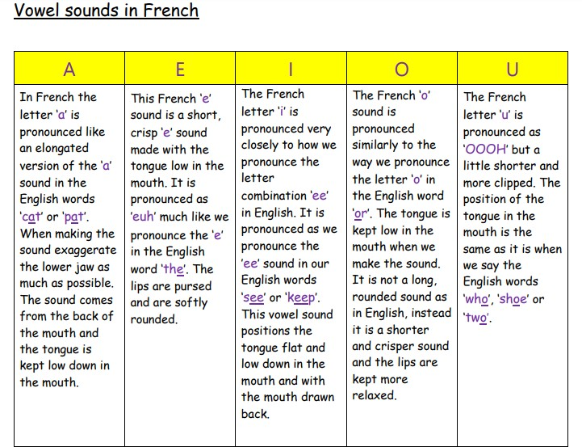
En famille (my family)
This unit cleverly teaches the nouns and article for members of the family. Children will be able to tell someone the members and their ages for a family (factual or fictitious). They continue working with numbers (reaching 100) to enable them to say the age of various family members. They will also understand the concept of possessives ("mon", "ma" and "mes") in relation to family members as these will be introduced in a very clear and uncomplicated fashion. This ultimately allows the opportunity for a presentation in French and is the ideal opportunity for children to start to present and speak French in front of others.

Je Me Présente (Presenting Myself)
This unit teaches enough language to the children to enable them to present themselves accurately in French. The unit covers saying who you are, how old you are, where you live and where you are from. We'll also teach the children how to ask someone else the same questions. This will allow them ample role play opportunities and offers the possibility for the children to engage in authentic French conversation. An excellent way to start role play conversations in your

classroom with everything you need provided! Continue to count, reaching 100,
to enable students to say the age of various family members.
Science | Work Scientifically Understand animals and humans  To understand the Earth’s  movement in space | Sound: Good Vibrations (Physics)  In this module children will build on their understanding of hearing, which was covered in Year 1 (Using our senses) during work around the senses. They will develop their vocabulary for describing sounds and identify different sound sources. They will learn that sounds are made by something vibrating and that these vibrations travel through a medium to the ear so that we hear them. They will learn that sounds get fainter as the distance from the sound source increases. They will explore ways to change the pitch and volume of sounds.  States of Matter: In A State (Chemistry)  This module introduces the concept of states of matter. Children will learn the characteristic properties of solids, liquids and gases, first through physically exploring typical materials and then by classifying examples, such as powders and very viscous liquids, which are harder to classify. Using first-hand experience and secondary sources they will learn about changes of state and begin to understand freezing and boiling points as identifying characteristics of a material. They will learn the names of some common gases. They will have the opportunity to explore the expansion of liquids and gases when they are heated, using this to make a simple thermometer and explain how it works. They will also learn about the water cycle, modelling it in different ways and further developing their understanding of changes of state. This module focuses on reversible changes; reversibility will be covered in more detail in Year 5, along with other types of change.  Maths Link – measuring mass and temperature | Ourselves (EYFS) Seasons/ Weather Senses

