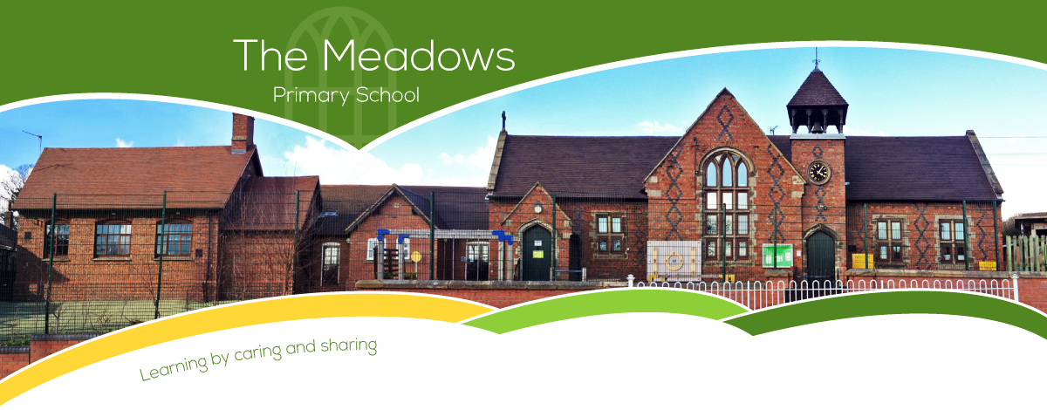

Class 3 – Even Year Planning (September 2022-July 2023)
Subject | Autumn Term |  | Spring Term |  | Summer Term
Writing | - Stone Age Boy (Fiction)  - Skara Brae – Holiday Brochure (Non-fiction)  - Wolves in the Walls (Fiction)  - Journey into the Wonderful World of your Microbiome (Explanation – Non-fiction)  - Still I Rise (Poetry) |  | - Fiction: The Last Bear  - Poetry: The River  - Non-fiction: The Creature  - Fiction: The Incredible Book Eating Boy |  | - Fiction: Thesus and the Minotaur  - Fiction: The Secret of the Black Rock  - Non-fiction: Scripts for a factual tour  - Poetry: I asked the little boy who couldn't see
Maths | - Number and place value  - + - ÷ x methods  - Properties of shape  - Position and direction | - Fractions  - Decimals  - Mass  - Time | - Number and place value  - + - ÷ x methods  - Properties of shape  - Fractions  - Length | - Decimals  - Statistics  - Percentages (FDP)  - Perimeter and area | - Number and place value  - + - ÷ x methods  - Properties of shape  - Money | - Volume and capacity  - Position and direction  - Fractions  - Area
Science | - Amazing Bodies  - Where does all the Food Go? |  | - Our Changing World  - Switched On |  | - The Power of the Force  - Can You See Me?  - Theme week: Space
Computing | - Online Safety (Year 4 Unit)  - Emailing (Year 3 Unit) |  | - Top Trumps: Databases (Year 3 Unit)  - Further coding with Scratch (Year 4 Unit) |  | - Computational Thinking (Year 4 Unit)  - Collaborative Learning (Year 4 Unit)
History | - Ancient Greece  - Alexander the Great |  | - Roman Republic  - The Roman Empire |  | - Roman Britain  - Christianity in 3 Empires
Geography | - Volcanoes  - Climate and Biomes |  | - The Rhine and the Mediterranean  - Population |  | - Tourism  - Coastal Processes and landforms
Art/DT | - Light and dark  - Adapting a recipe |  | - Fabric of nature  - Torches |  | - Abstract shape and space  - Pneumatic toys
Music | - Ukulele |  | - Ukulele |  | - Ukulele
PSHE | - Healthy relationships (provided by Glow)  - Be Yourself |  | - Aiming High  - Growing Up |  | - VIPs  - Britain

PE | - Swimming  - Hockey  - Netball  - Gymnastics | - Cricket  - Tag rugby  - Gymnastics/Dance | - Athletics  - Dance
RE | - Joseph, Moses and the Exodus  - The kings, the temple & living as a Jew | - The family of Jesus  - The birth of Jesus | - The life and teachings of Jesus  - Death and Resurrection of Jesus
Spanish | - Phonics 1&2 (C)  - I’m Learning Spanish (E)  - Animals (E) | - I Can (E)  - Fruits (E) | - Presenting Myself (I)  - At the Café (I)

