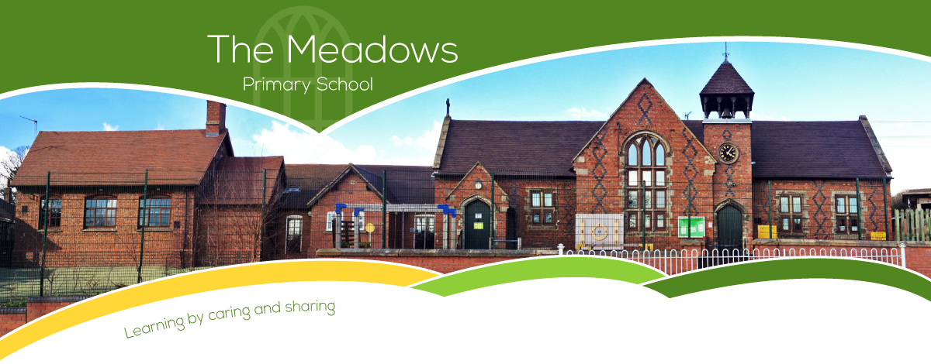

Class 4 – Even Year Planning
Subject | Autumn Term |  | Spring Term |  | Summer Term
Literacy | - Traditional Tale – Hansel and Gretel by Neil Gaiman  - Balanced Arguments  - Recounts – Letters from the Lighthouse by Emma Carroll  - Narrative – Rose Blanche by Ian McEwan |  | - Fiction: Narrative - The Firework Maker’s Daughter by Phillip Pullman  - Poetry – Thinker's Rap  - Non-fiction: Ancient Greece |  | - Fiction: The No-where Emporium  - Non-fiction: The Origin of the Species  - Non-fiction: Pet Peeves  - Poetry: Highway Man
Maths | - Number and place value  - + - ÷ x methods  - Properties of shape  - Position and direction | - Fractions  - Decimals  - Mass  - Time | - Number and place value  - + - ÷ x methods  - Properties of shape  - Fractions  - Length | - Decimals  - Statistics  - Percentages (FDP)  - Perimeter and area | - Number and place value  - + - ÷ x methods  - Properties of shape  - Money  - Fractions | - Volume and capacity  - Percentages (FDP)  - Position and direction  - Statistics
Science | - Getting Sorted (Materials)  - Body Pump |  | - Biology - Adaptation: Everything changes  - Chemistry – Investigating Materials (All Change) |  | - Danger! Low Voltage  - Physics – Light up Your World
Computing | - Year 5 - Online Safety  - Creating Media - History of computers |  | - Computing systems and networks: Bletchley Park  - Data handling 1: Big Data |  | - Data handing 2: Big data  - Intro to Python
History | - The Maya  - Life in two kingdoms in Africa |  | - A theme through time - Part 1  - A theme through time - Part 2 |  | - Britain in the era of the Second World War  - Local history unit
Geography | - Energy and climate change  - Ethiopia |  | - Changing Birmingham  - Jamacia |  | - Local area enquiry - Part 1  - Local area enquiry - Part 2
Art/DT | - Automata toys (Y6)  - Make my voice heard |  | - Come dine with me (Y6)  - Making memories (Y6) |  | - Steady Hand Game (Y6)  - Architecture
Music | - Songs of World War 2  - Blues |  | - Baroque  - Dynamics, pitch and texture (Theme: Coast - Fingal’s Cave by Mendelssohn) |  | - Composing and performing a Leavers' song  - Musical theatre
PE | - Hockey  - Netball  - Gymnastics |  | - Cricket  - Tag rugby  - Gymnastics/Dance |  | - Outdoor Adventure  - Athletics  - Dance
RE | - Dharmic religions  - Abrahamic religions |  | - Changing religion in Britain - Part 1  - Changing religion in Britain - Part 2 |  | - Deepening understanding of religious traditions
Spanish | - Phonics 1,2(C)  - The Weather (I)  - Family (I) |  | - Pets (I)  - Olympics (I) |  | - At school (P)  - At the weekend (P)

