Promoting Pupils' Personal Success and Wellbeing
At The Meadows, one of our aims is to help our children to be personally successful. We know that strong academic achievement goes hand in hand with positive wellbeing – both mental and physical. As a result, we work with our children to help their personal development and promote positive wellbeing through:
- Our ambitious and inclusive curriculum, where personal development is an integral, interweaving thread
- Teaching and learning that promotes self-regulation and the development of social and emotional literacy
- Dialogue with and support for our pupils (e.g. nurture)
- Our restorative approach to behaviour management
- Pupil leadership, including our wellbeing monitors
- The use of external emotion coaches from VIP
- The use of the online platform Zumos
- Whole school and class assemblies
- Through our reading approach

Every day, our pupils come into school and have one-to-one time with their teacher to scale how they are feeling. This daily dialogue helps our children to feel recognised, to develop their social and emotional language and it also helps our teacher to triage and address any worries or concerns they may have, putting immediate support into place. We use Zumos to help us do this, which all children have access to at home. Zumos | The Meadows Primary School

This year, across the school, we have enhanced our approach to supporting self-regulation and emotional literacy by launching our new ‘Red 2 Blue’ approach. This is an approach that has been launched across The Shaw Education Trust family. Our Mental Health leads, Mrs Davies and Mrs Panagi, have completed their coaching qualifications and are leading the implementation across the school.

What is the 'Red 2 Blue' approach?
The 'Red 2 Blue' approach is designed to help children to recognise and manage their feelings so that they can focus on the things they need to be doing, like their learning. We recognise that where our attention goes, our energy follows. Certain feelings can stop us from focusing on the things we need to be doing for example, feeling worries, anxious, upset, overly excited, angry or nervous. Whilst these are normal emotions we all experience at times, they can be unhelpful because they can divert our attention and energy away from this things we are supposed to be doing.

‘Red Head’

When we are feeling these emotions, we refer to them as our ‘Red Head’ state. Having a ‘Red Head’ might make us feel:
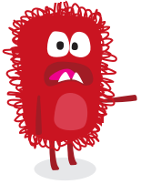
• hot
• uncomfortable
• not ourselves
• distracted
• not able to concentrate

Having a ‘Red Head’ might make us:
• Act aggressively (shouting, pushing, shoving)
• Say, “I Can’t!”
• Say, “I won’t!”
• Use unkind words
• Do and say things we don’t mean
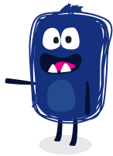
‘Blue Head’

We are working with the children to help them to know the tools and techniques they can use to move from red to blue.

When we have a ‘Blue Head’ we can concentrate. We might feel cool, calm, clear and aware of what we have got to do.
Also:
- We will say, “I will try!”
- We will say, “I will do!”
- We control our actions and our words and make good choices.

Moving from ‘Red’ to ‘Blue’
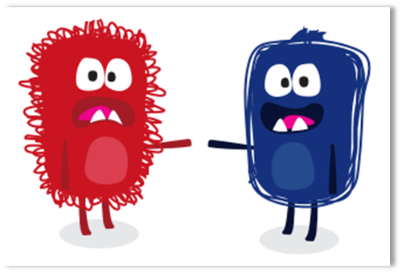
Moving from Red to Blue is a choice, and sometimes we need strategies to help us. We are working with the children to choose some techniques to help them to regulate their emotions and move to Blue. This could include breathing techniques such as hot chocolate breathing or rollercoaster breathing. It could involve diversion techniques such as asking children to spot things that are a certain shaper or colour. It might involve physical activities such as completing physical actions, changing their body positions, grounding themselves. The children can also use their logins to access Zumos, where they can play games based on cognitive behaviour therapy, as well as access mindfulness activities and self-help audio guides. We are supporting our children to know what helps them to regulate their emotions. We even ask the children to care about others around them and help them if they are in a ‘Red Head’ state.

Our Curriculum
Wellbeing (both physical and mental) is also taught discretely through our PSHE, Science and PE curriculum.

 | PSHE/ PSED (EYFS) | Science | PE
EYFS | - Main Topics and Themes:  - Life journeys – Growing up and human growth Senses  - Spring Growth and Change Farm and baby animals  - Spring Growth, change and metamorphism Lifecycles
- Becoming Me –
Character virtues
- Becoming a friend -
Self image
- Becoming Me -
Becoming a citizen
- Be Healthy and Safe
- Growth and Change
- Fundacats - PE
 | PSHE/ PSED (EYFS) | Science | PE
Y1/2 | VIPs  TEAM – Together Everyone Achieves More  Safety First  Think Positive  Be Yourself  Aiming High  Safety First  It’s My Body  Growing up  Britain  One World  Respecting Rights  Aiming High  See our website for more detail.  PSHE and RSE | The Meadows Primary School | Growing up  Taking Care  Looking at animals | Learning Hook: To develop practical skills in order to participate, compete and lead a healthy lifestyle.  Gymnastics  - Climb safely on equipment.  - Move with some control and awareness of space.  Games  - Use the terms ‘opponent’ and ‘team-mate’.  - Lead others when appropriate.  Dance  - Choose movements to communicate a mood, feeling or idea.
 | PSHE/ PSED (EYFS) | Science | PE
Y3/4 | VIPs  TEAM – Together Everyone Achieves More  Safety First  Think Positive  Be Yourself  Aiming High  Safety First  It’s My Body  Growing up  Britain  One World  Respecting Rights  Aiming High  See our website for more detail.  PSHE and RSE | The Meadows Primary School | Amazing Bodies  Where does our food go? | Learning Hook: To develop practical skills in order to participate, compete and lead a healthy lifestyle.  Games  - Lead others and act as a respectful team member.  - Follow the rules of the game and play fairly.  Athletics  • Compete with others and aim to improve personal best performances.  Outdoor and Adventurous Activities  - Support others and seek support if required when the situation dictates.  - Show resilience when plans do not work and initiative to try new ways of working.
 | PSHE/ PSED (EYFS) | Science | PE
Y5/6 | VIPs  TEAM – Together Everyone Achieves More  Safety First  Think Positive  Be Yourself  Aiming High  Safety First  It’s My Body  Growing up  Britain  One World  Respecting Rights  Aiming High  See our website for more detail.  PSHE and RSE | The Meadows Primary School | Body Pump  All Change | Learning Hook: To develop practical skills in order to participate, compete and lead a healthy lifestyle.  Games  - Uphold the spirit of fair play and respect in all competitive situations.  - Lead others when called upon and act as a good role model within a team.  Gymnastics  - Swing and hang from equipment safely (using hands).  Athletics  - Compete with others and keep track of personal best performances, setting targets for improvement.  Outdoor and Adventurous Activities  - Quickly assess changing conditions and adapt plans to ensure safety comes first.  - Identify possible risks and ways to manage them, asking for and listening carefully to expert advice.  - Embrace both leadership and team roles and gain the commitment and respect of a team.  - Empathise with others and offer support without being asked. Seek support from the team and the experts if in any doubt.  - Remain positive even in the most challenging circumstances, rallying others if need be.

