Lessons for Week Commencing – 01/02/2021
The resources needed have been delivered to your home by transport.
You will also have received an email with activities designed specifically for your child to work towards their EHCP targets.
Bucket Therapy  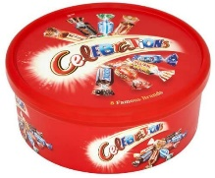 | Here are 5 new Bucket Therapy Videos for this week  Bucket 16  https://youtu.be/0bOKWuvvh3I  Bucket 17  https://youtu.be/fqyZS5QbQwY  Bucket 18  https://youtu.be/aqPHJHmA5ok  Bucket 19  https://youtu.be/YN5AuZPTQuc  Bucket 20  https://youtu.be/o938vYt6aY0
Literacy  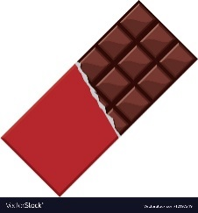 | Continue to read the class text ‘How is Chocolate Made?’ and learn the symbols and signs that go with it. Talk about the process and encourage your child to join in with retelling the story.  https://www.youtube.com/watch?v=gqKseA7G1ow&feature=youtu.be  https://www.youtube.com/watch?v=cg4z_1qGv5k&feature=youtu.be
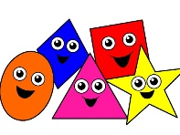  Numeracy | To support and maintain learning in maths please engage with this Oak Academy Lesson Video with your child  https://classroom.thenational.academy/specialist/subjects/numeracy/access-points/building-understanding/lessons/making-a-model-with-3d-shapes-6nh62c
My  Independence  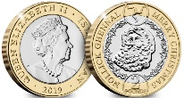 | Chocolate Shop  You will need the resources from your pack to complete this task. Click on the link to see what you should do during this lesson.  https://youtu.be/gyoCwOs-HiE
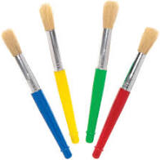  Art | Skittles Rainbow  You will need the resources from your pack to complete this task. Click on the link to see what you should do during this lesson.  https://youtu.be/30qqUKK0HvU
Humanities  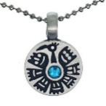 | Mayan Jewellery Making – making an amulet  You will need the resources from your pack to complete this task. Click on the link to see what you should do during this lesson.  https://youtu.be/vnPIwBkwCpI
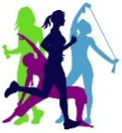  Science | Try out these three different exercise activities this week. Then complete the worksheet that is in your pack to show which one was your favourite.  Yoga - https://www.youtube.com/watch?v=iQa9qsYDH_Y  Joe Wicks https://www.youtube.com/watch?v=d3LPrhI0v-w  Dance game https://www.youtube.com/watch?v=388Q44ReOWE

