Lessons for Week Commencing - 08/02/2021
You do not require any additional resources this week. Transport are delivering a pack for the week commencing 22.3.21
You will also have received an email with activities designed specifically for your child to work towards their EHCP targets.
Join in our morning routine. We sing these songs together each morning so they will be familiar to your child and they may like to see you joining in too.
https://www.youtube.com/watch?v=1gUbdNbu6ak
https://www.youtube.com/watch?v=x3buaK0DVHs
https://www.youtube.com/watch?v=dy_BWXT6Fjc
Bucket Therapy  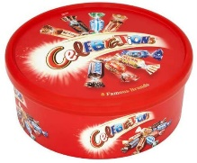 | Here are 5 new Bucket Therapy Videos for this week  Bucket 21  https://youtu.be/dLshfjmhda4  Bucket 22  https://youtu.be/j9T550aHDBw  Bucket 23  https://youtu.be/6wmLf3fD9_4  Bucket 24  https://youtu.be/dmaze86WaP8  Bucket 25  https://youtu.be/Uh_E0SNzCec
Literacy  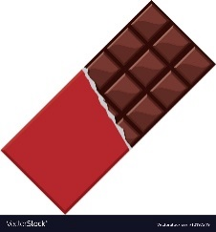 | Your child should be very familiar with the story by now and may even be joining in key parts. This type of story is called an explanation text. It tells us about a process. Have a go at pausing the video and asking your child to use their Aided Language Display (ALD) to tell you what is next in the process.  https://www.youtube.com/watch?v=gqKseA7G1ow&feature=youtu.be  https://www.youtube.com/watch?v=cg4z_1qGv5k&feature=youtu.be
Numeracy | Grid Maker Maths – please watch this video. In it, I show you a free App you can download onto your tablet or phone and which is a very useful tool for communication. This week I will demonstrate how it can be used to do a range of maths activities such as counting, sorting and talking about size and shape.  https://youtu.be/Me71T7ca2u4
Science | In this video we explore the difference between food packages and medicine packages. You can do this activity at home with your child using food packages from your cupboard and medicines you have at home. Use this as a really useful opportunity to talk to your child about what is/isn’t safe to eat.  https://youtu.be/8Msf4remULY
Drama | Take a look at these funny videos made by the team who come to our school to deliver drama lessons. It is opposite week. After watching these videos have a go at thinking of opposites at home. Find things that are big and things that are small. Find things that are hot and things that are cold. Find things that are soft and things that are hard.  https://www.youtube.com/watch?v=_qmuYOeRs-w&feature=youtu.be  https://www.youtube.com/watch?v=ZOfC9QInFZo&feature=youtu.be
Pawprint Family badge  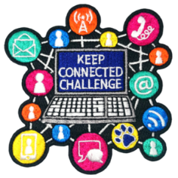 | Earn a real badge that you can sew onto your school scarf (we will be purchasing you a scarf).  To earn your badge you must complete one activity from each of the 4 areas (craft, food, games, other.) Once you have sent me a photo showing the activity you have completed your badge will be ordered for you.  Craft  Option 1 – write a letter/draw a picture and post it to a friend or family member  Option 2 paint a rock and leave it in your local park  Food  Option 1 – make popcorn for a film night with your family  Option 2 – do some baking. You could try making a microwave mug cake!  Games  Option 1 – play pin the tail on the donkey or a similar game  Option 2 – Have a scavenger hunt walk to find the following objects; green leaf, small stone, number 6, a letter box, a red car.  Other  Option 1 – Make a facetime call and tell the person something that you like about them  Option 2 – Put on a puppet show (you could make sock puppets or shadow puppets perhaps)

