Week 2 - My Independence - Chocolate Treats https://www.youtube.com/watch?v=EioalEEscnE&feature=youtu.be
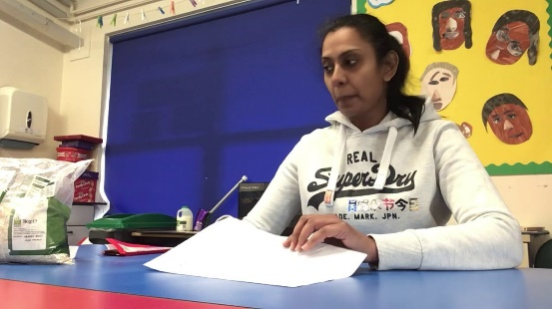 | Week 2 My Independence - chocolate treats  www.youtube.com

Week 2 - Science - Healthy and Unhealthy foods https://www.youtube.com/watch?v=XdrOpaD02XQ&feature=youtu.be
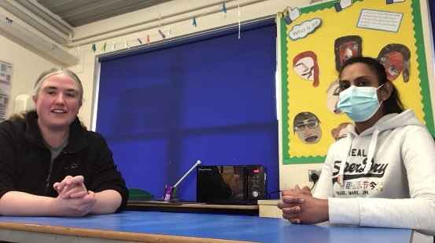 | Week 2 science - healthy and unhealthy  www.youtube.com

Week 2 - Art - Hot Chocolate Painting https://www.youtube.com/watch?v=hLk0K_7Qnos&feature=youtu.be
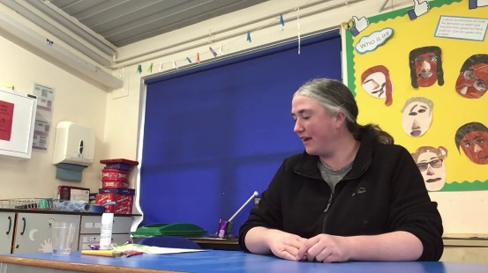 | Week 2 art lesson - hot chocolate painting  www.youtube.com

Week 2 - History - Mayan Masks
https://www.youtube.com/watch?v=SZqtkpClQPo&feature=youtu.be
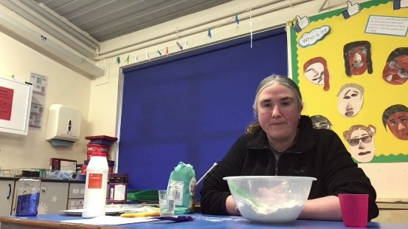 | Week 2 History lesson - Mayan Masks  www.youtube.com

Bucket video 6 https://www.youtube.com/watch?v=cu_Vwi4TsX4&feature=youtu.be
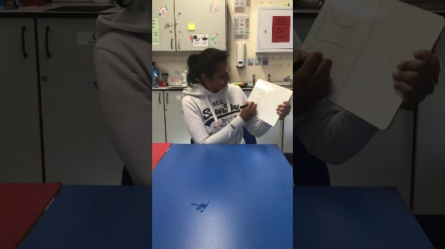 | Bucket video 6  www.youtube.com

Bucket video 7 https://www.youtube.com/watch?v=oqJD2df4UK8&feature=youtu.be

Bucket video 8 https://www.youtube.com/watch?v=fttGQ-aPnmw&feature=youtu.be

Bucket video 9 https://www.youtube.com/watch?v=io8LEKvdKLE&feature=youtu.be
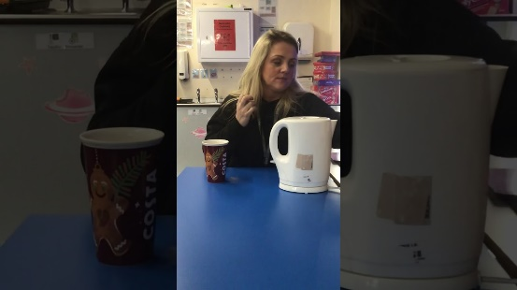 | Bucket video 9  www.youtube.com

Bucket video 10 https://www.youtube.com/watch?v=K5kuz6lJiuM&feature=youtu.be
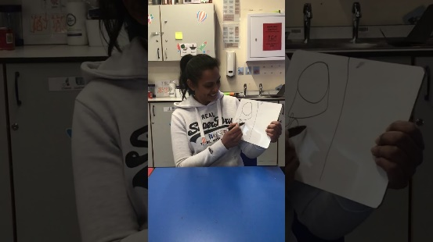 | Bucket video 10  www.youtube.com

