My Communication | Whilst at home keep practicing your PECs and symbols for snacks, drinks, personal care and requesting activities.  I have included a Science recipe for making chocolate slime.  All ingredients can be found in ASDA.  Cut out the symbols and instructions.  Introduce each ingredient to your child. Let them explore and tell them what it is verbally and with the symbol.  You might want to try and get your child to label one or two items.  RB  LW  Can put the instructions in order.  As you follow the recipe ask your child for the items to place in the bowl.
My Thinking | Take part in Maths lessons online which are appropriate to your child’s ability;  https://classroom.thenational.academy/units/numbers-within-6-9e95
My Independence | Sorting the washing  Get your child to sort the washing- colours, types of clothing or even matching socks.  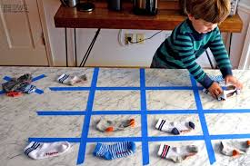  Hand washing on the line.  Sequence 2 to 5 pictures on the order of using the washing machine. Or getting the washing and pegging it on a line.  Some online lesson to try you’re your child:  https://classroom.thenational.academy/specialist/subjects/independent-living/access-points/applying-learning/lessons/organising-clothes-69h30c
My lifestyle | Healthy Diets- healthy fruit smoothie- follow lessons and pause as you go.  Go to link:  https://classroom.thenational.academy/specialist/subjects/independent-living/access-points/building-understanding/lessons/five-a-day-75k36c  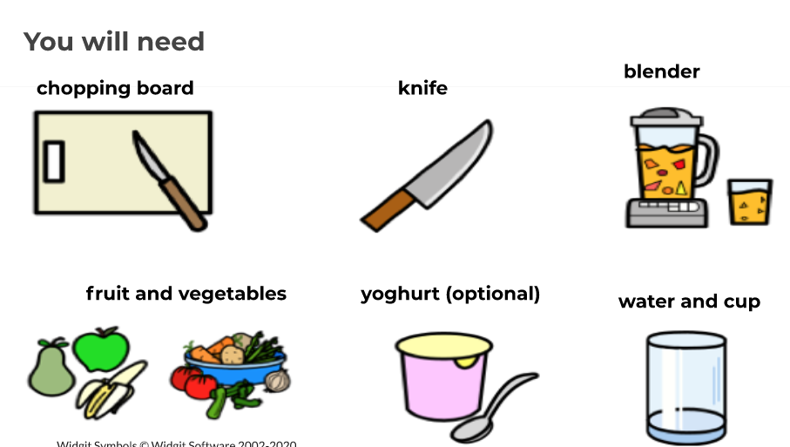
My Body | Circuits for exercise  https://classroom.thenational.academy/specialist/subjects/independent-living/access-points/building-understanding/lessons/finegross-motor-circuits-65hked  Relaxation  https://www.youtube.com/user/CosmicKidsYoga

