**Treasure Hunt Locations**

**C** = Halesowen College Stand

**A** = University of Wolverhampton Stand

**R** = Bangor University Stand

**E** (1) = Nova Training Stand

**E** (2) = Heart of England Training Stand

**R** = Staffordshire University Stand

**S** = Make UK Stand

**Wordsearch Answers**

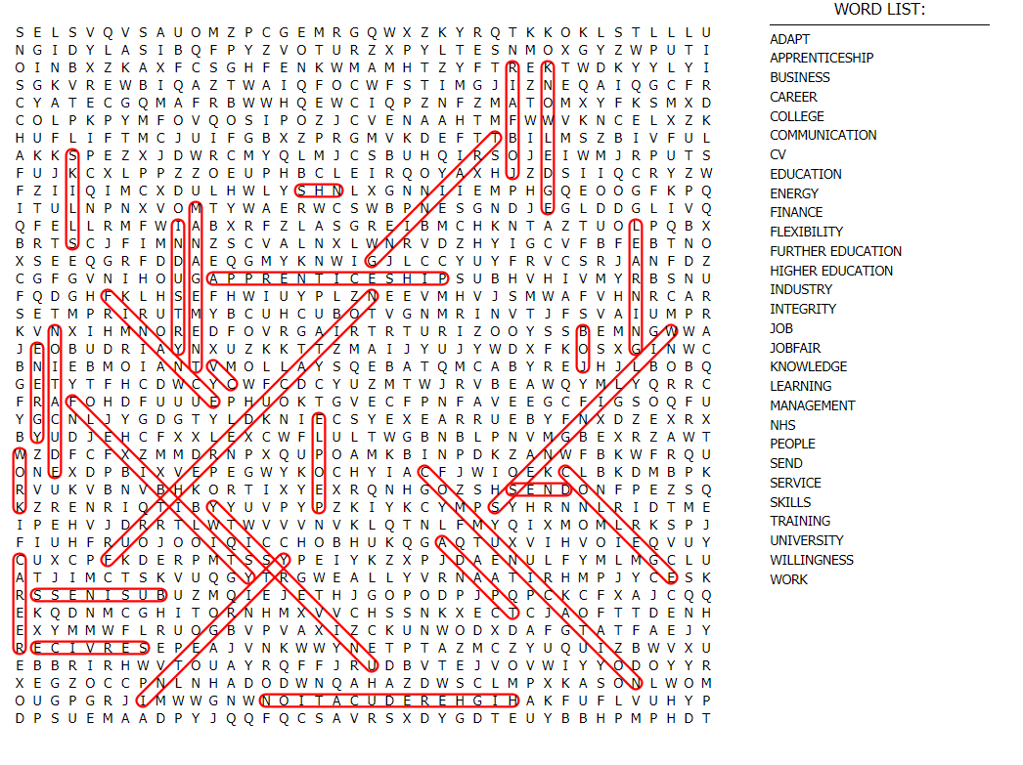

**Crossword Answers**

