Chinese New Year Sensory Spaghetti

https://www.learningandexploringthroughplay.com/2018/02/chinese-new-year-sensory-spaghetti.html?m=1
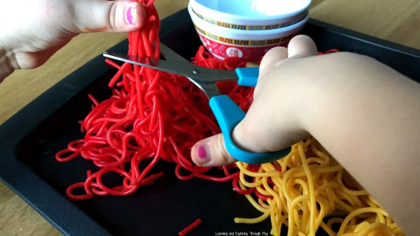
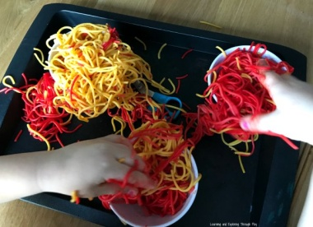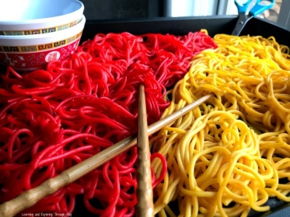 Food Colouring
What you need:
Spaghetti
Bowls
Trays
Sandwich Bags
Utensils/Spoons/Chop Sticks

Method

Fill two sauce pans up with water and add the food colouring, then add the spaghetti and cooked as required.
Remove the water once cooked and wait for the pasta to cool. If you want the colour to be more prominent tip the spaghetti into a sandwich bag and added the smallest amount of colour and mixed it around till the colour dispersed evenly.
Tip it out onto the tray and add the bowls, some chop sticks and spoons.
All of this promotes - developing control in their hands, building fine motor skills and control.
Students will enjoy exploring the spaghetti and the bright colour. Encourage the student to use their hands or different utensils.

