Curriculum update for Governors’ Report 05.10.2022 (E Pace)
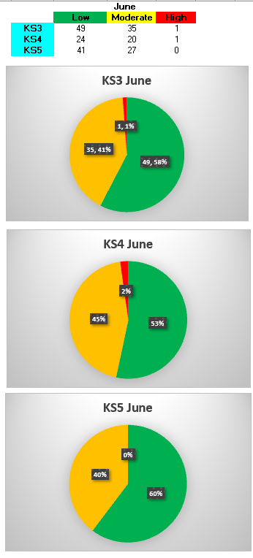
Recovery Curriculum and Vulnerability Assessments update
Vulnerability Assessments in June 2022 highlighted 3 students as being ‘high’. For one student, this was due to a family bereavement. The other was due to a breakdown in the family, inconsistent place of living and a change in parentship. The school is currently working with numerous external multi-agencies to support this student and their family. The Semi-Formal Key Stage 4 teacher reported back that the student had lost family members and close family friends to COVID. This student also has a very good relationship with a member of staff who is leaving. Social stories are being used in class and shared with family.
Bubbles
For Summer 2022, there has been no change in Bubble Leads and the 2 interim appointments are still in place. However, interviews were held in June 2022 to replace the Communication Bubble Lead due to leaving the school. As from Autumn 2022, the leads for each bubble area will be:
My Communication - Ariane Purcell (newly appointed)
My Cognition - Stewart Harris
My Lifestyle - Leonora Curtis (ongoing interim due to staff illness)
My Body - Kieran Bradley (newly appointed)
My Independence - Ash Furness
Across the term, Bubble meetings were held. Thanks to the support from SLT members and school staff, Bubble Leads were able to participate in KS4 and KS5 planning days. New curricula have now been written for both of these Key Stages and disseminated to staff to use for Autumn 2022.

Key Stage Planning Days
Academic year 2021- 2022 has been very challenging, on many different levels, but one of the major contributions to this has been staffing issues. For the Bubble Leads, these planning days have increased their knowledge and understanding of different pathways and key stages. Moving forward, it would be beneficial for these days to continue into the next academic year. These sessions provide a marvellous opportunity to work as a team, give emotional support to each other and increase their own CPD. This has yet to be discussed in SLT.

