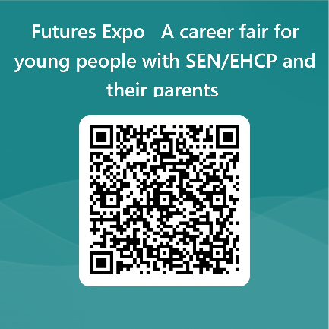

**Does your young person attend another school or college?**

**Would you like to find out more about future options or next steps?**

**We welcome parents outside the Westminster community to attend to explore an array of future options**

**Scan here to book your place**

**10.30am – 12.30pm**