How to login and view vouchers

Step 1
Go to Evouchers.com and press 'login' in the top right-hand corner
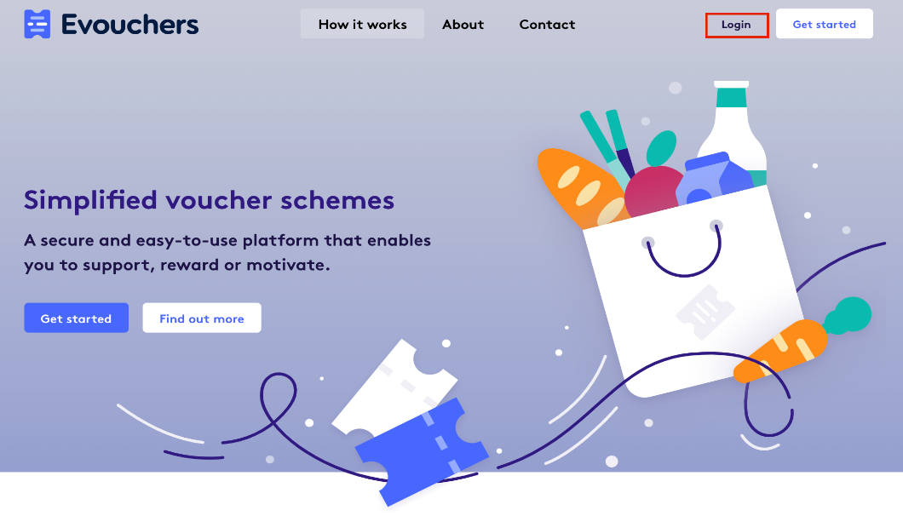

Step 2
Enter the email address or mobile number you used to create the account and press 'continue'.

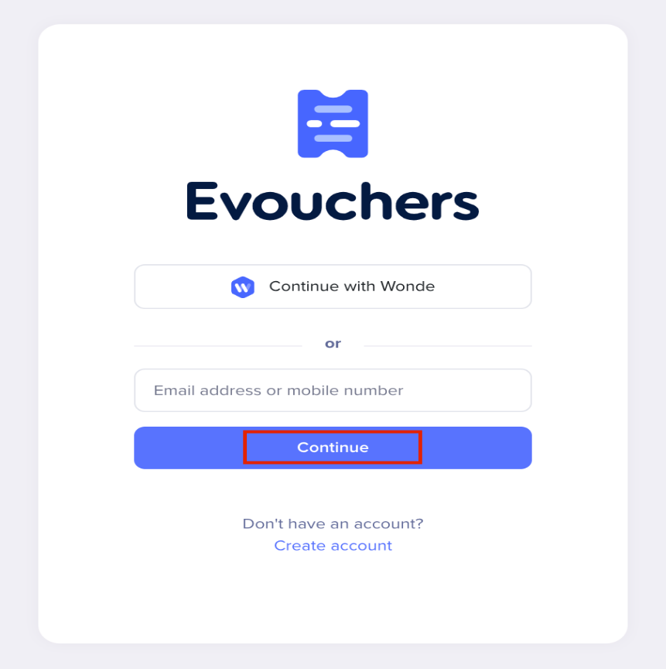

Step 3
Check your inbox/messages for the secure link to login.
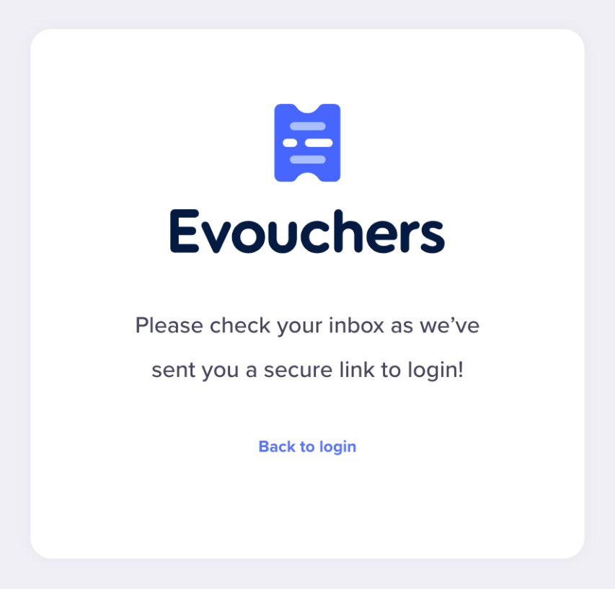

Step 4
Press 'click here to login' via the email;
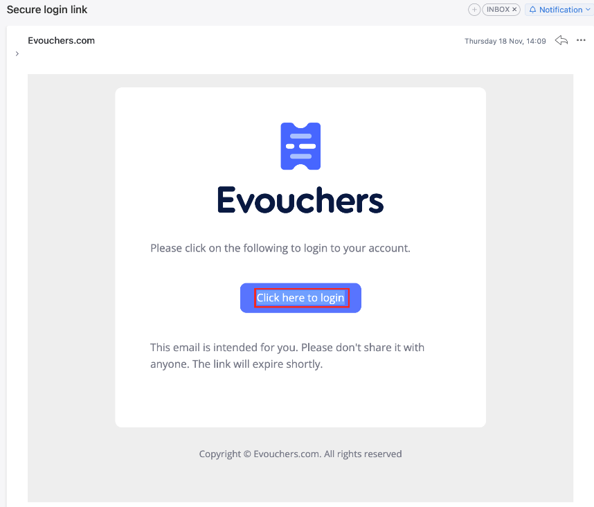

or click on the link in the text message;
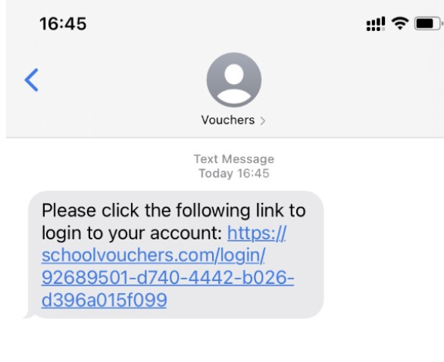

Step 5
You will then be taken into your account where you can view your vouchers.

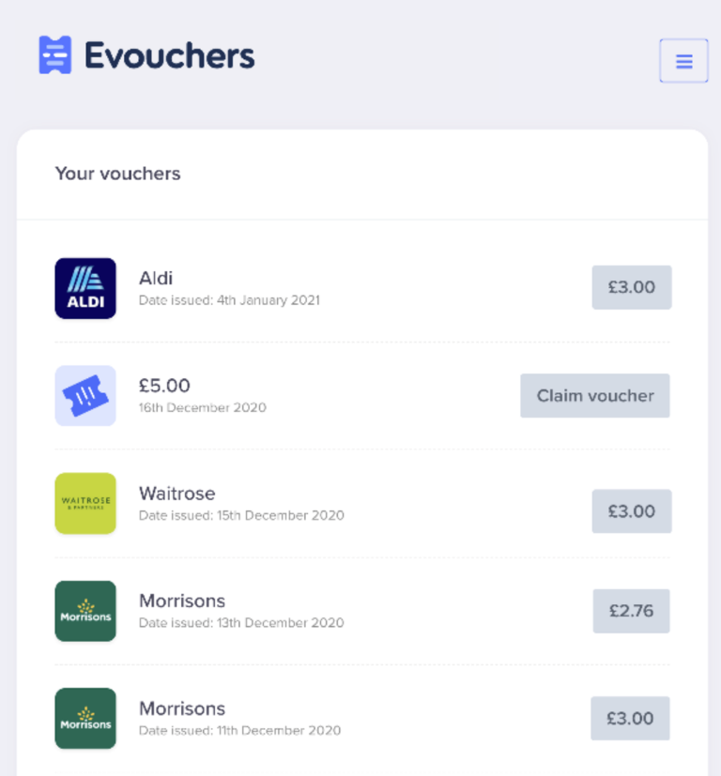

Step 6 Click VIEW VOUCHER

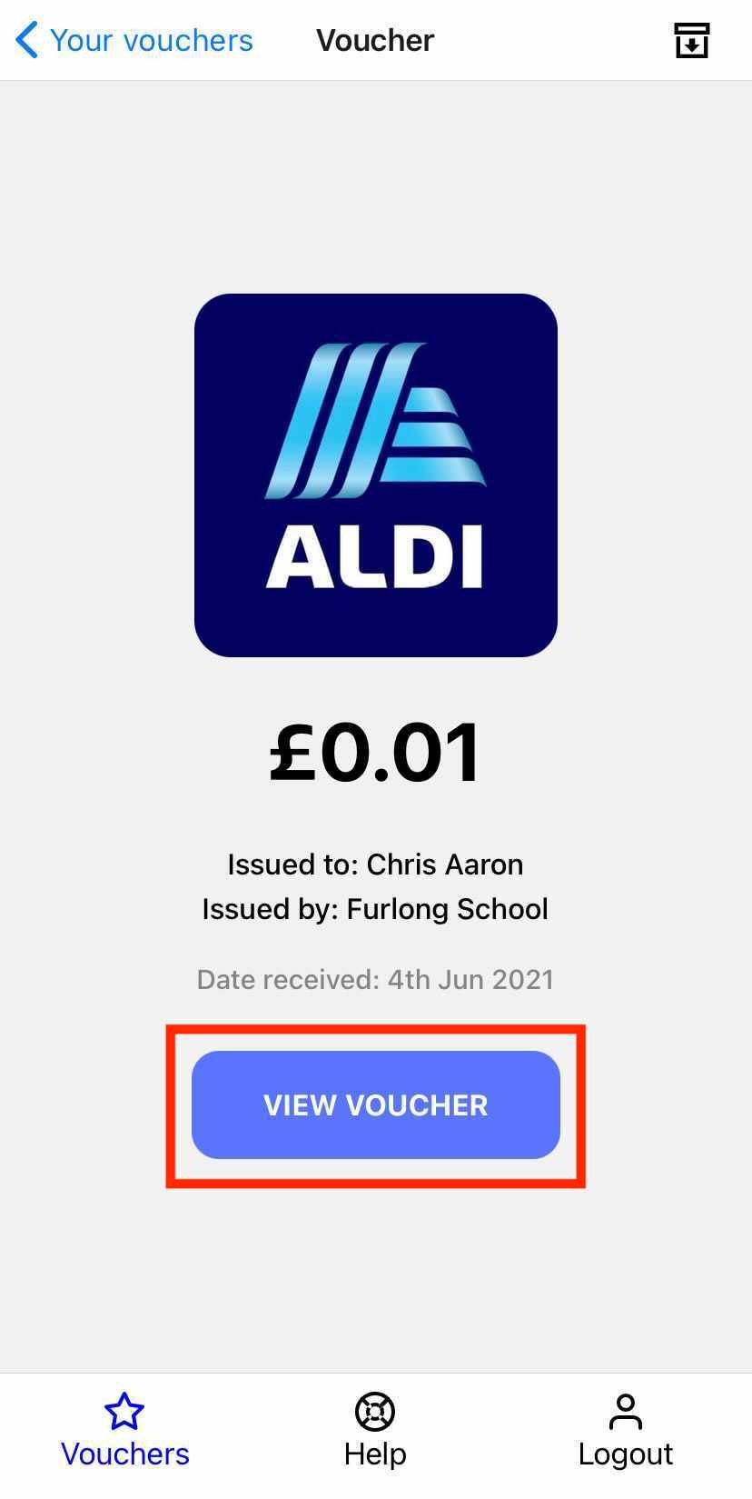

Step 7 Your voucher will then open for you to view, and will save within your app!



