Lessons for Week Commencing – 01/03/2021
The resources needed have been delivered to your home by transport.
You will also have received an email with activities designed specifically for your child to work towards their EHCP targets.
Bucket Therapy  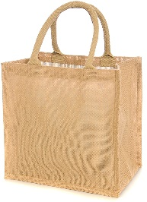 | Here are 5 new Bucket Therapy Videos for this week  Bucket 31  https://youtu.be/SrD-rdOgj6o  Bucket 32  https://youtu.be/karQdf-2HCM  Bucket 33  https://youtu.be/oLSMD8t2r8Y  Bucket 34  https://youtu.be/l8VfbT3wsEw  Bucket 35  https://youtu.be/bJ2UCCRl_zc
Literacy | This term we are learning about money and advertising. The objective of this activity is to join in retelling a story using signing and symbols.  Join in the video advert using Makaton and read the accompanying book with your family. Watch this regularly to help you become familiar and fluent in your retelling. Make you own McMeadows burger on the laminated board in your lesson pack.  https://youtu.be/lJBM-QbFqew
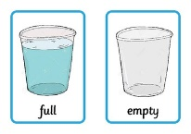  Numeracy | Geometry - Pattern making. Watch the video to see how you could make a range of different patterns at home and how you can make this more challenging.  https://youtu.be/iu0jPCv-9dU  Measurement- Capacity. Watch the video to see how you can explore capacity at home.  https://youtu.be/C1QEb6l_RFY
My  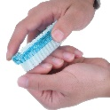  Independence | Using a Nail Brush  You will need the resources from your pack to complete this task. Click on the link to see what you should do during this lesson.  https://youtu.be/3b00xVCCH5I
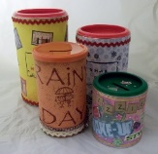  Art | Money Container  Click on the link to see what you should do during this lesson.  https://youtu.be/UDqb2Z6XQ4E
Science | Grow Cress  You will need the resources from your pack to complete this task. Click on the link to see what you should do during this lesson.  https://youtu.be/a5ak7449pZE
PSHE | Earning Money  Watch the video to find out how we can earn money by working  https://youtu.be/lr6JYqRrhYc

