Lessons for Week Commencing 25/01/2021
The resources needed have been delivered to your home by transport.
You will also have received an email with activities designed specifically for your child to work towards their EHCP targets.
Bucket Therapy  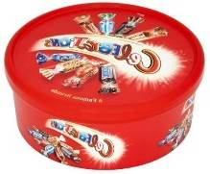 | Here are 5 new Bucket Therapy Videos for this week  Bucket 11  https://youtu.be/GSjZ3TVF99w  Bucket 12  https://youtu.be/gEELthNqfQ0  Bucket 13  https://youtu.be/wRSWQcr9DVk  Bucket 14  https://youtu.be/2owBSMDId3g  Bucket 15  https://youtu.be/-Y2uYicBxu4
Literacy  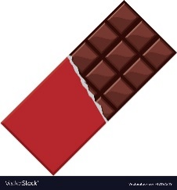 | Continue to read the class text ‘How is Chocolate Made?’ and learn the symbols and signs that go with it. Talk about the process and encourage your child to join in with retelling the story.  https://www.youtube.com/watch?v=gqKseA7G1ow&feature=youtu.be  https://www.youtube.com/watch?v=cg4z_1qGv5k&feature=youtu.be
Numeracy | To support and maintain learning in maths please engage with these Oak Academy Lesson Videos with your child  https://classroom.thenational.academy/specialist/subjects/numeracy/access-points/applying-learning/lessons/counting-individual-objects-cgt3jc  https://classroom.thenational.academy/specialist/subjects/numeracy/access-points/building-understanding/lessons/counting-individual-objects-one-to-one-correspondence-6nh32d
My  Independence | Chocolate Treat Designer  You will need the resources from your pack to complete this task. Click on the link to see what you should do during this lesson.  https://youtu.be/ZGctR5Yjj7g
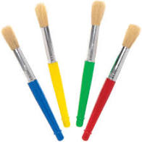  Art | Print Making  You will need the resources from your pack to complete this task. Click on the link to see what you should do during this lesson.  https://youtu.be/ujEoh7on6ZY
Humanities | Mayan Jewellery Making  You will need the resources from your pack to complete this task. Click on the link to see what you should do during this lesson.  https://youtu.be/JwhP1e14OWA

