Love Bug Valentine Craft

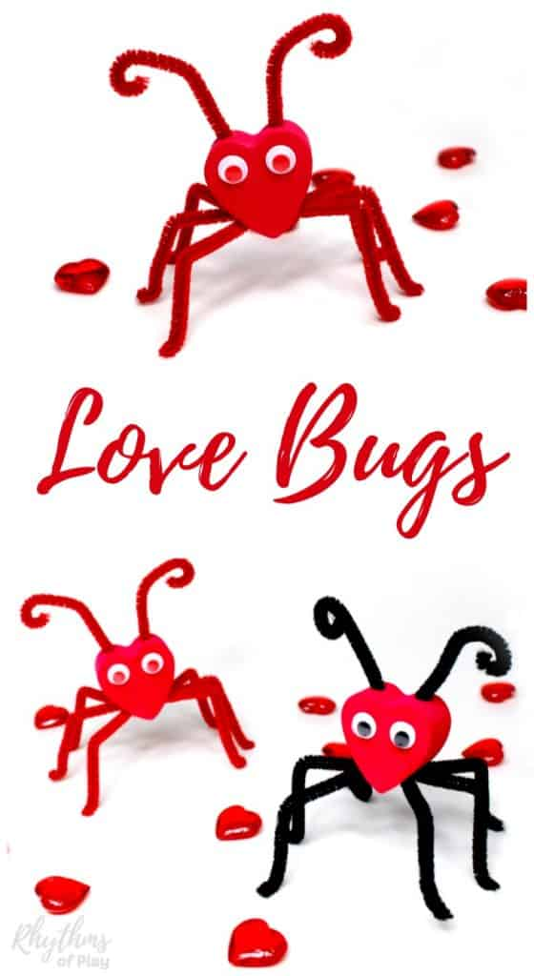
https://rhythmsofplay.com/heart-love-bugs-craft/

Making love bug crafts is a fun way for our students to practice their fine motor skills. Fine motor activities like this can help develop the small motor muscles of the hand. Developing these small motor muscles helps children.

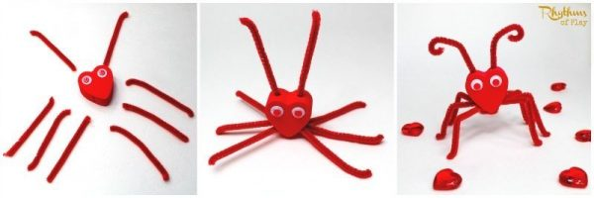
FOR EACH VALENTINE LOVE BUG CRAFT YOU WILL NEED:

1 foam heart 4 pipe cleaners (cut into 2 equal sections) 1 pair of googly eyes

HOW TO MAKE LOVE BUGS
Cut each pipe cleaner into 2 equal sections so there are 8 half sections of pipe cleaners for each heart love bug. They don’t have to be perfect, different lengths add character. Place a dab of glue on the tip of each pipe cleaner, and put one into each hole to make the legs for the love bug. Bend the legs to create a knee and foot for each leg of your love bug craft. Curl the tips of each antenna to make the love bug face super cute. Glue googly eyes onto each love bug face.

