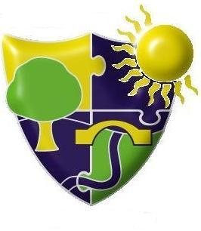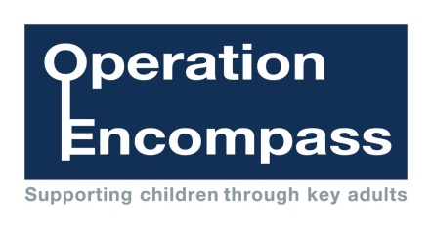

The Meadows School, Dudley Road East,

Oldbury, B69 3BU

Operation Encompass is the early reporting on to schools that a child or young person has been exposed to domestic abuse

In every force, in every school, for every child