Lessons for Week Commencing – 22/02/2021
The resources needed have been delivered to your home by transport.
You will also have received an email with activities designed specifically for your child to work towards their EHCP targets.
Bucket Therapy  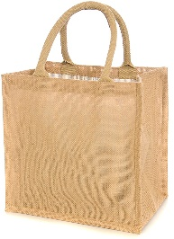 | Here are 5 new Bucket Therapy Videos for this week  Bucket 26  https://youtu.be/FYG3KT7dnK8  Bucket 27  https://youtu.be/slQA3p_wKfs  Bucket 28  https://youtu.be/0JUmTrpSADY  Bucket 29  https://youtu.be/25IJKb-DNlw  Bucket 30  https://youtu.be/iqre7jOO4jQ
Literacy | This term we are learning about money and advertising. The objective of this activity is to develop your child’s interest in different types of text and to help them understand that adverts are designed to make us want things.  Explore the leaflets and junk mail that comes through your door. Talk about what you see in the pictures. Look at the prices and look for logos you might recognise e.g. Pizza Hut, Tesco etc. Talk about what you might like to buy or not like to buy.
Numeracy | To support and maintain learning in maths please engage with this Oak Academy Lesson Video with your child  https://classroom.thenational.academy/specialist/subjects/numeracy/access-points/building-understanding/lessons/exploring-position-6thkje
My  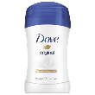  Independence | Hygiene Bingo  You will need the resources from your pack to complete this task. Click on the link to see what you should do during this lesson.  https://youtu.be/eZsdkdAKA7I
Art | Penny Spinner  You will need the resources from your pack to complete this task. Click on the link to see what you should do during this lesson.  https://youtu.be/XDcVcu53QRE
Humanities | Using coins  You will need the resources from your pack to complete this task. Click on the link to see what you should do during this lesson.  https://youtu.be/nY4-1_YMUmQ
Science | Make a grass head  You will need the resources from your pack to complete this task. Click on the link to see what you should do during this lesson.  https://youtu.be/HY6uY94V9oU

