F o r
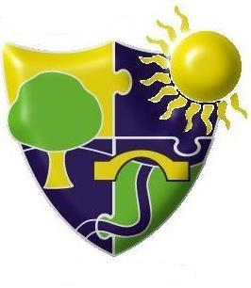
The Meadows School
Dudley Road East, Oldbury, West Midlands, B69 3BU

Telephone: 0121 569 7080
Medical Office: 0121 544 6754

Electronic mail: headteacher@themeadows.sandwell.sch.uk
Website: www.themeadows.sandwell.sch.uk

Headteacher: Ms Rupe Virk

18th December 2020

Dear Families,

You may be aware of the news reports regarding the government’s intention to stagger secondary school students’ return to school in January because of COVID-19.

However, at the Meadows school, we intend to open as planned for students on Tuesday 5th January 2021, as we are already in four zones and do not wish for further disruptions to the students’ education. We endeavour to ensure that all students are educated in school and we envisage this to be the case in January.

Should the government make further changes to their guidance during the Christmas break we will inform you accordingly.

Also based on the latest government’s stance that testing will be implemented within schools, we are waiting on government guidance but we really value your opinion.
Therefore, we would like to gauge your feedback. It would be helpful if you could fill in and return the permission slip below on 5th January when your child returns school.

Yours sincerely

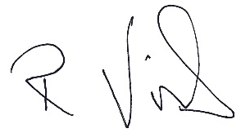

Rupe Virk (Ms)
Head Teacher

______________________________________________________________________________________

Would you please give permission for your child to have regular COVID-19 TESTING

I/we parents/carers of _________________________________________________ (child’s name)

Give permission for my child to have regular COVID-19 tests.

Do not give permission for my child to have regular COVID-19 tests

Please tick one box.

Signed ___________________________________________________________ parent/carer.

