The Meadows School

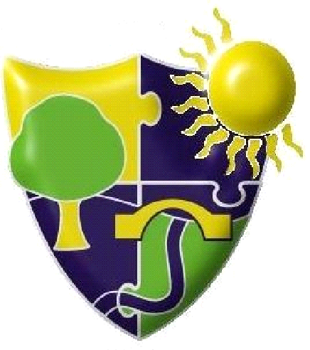

Safer People Handling Policy

Updated: | November 2022
Date to be reviewed: | November 2025
Ratified by Governors: | Pending

Amendment Register

Amendment  Number | Date | Detail | Amended  By | Approved  By
0 | 14.11.18 | Initial Issue | SLT | Headteacher
1 | 16.12.2019 | Reformatted | G Barham | Headteacher
2 | 23/11/2020 | Ratified | C Swoffer | FGB
3 | Nov 2022 | Reviewed – no revisions required | G Spencer | Headteacher

Table of Contents

Serial | Description | Page No.
1 | Rationale | 2
2 | Aims of The Meadows School | 2
3 | Staff employed by The Meadows School will | 3
4 | Pupils (who need assistance with moving) at The Meadows School will | 4

- Rationale

The Meadows School recognises its responsibility to both provide access to the curriculum for pupils with disabilities and to ensure the health, safety and welfare of its pupils and employees as far as is reasonable practicable. This Safer People Handling Policy complies with the requirements of The Manual Handling Operations Regulations (1992), The Health and Safety at Work Act 1974, Lifting Operations and Lifting Equipment Regulations (1998) and The Reporting of Incidents, Diseases and Dangerous Occurrences Regulations 1995. It also takes account of the SEN and Disability Act (SENDA) 2001and the Equality Act 2010.

This policy applies to all staff (including supply staff), pupils, contractors/any other individuals present on the school premises for the purpose of work. It will be reviewed every 3 years or sooner if required as a result of significant/ pertinent changes.

- Aims of The Meadows School:

  - Ensure full access to the curriculum and participation in the life of the school of children with disabilities
  - Ensure the dignity and right to privacy of such children
  - Implement and maintain systems of work (Safer People Handling Plans) that are safe and without health risks. Measures to achieve this will include, as far as possible/appropriate

  - ergonomic design of the working environment
  - clear operational procedures to ensure safe systems of working, including the adequate servicing of equipment
  - accredited/appropriate training for staff (legal requirement) and the provision of appropriate mechanical aids/equipment

  - Review all Safer People Handling Plans and risk assessments annually, or sooner, if significant changes occur
  - Avoid people handling, which pose a risk to its employees. Risk-assess fully, all people - handling operations judged to be potentially hazardous. Safe systems of work (i.e. Risk Assessment and a Safer People Handling Plan) which apply to routine procedures for many pupils will be carried out at least annually or sooner if systems of work change significantly. Individual Risk Assessments will be carried out for every pupil who has a Safer People Handling Plan (as part of the initial preparation of the plan), and will be reviewed annually (or sooner if significant changes occur in the condition/needs of the pupil).
  - Reduce any risks that are identified to the lowest level, which is reasonably practicable
  - Ensure that employees who carry out Safer People Handling tasks are competent/capable and appropriately trained
  - Provide such information, instruction/ training* and supervision as is necessary to ensure the health, safety and welfare at work of all employees and ensure that employees involved in manual handling of pupils receive training on safe systems of working
  - Make reasonable allowances for employees who become pregnant or develop a medical condition that may affect their ability to perform the required Safer People Handling tasks
  - Ensure equipment provided is safe and available for use, e.g. charged up, checked at required intervals (Lifting Operations and Lifting Regulations 1998), serviced, faults reported, etc
  - Monitor all accidents and incidents and ensure they are correctly reported
  - Ensure that every room where people work shall have sufficient floor area, height and unoccupied space for the purposes of health, safety and welfare
  - Ensure that staff are aware of this policy and have read and understood relevant risk assessments, Safer People Handling plans and the Personal Emergency Egress Plans
  - Protect the health and safety of visitors to the school whilst they are on the premises as far as is reasonably practicable

- Staff employed by The Meadows School will:

Take reasonable care of the health and safety of themselves and others who may be affected by their actions. In order to do this they will:

  - Comply with this Safer People Handling Policy
  - Report to the Head Teacher/Line Manager any medical condition (temporary or permanent) that may develop (including pregnancy) which may affect their ability to carry out Safer People Handling tasks
  - Report to the appropriate Head Teacher/Line Manager any issues or practice that they consider to be a risk to health and safety, including any equipment faults
  - Wear appropriate clothing and shoes (as detailed in the risk assessment or Safer People Handling plan) Ensure their clothing is compliant with school policy.
  - Co-operate with the Head Teacher to allow him/her to comply with his/her health and safety duties
  - Use equipment safely and appropriately in accordance with training and instructions provided
  - Follow the Safer People Handling plans agreed and written for each pupil
  - Undertake any specified training to fulfil their duties
  - Not carry out Safer People Handling procedures without appropriate advice/training
  - Report any accident or incident to the appropriate Line Manager in line with school procedures
  - Assess a situation first without rushing in to lift a pupil. (If a pupil has fallen, the member of staff will reassure the pupil and get help if necessary. They will give him/her time to recover and then encourage the pupil to get up by him/herself, or with the minimum of assistance as needed. A situation like this should have been planned for and should therefore not be seen as an emergency).

Note: A pupil should never be lifted manually except in life threatening situations e.g. fire, collapsing building or danger of drowning. Small children i.e. under 16 kilos excepted from this rule and can be lifted following appropriate training. The procedure to be followed in such situations should be detailed in the Personal Emergency Egress Plan, as part of the school’s Emergency Evacuation Procedures / Health and Safety Policy.

- Pupils (who need assistance with moving) at The Meadows School will:

  - Receive assistance from appropriately trained staff who follow safe systems of work
  - Have their safety guarded so that the risk of injury will be eliminated or minimised to the lowest level
  - Have individual Safer People Handling plans and accompanying risk assessments
  - Participate in drawing up their handling plan
  - Have their Safer People Handling plans reviewed at least annually or sooner if any circumstances change
  - Have their privacy and dignity protected at all times
  - Within the limits of their ability, be encouraged to move independently and take responsibility for their own safety as well as that of others
  - Have their entitlement to curriculum access and full participation in the life of the school (including extended day activities and school trips etc) acknowledged

