Sensory Art /exploration linked with valentines

DIY TOUCH AND FEEL VALENTINE’S DAY

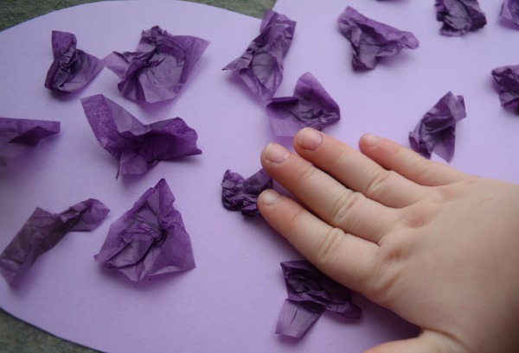
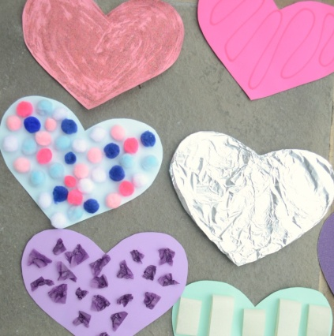
http://simpleplayideas.com/sensory-activity-valentines-day-heart

Let’s have some fun making some Valentine hearts! Students will enjoy making this hearts feeling and exploring all kinds of different textures.
What equipment’s you will need
Coloured card Sellotape
Glitter Scrunched tissue paper
Glue Scissors
Foil Pompoms
Material Sand paper
Coloured sand
How to make Valentine’s hearts Instruction’s
Chose your coloured card, and then cut a heart shape with help from an adult. Then chose what you’re going to decorate the heart with, out of all the different textiles. Put some glue on your heart and apply the textiles.
Additionally student’s who are able to hold or grasp items, encourage them to do so they can explore the different textures.

