**THIS IS ME: Understanding my behaviours as I have different needs**

**Weekly workshops for children with AUTISM/ADHD or on a pathway, to help understand their emotions and behaviours**

**Each child will complete a “This Is Me work sheet” and have their own monsters emotions cards. (delivered in schools)**

**Session one:**

* Getting to know each other
* What are our different needs (ASD/ADHD)
* Monster Emotions cards Introducing “Emotions Volcano”
* Complete activity from “a Volcano in my Tummy” (A Volcano In My Tummy)

**Session two:**

* Developing an understanding of our emotions and behaviour
* Monster Emotions cards
* Complete activity from “a Volcano in my Tummy” (Are You A Volcano)
* Introduce TIM: “this is me” work sheet.

**Session three:**

* Monster Emotions cards (these are A4 and should be laid out on the table)
* Potions emotions experiment
* Completing my TIM: This is me sheet: what can I do to help me stay calm
* 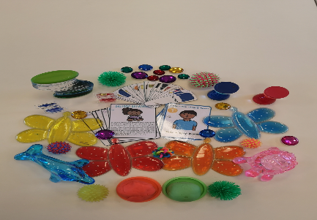 Start completing the Monster Emotions worksheet

**Session four:**

* Complete any outstanding work
* Complete “how I am feeling” work sheet.
* Celebration, giving attendance certificate.
* Parents invited to join in with child, to help celebrate their achievements.

**Sam Edwards**

**Helping Hands Service Manager**

**Telephone: 07881 265320**

**Email:** [**sam.edwards@family-action.org.uk**](mailto:sam.edwards@family-action.org.uk)