A group of young people visited the West Bromwich Albion football stadium for a presentation ceremony.
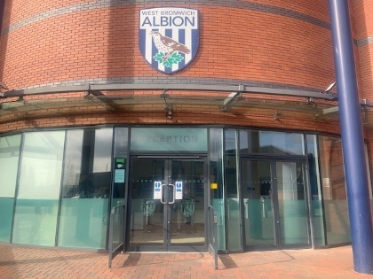
The Meadows School have won awarded 2nd place in the DPD Green Project.
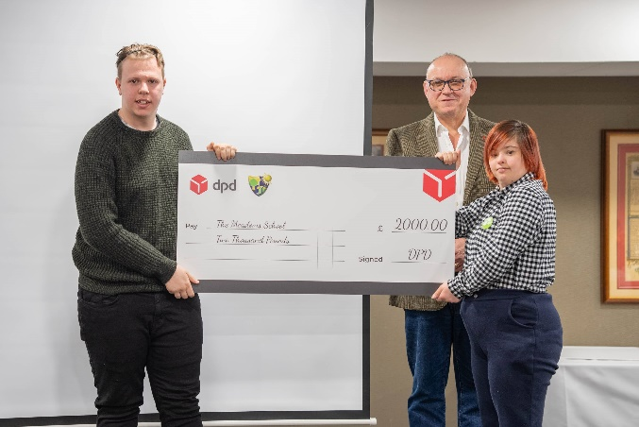
We were awarded £2000 which we will be using to continue developing our outdoor gardens.

