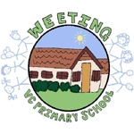 Reading At Home Together
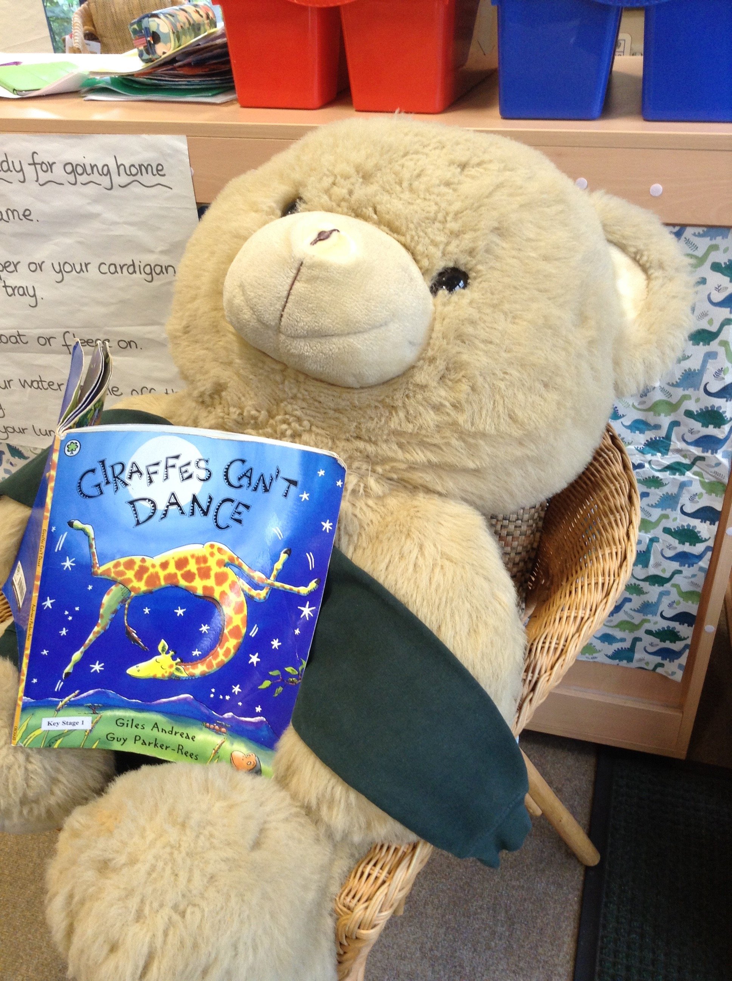
“A cord of three strands is not easily broken”
Ecclesiastes 4:12

In Chestnut Class we want the children to enjoy sharing stories, talk about what is happening in stories and sing songs and rhymes. All of these activities will help them to develop their reading and language skills.

Reading with your child can mean sharing books, stories, rhymes, or any other writing.
You can:
- Read books together.

- Tell each other stories.

- Chat about the things that you have read.

- Talk about pictures in books.

- Share stories even when you don’t have a book in front of you. Why not re-tell your favourite stories?

What should we read?
You can read anything!
- Try out a range of picture books, comics, poems, and rhymes.
- You can read the same book over and over again. Familiar books are comforting and build confidence.
- You can choose new books. Pick something together that you can both enjoy.
- Books don’t have to be full of words. Picture books are perfect for sharing and talking about with your child. You can use pictures to explore stories and help your child understand books that are more difficult.
- Find your local library and see what your child likes.
- Visit the bookfinder on the Book Trust website for some ideas: www.booktrust.org.uk/bookfinder
- You can find storytelling apps and stories on tablets and computers too. Just be sure to stay with your child and enjoy sharing the story with them.

When should we read?
Share stories whenever you can find the time. Reading for just ten minutes a day with your child makes a huge difference.
- Take books with you so you always have a story to share. You can read on the train or bus, or even if you are waiting in a queue together.
- When you are outside, take time to notice what is going on around you. Make up stories about what you see with your child.
- Bedtime is the perfect time to read together. It helps create a routine and can make going to bed something your child looks forward to. It is a special time for your and child to share.

How?
- Find a quiet place with no distractions. Turn off televisions, radios, computers and tablets. Take time to look at each page.
- You don’t need to make sure your child gets every word right. It is ok for both of you to make mistakes! Let them talk to you about the pictures. This helps them look for meaning and to think about what they see happening on the page.
- Don’t forget to smile. If you feel comfortable try pulling funny faces, making animal noises and putting on character voices – these always make children giggle!
Ask questions when you are reading together
For example:
- What do you see on this page?
- How do you think the characters feel? What do you think is going to happen next?
When you have finished, talk about how your child feels about the book:
- What did they like?
- What didn’t they like?
- What can they remember about what happened?
- Who was their favourite character? Why?
- Link the story to their own experiences. Can they remember when they did something similar?
Most importantly, have fun!

Your Reading Packet
Your child has been given a reading packet. There are lots of things inside that you can share together at home to support your child’s enjoyment.
- A reading dog. Your child’s dog can listen to stories at bedtime, or another quiet time. Your child might enjoy sharing their book with their dog.
- A collection of rhymes. We introduce the children to a new rhyme each week.
- A library book. Your child visits our school library each week and chooses a book that they would like to bring home to share with you.
- A reading record. Please comment on what you shared together, things that your child talked about as you shared a book, or even what you acted out after sharing the story or singing a rhyme.

Please make sure all the items in your child’s reading packet are kept safely inside. Reading packets will be sent home on Fridays and should be returned to school on Thursdays. Please keep these at home in between these times.
