Intention:  - This unit will consolidate the creative writing skills from Years 7 and 8. Eduqas Component 1 Section B is narrative writing and students by the end of year 9 will have attempted narrative across different genres. |  |  |  |  | Key Texts:  - Murder on the Orient Express – Agatha Christie.  - Lamb to the Slaughter – Roald Dahl.  - And then There were None – Agatha Christie.  - The Mysterious Affair at Styles – Agatha Christie.
Key Terminology: |  | Characters and Key Figures: |  | Narrative Structure – Key Terminology:
Omission  Tension  In medias res  Foregrounding  Flashback  Non-linear  Dialogue  Characterisation  Atmosphere  Red Herring | Deliberately leaving something out. Often used to create tension.  A feeling of nervousness before and important or difficult event.  Starting the story in the middle of the action.  Focusing on a key detail in order to draw the reader’s attention to it.  Looking at something which has happened in the past.  A narrative which follows events, but not in the order that they happened.  Speech  The way an author creates a character.  The mood or feeling associated with a piece of writing.  A piece of false information designed to mislead the reader. | Hercule Poirot  Mary Maloney  Agatha Christie | The world-renowned, moustachioed Belgian private detective. Known for his intelligence and understanding of the criminal mind. Respected and admired by police forces and heads of state across the globe!  The protagonist of ‘Lamb to the Slaughter.’ A happy and devoted housewife who is six months pregnant, Mary spends much of her time caring for and thinking about her husband, Patrick.    The best-selling novelist of all time. Best known for her 66 detective novels and 14 short story collections as well as the world’s longest-running play (The Mousetrap). | Exposition  Inciting Incident  Rising Action  Climax  Falling action  Resolution/  Denouncement |  | The beginning of the story. It introduces the main characters, settings and themes as well as the idea of the central conflict that needs to be resolved.  The event that ignites the plot.  The longest section of the story. This is essentially the journey from the initial conflict through to the climax. Tension is built.  The height of the action/the point of highest tension.  This is usually a short section describing the aftermath of the climax. Leads the reader smoothly to the conclusion of the story.  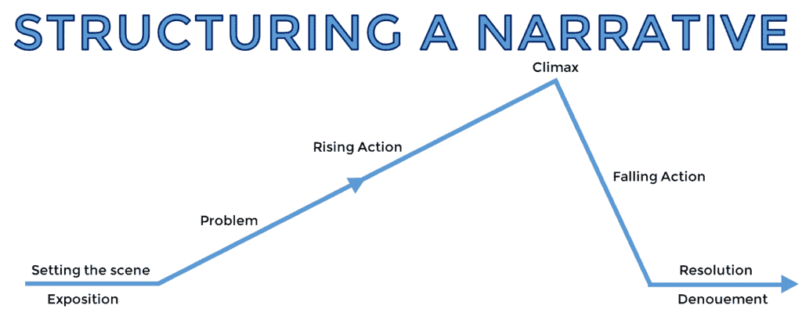  The conclusion of the narrative, where conflicts are resolved (either happily or sadly).

