Topic/Skill | Definition/Tips | Example  Topic: Standard Form
1. Standard Form | $$A × {10}^{b}$$  $$where 1≤A<10, b=integer$$ | 8400 = 8.4 x ${10}^{3}$  0.00036 = 3.6 x ${10}^{-4}$
2. Multiplying or Dividing with Standard Form | Multiply: Multiply the numbers and add the powers.  Divide: Divide the numbers and subtract the powers. | $$\left(1.2×{10}^{3}\right)×\left(4×{10}^{6}\right)=8.8×{10}^{9}$$  $$\left(4.5×{10}^{5}\right)÷\left(3×{10}^{2}\right)=1.5×{10}^{3}$$
3. Adding or Subtracting with Standard Form | Convert in to ordinary numbers, calculate and then convert back in to standard form | $$2.7×{10}^{4}+4.6×{10}^{3}$$  $$=27000+4600=31600$$  $$=3.16×{10}^{4}$$
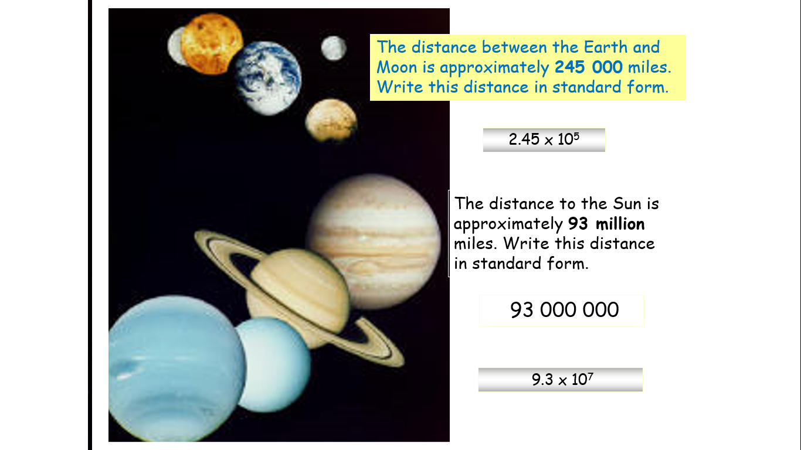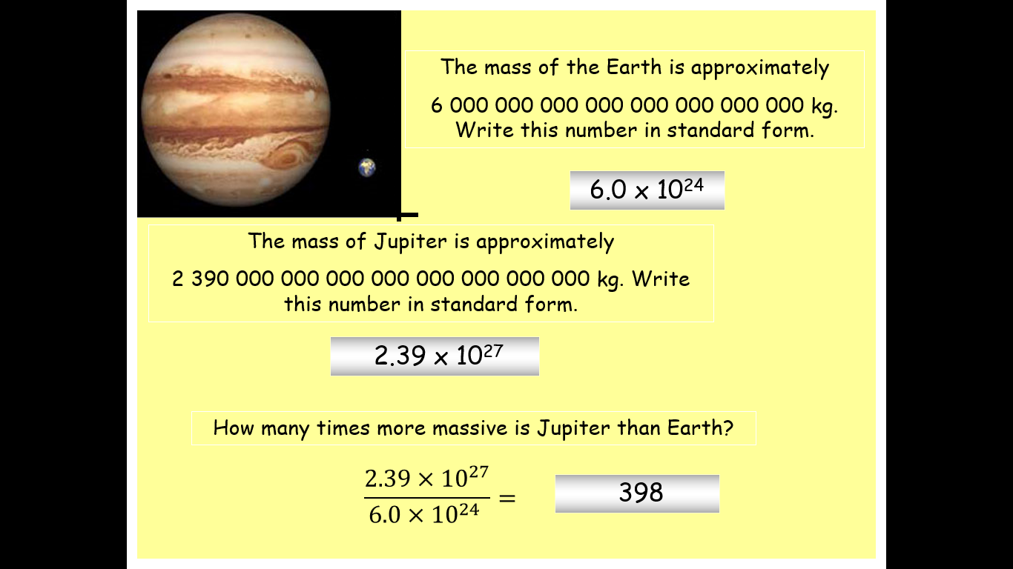
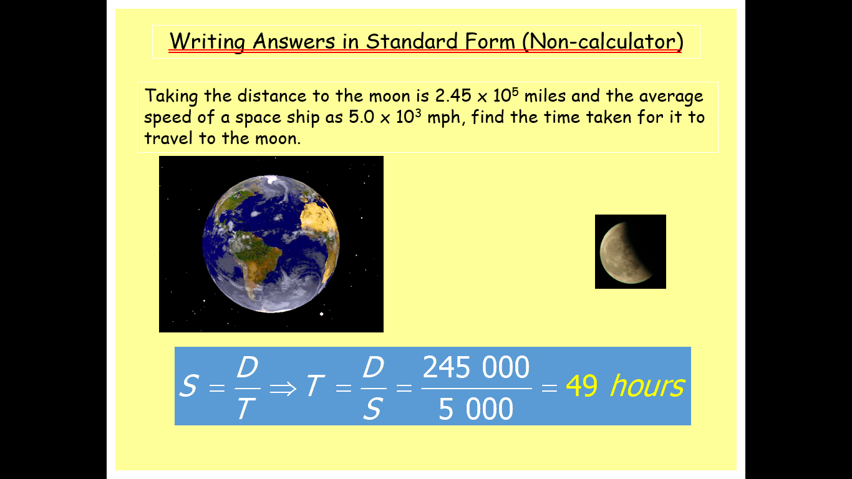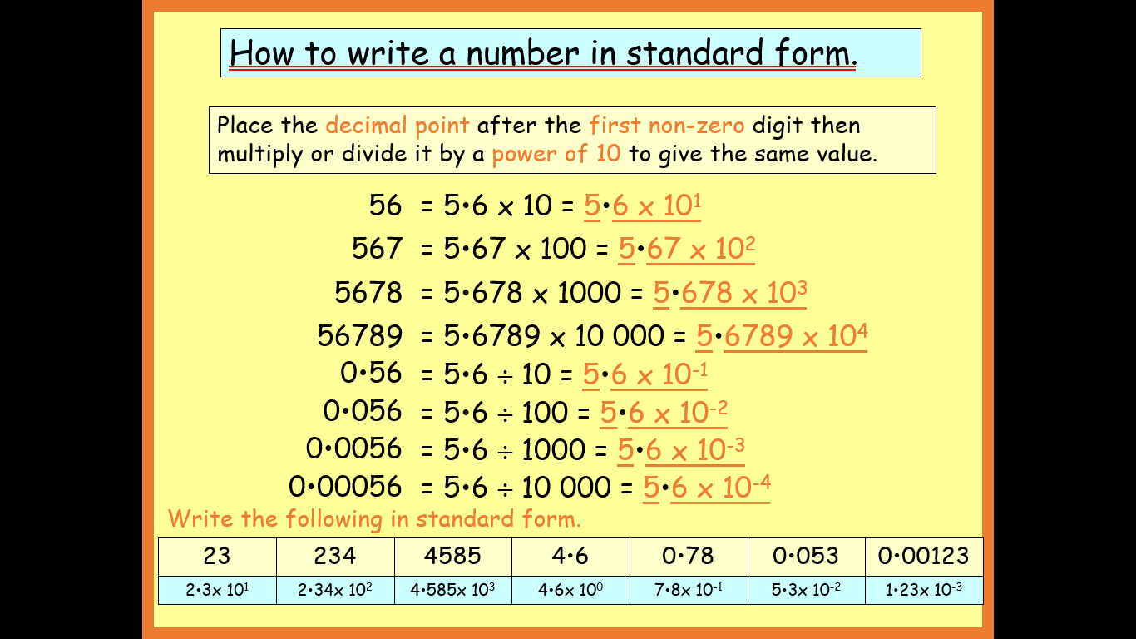

Knowledge Organiser

