Topic/Skill | Definition/Tips | Example  Topic: Volume
1. Volume | Volume is a measure of the amount of space inside a solid shape.  Units: $mm^{3}, cm^{3},m^{3}$ etc. | 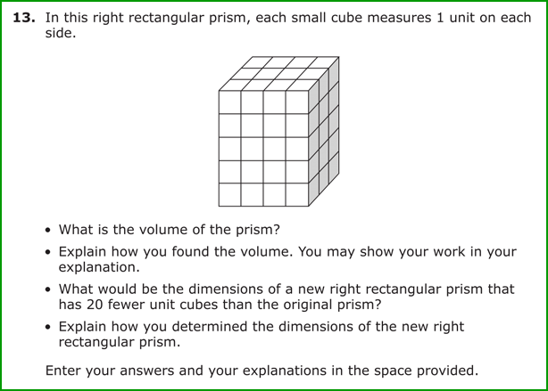
2. Volume of a Cube/Cuboid | $$V=Length×Width×Height$$  $$V=L×W×H$$  You can also use the Volume of a Prism formula for a cube/cuboid. | 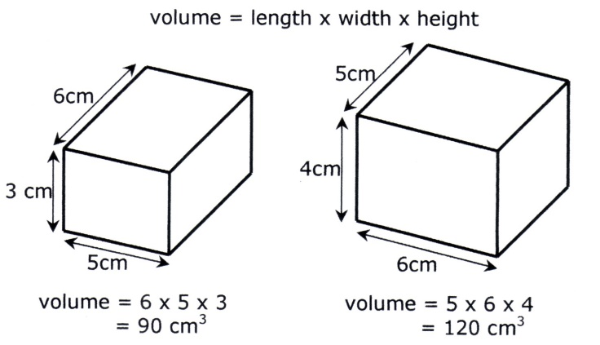
3. Prism | A prism is a 3D shape whose cross section is the same throughout. | 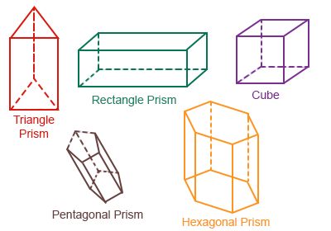
4. Cross Section | The cross section is the shape that continues all the way through the prism. | 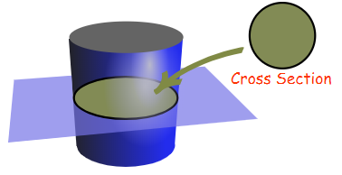
5. Volume of a Prism | $$V= Area of Cross Section×Length$$  The cross section can be as simple as a square face, but here we have a piece of curved piping . Sometimes in the exam they will give you the area of the  cross-section .  Eg., say here the cross section has an area of 50${cm}^{2}$, the length is 20cm what is the volume of this prism  So all you would need to do is  V = 50 $×20$ = 1000${cm}^{3}$ | 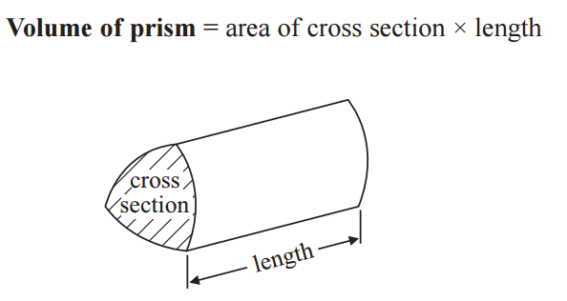
6. Volume of a Cylinder | $$V= Area of Cross Section×Length$$  V = Area of circle $×$ length  Since cylinders often hold liquid they are upright so we use  V = Area of circle $×$ height  $$V=πr^{2}h$$ | 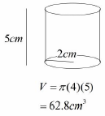
7. Volume of a Cone | $$V=\frac{1}{3}πr^{2}h$$  A cone is circle based pyramid so  V= $\frac{1}{3}×volume of cylinder$  Hence  $$V=\frac{1}{3}πr^{2}h$$ | 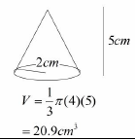
8. Volume of a Pyramid | Volume of any pyramid = $\frac{1}{3}×volume of 3d shape its inside$  So here its $\frac{1}{3}×volume of a cuboid$  V = $\frac{1}{3}×base ×width×height$ | 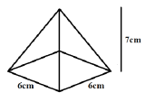  $$V=\frac{1}{3}×6×6×7=84{cm}^{3}$$
9. Volume of a Sphere | $$V=\frac{4}{3}πr^{3}$$  Look out for hemispheres – just halve the volume of a sphere. | Find the volume of a sphere with diameter 10cm.Since d=10, r=5  $$V=\frac{4}{3}π{(5)}^{3}=\frac{500π}{3}{cm}^{3}$$
10. Frustums | A frustum is a solid (usually a cone or pyramid) with the top removed.  Find the volume of the whole shape, then take away the volume of the small cone/pyramid removed at the top. | 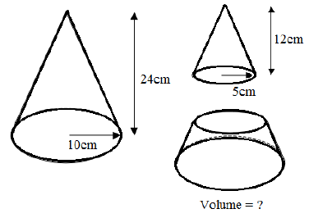  $$V=\frac{1}{3}π{\left(10\right)}^{2}\left(24\right)-\frac{1}{3}π{\left(5\right)}^{2}\left(12\right)=700π{cm}^{3}$$
$$Topic: Geometry and Measures (H)$$

Knowledge Organiser

