

Essential Equipment and Uniform

A well-stocked pencil case containing the following:

Black pen | Red Pen | Pencil | Rubber
Ruler | Protractor | Glue Stick | Highlight pens
Colouring pencils | Scientific Calculator

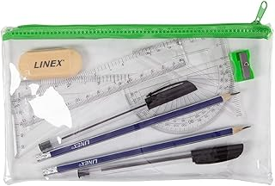

Uniform
We expect pupils to arrive at school each day looking smart, in full uniform and ready for school. At The Oaks Academy we feel that a high standard of uniform creates a good impression within the school and has a positive effect on behaviour and attitude to schoolwork.

Uniform Item | Things to note...
Grey School blazer*
Grey V-Neck jumper* (Optional under the school blazer)
School tie*
Black trousers | Must be tailored, full length and loose fitting. ‘Skinny’, lycra, denim, cords or leggings are not permitted.
White shirt | Button up and suitable for wearing with a tie. Both short and long-sleeved shirts are permitted.
Black pleated skirt | Must be pleated (Appropriate style for school), not made from Lycra and be no shorter than 5cm above the knee or longer than 2cm below the knee. Pencil skirts are not appropriate.
Black shoes | Must be plain black leather or faux leather school shoes with a sensible heal height. Visible stripes, flashes, logos, canvas pumps are NOT permitted.
Black socks | Knee length, ankle socks or tights are suitable.

Physical Education Kit

Boys | Girls
Short sleeved purple PE Top * | Short sleeved purple PE Top *
Black shorts | Black shorts or leggings
PE Track Pants* (optional) | PE Track Pants* (optional)
Black training top * (optional) | Black training top * (optional)
Trainers | Trainers
Black football socks | Black football socks
Shin pads | Shin pads
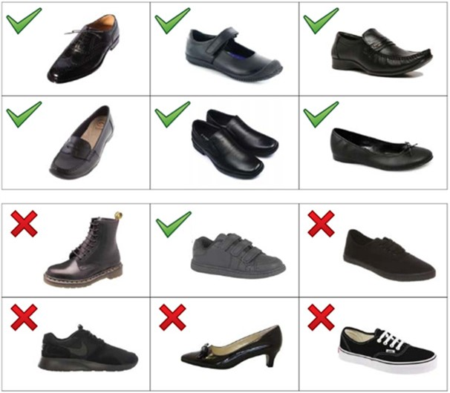
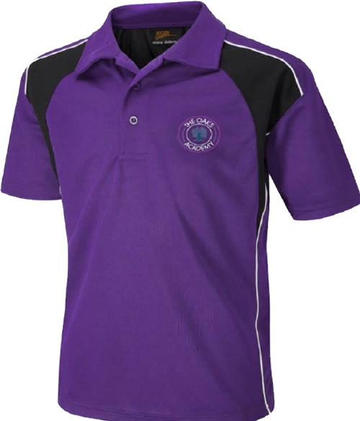
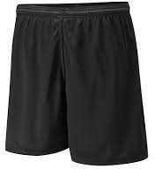
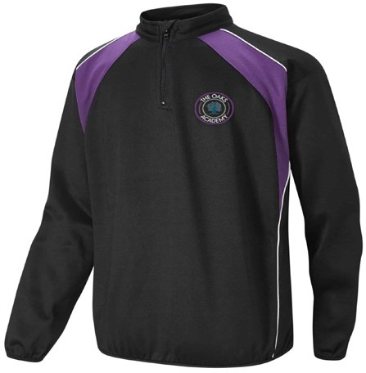
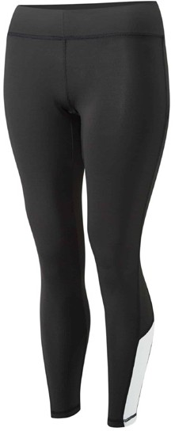
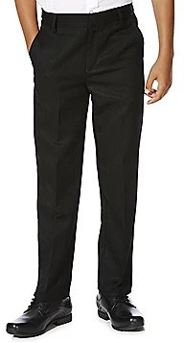
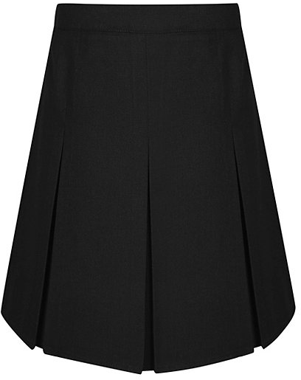
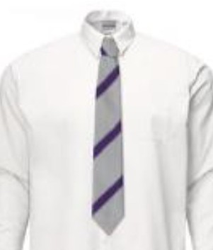
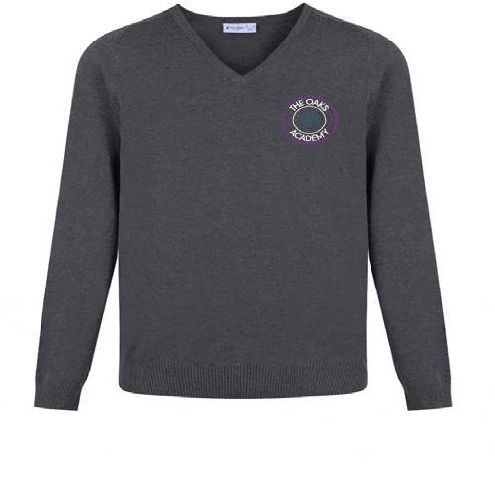
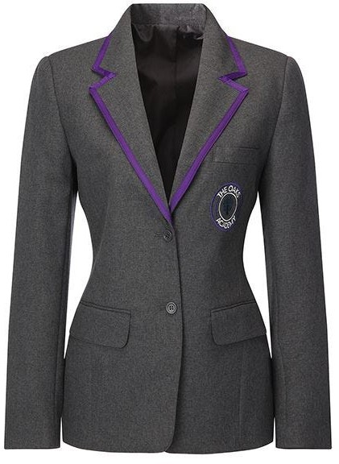
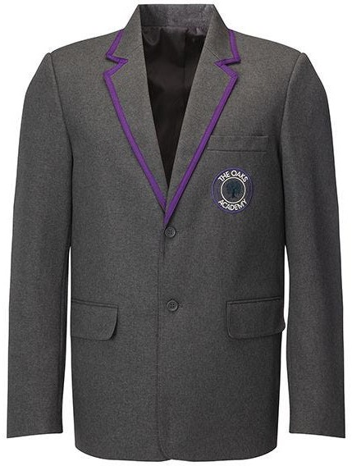
*These uniforms items must display the school logo. These items can be purchased from ‘Schools in Uniform’.

Ordering Uniform
Uniform needs to be ordered from our uniform supplier ‘School’s in Uniform’ via their website www.schoolsinuniform.co.uk.
Contact Details:
Address: 54 Hospital Street
Nantwich
Cheshire
CW5 5RP
Telephone: 01270 618957
Email: sales@schoolsinuniform.co.uk

Uniform Guide

Uniform Guidelines for Parents

Uniform Guidelines

- Only one pair of stud earrings are permitted. Any other body piercings must be removed
- Blazers must be worn at all times but may be re moved in a classroom at the teacher’s discretion
- No hoodies allowed
- Shirts must be tucked in at all times, including to and from school
- The school discourages the use of make-up
- Extreme hairstyles are not allowed. These are defined as hairstyle s which in our opinion
do not follow social conventions, can be considered to be part of an unsuitable fashion
trend or would not be considered appropriate in many work environments. Examples of
extreme hairstyles would include: patterns, logos and/or designs coloured or cut into the hair
- Coloured hair where the colour is considered not to be a natural hair colour
- Expensive items of clothing should not be worn or brought into school
- Please ensure that all items are clearly named/labelled
- Students’ school bags must be appropriate for carrying A4 books, stationery, sportswear
and other necessary equipment
- Uniform regulations, including those for outdoor clothing, apply to the journey to and
from school, as well as on school premises
- Students should not bring more money into school than they should reasonably need for
food, drink and travel

Uniform Expectations Outside of School

We remind parents that sending their children to The Oaks Academy assumes an acceptance of
The Oaks Academy Uniform regulations, which also apply on the way to and from school.
Tracksuit tops, non-school sweatshirts and hooded sweatshirts are not permitted to be worn
underneath or over the school blazer. In cold or wet weather, a coat can be worn over the blazer.

