SUBJECT: PE KNOWLEDGE ORGANISER
KEY QUESTIONS
What are the rules that govern the serve in Table Tennis?
When playing the forehand push how should bat be positioned to help the balls go in the correct direction?
What must happen to the bat to achieve topspin in the rally?
What is different between the backhand and forehand push?

ACTIVITY: TABLE TENNIS
YEAR: 7 TERM: 2A
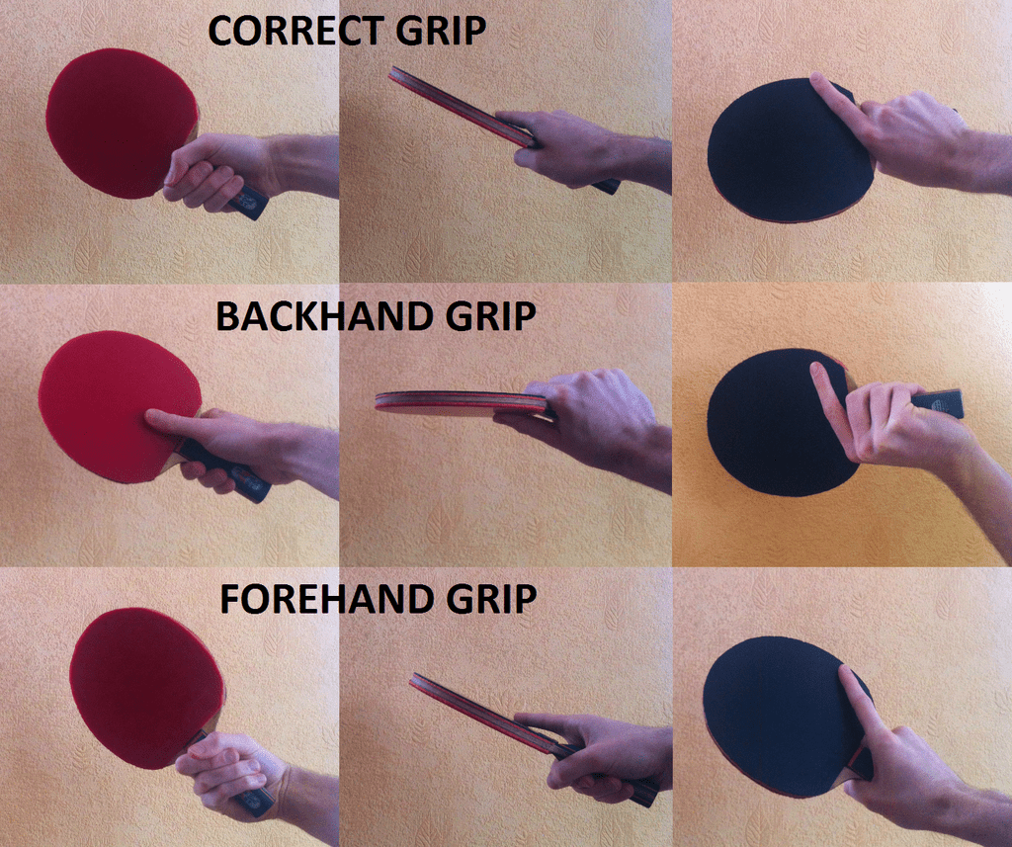
KEY VOCABULARY
Grip | How you hold the bat to make contact with the ball to help it land on the table.
Backhand push | The ball is played on the backhand side, with a flat bat face to push the ball over the net.
Forehand push | The ball is played on the forehand side, with a flat bat face to push the ball over the net.
Serve | 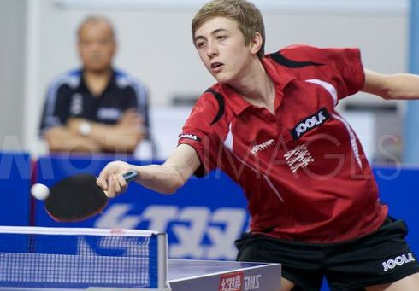  The first shot to begin a rally. The serve is alternated between the two players, after two serves the service goes to the opposite player regardless of the winning shot.
Forehand topspin | A shot played on the forehand side, contact cuts on an angle to the ball to make it move differently.
Doubles play | Working as a two to outwit the opponents.
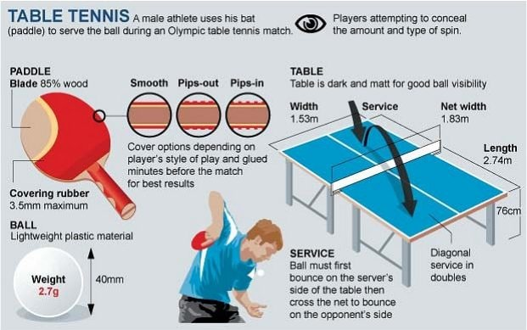
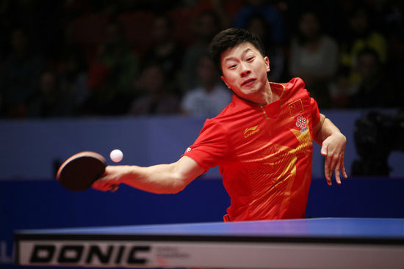
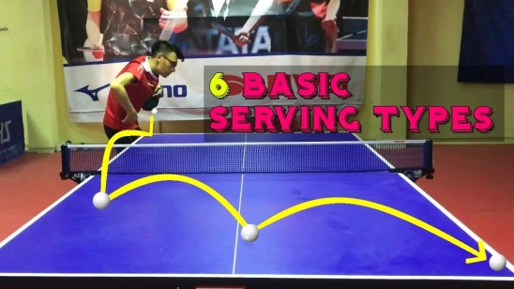

Purpose of game

