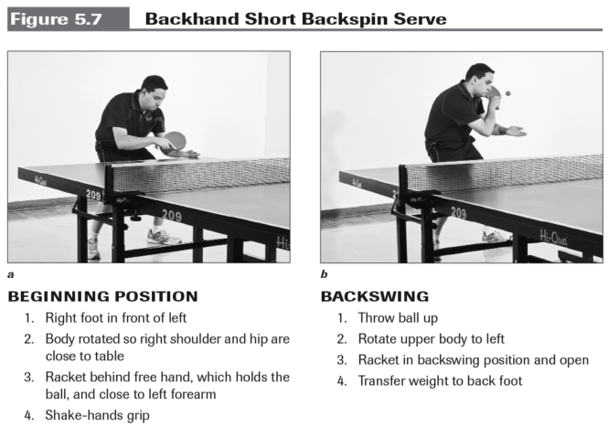
SUBJECT: PE KNOWLEDGE ORGANISER
ACTIVITY: TABLE TENNIS
YEAR: 8 TERM: 2A

Backhand push (Develop) | The ball is played on the backhand side, with a flat bat face to push the ball over the net, and move the opponent consistently out of position
Forehand push (Develop) | The ball is played on the forehand side, with a flat bat face to push the ball over the net, and move the opponent consistently out of position
Serve (Develop) | The first shot to begin a rally. The serve is alternated between the two players, after two serves the service goes to the opposite player regardless of the winning shot. Play a variety of shots to move the opponent out of position
Forehand topspin | 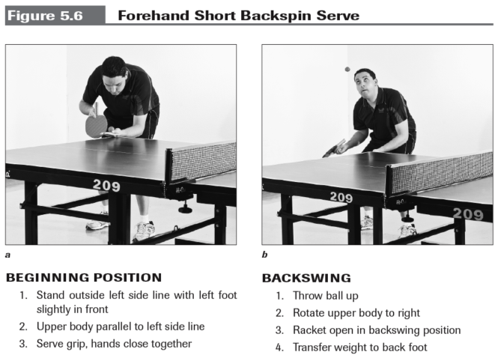  A shot played on the forehand side, contact cuts on an angle to the ball to make it move differently, and move the opponent consistently out of position
Doubles/Singles play | Working alone or as a two to outwit the opponents.

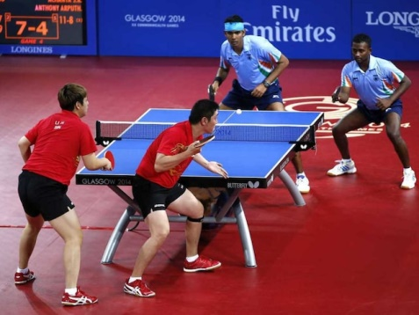
KEY QUESTIONS
What ways can we vary the service to an opponent?
When playing the forehand push how should bat be positioned to help the balls land in court consistently?
What tactics can we use to outwit an opponent in Doubles /Singles?

