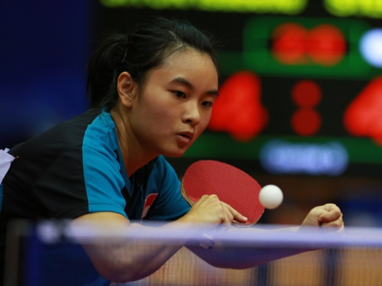
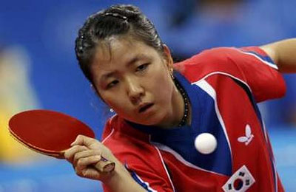
SUBJECT: PE KNOWLEDGE ORGANISER
ACTIVITY: TABLE TENNIS
YEAR: 9 TERM: 2A

Slice (Forehand and Backhand) | 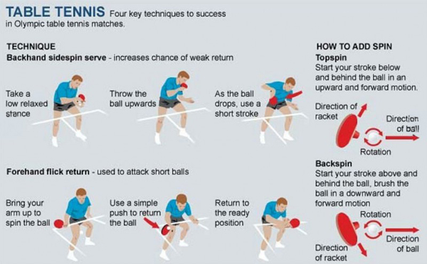  A shot played in which the ball is cut underneath to alter the direction when it lands on the table.
Backhand push (Develop) | The ball is played on the backhand side, with a flat bat face to push the ball over the net, and move the opponent consistently out of position and accurately play the shot into the target area.
Forehand push (Develop) | The ball is played on the forehand side, with a flat bat face to push the ball over the net, and move the opponent consistently out of position and accurately play the shot into the target area.
Serve (Develop) | The first shot to begin a rally. The serve is alternated between the two players, after two serves the service goes to the opposite player regardless of the winning shot. Play a variety of shots to move the opponent out of position and accurately play the shot into the target area.
Forehand topspin | A shot played on the forehand side, contact cuts on an angle to the ball to make it move differently, and move the opponent consistently out of position and accurately play the shot into the target area.
Doubles/Singles play | 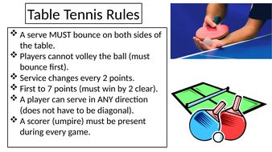  Working alone or as a two to outwit the opponents.
Scoring and Umpiring | The performer who keeps track of the game situation.
KEY QUESTIONS
How would you play the slice shot on the forehand/backhand side?
How is this different to the topspin technique?
How can adding spin or slice influence your opponent during a rally?

KEY QUESTIONS
What ways can we vary the service to an opponent?
When playing the forehand push how should bat be positioned to help the balls land in court consistently?
What tactics can we use to outwit an opponent in Doubles /Singles?

