The Structure of the Lungs
- The lungs consist of the trachea, bronchi, alveoli and the capillary network surrounding the alveoli
- The lungs are surrounded by the ribcage which protects them and allows breathing to occur
- The trachea is a rigid tube that allows air to pass from the atmosphere into the lungs
- At the end of the trachea are two branches called bronchi (sing. bronchus). These allow air to pass in and out of each lung.
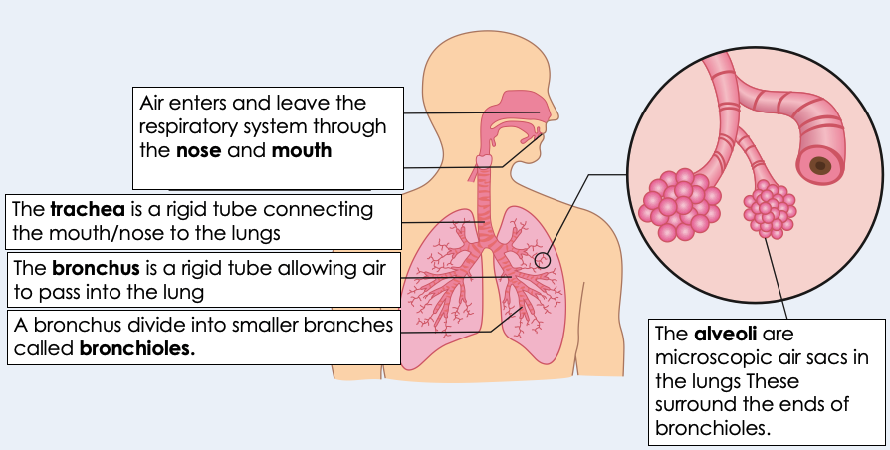
- The bronchi then divide into bronchioles that carry air throughout the lung tissue
- Lung tissue consists of millions of alveoli (sing. alveolus).
- Alveoli have a large surface area and thin walls (just one cell thick).
- Each alveolus is surrounded by many capillaries that ensure a good blood supply
- Alveoli allow for the exchange of gases between air and the blood.
- Oxygen diffuses out of the alveoli into the blood, to be circulated around the body for use in respiration.
- Carbon dioxide diffuses out of the blood into the alveoli, to be expelled from the body during exhalation

The Circulatory System
- The heart is an organ that pumps blood around the body in a double circulatory system.
- The right ventricle pumps blood to the lungs where gas exchange takes place.
- The left ventricle pumps blood around the rest of the body.
- The wall of the left ventricle is thicker than the wall of the right ventricle because it contains more muscular tissue. This means that it can contract to produce a stronger beat so that blood can be transported around the whole body.
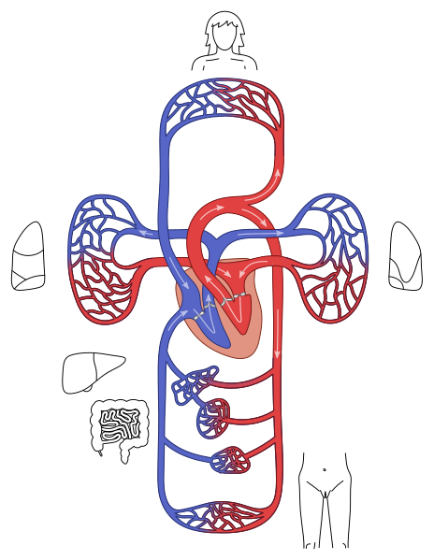
- Valves of the heart ensure one-way flow of blood and prevent back-flow
- The aorta transports oxygenated blood from the left ventricle to the body
- The vena cava transports deoxygenated blood from the body to the right atrium
- The pulmonary artery transports deoxygenated blood from the right ventricle to the lungs
- The pulmonary vein transports oxygenated blood from the lungs to the left atrium
- The natural resting heart rate is controlled by a group of cells located in the right atrium that act as a pacemaker. This group of cells sends electrical impulses across the heart to trigger contractions
- Artificial pacemakers are electrical devices used to correct an irregular heart rate.

Blood
- Blood is a tissue consisting of plasma, in which the red blood cells, white blood cells and platelets are suspended.
- Each of these blood components has a different function. The structure of blood cells relates to their function.
- Red blood cells are biconcave which increases their surface area. They have no nucleus and contain large amounts of haemoglobin so that they are able to transport large quantities of oxygen to respiring cells
- A lack of red blood cells can result in tiredness, muscle fatigue and anaemia
- White blood cells protect the body against infection by destroying pathogens (microorganisms)
- Plasma is a liquid substance that transports dissolved substances around the body. These substances include glucose, carbon dioxide, amino acids, hormones, antibodies and urea.
- Platelets begin the process of blood clotting. This prevents excessive bleeding when a blood vessel is damaged.

Coronary Heart Disease and Heart Treatments
- In coronary heart disease layers of fatty material build up inside the coronary arteries, narrowing them. This reduces the flow of blood through the coronary arteries, resulting in a lack of oxygen for the heart muscle.
- Cholesterol is a fatty substance that can build up inside the coronary arteries
- High blood cholesterol levels are treated using statins.
- Statins are widely used to reduce blood cholesterol which slows down the rate of fatty material deposit. Once a person starts on statins, they must take them for the rest of their life which is a disadvantage.
- Stents are used to keep the coronary arteries open. Stents can also be used to keep other arteries open, as well as the trachea.
- A rapid heart rate can be treated using a drug called Digitalis. This drug originates from foxglove plants and has been used for many years.
- Cardiovascular diseases are treated by the use of drugs, mechanical devices or transplant. Each of these methods has advantages and disadvantages.
- In some people heart valves may become faulty, preventing the valve from opening fully, or the heart valve might develop a leak.
- Faulty heart valves can be replaced using biological or mechanical valves.
- There are advantages and disadvantages to each type of valve. Patients and doctors must evaluate the different types of valves before making a decision about the best replacement.
- In the case of heart failure a donor heart, or heart and lungs can be transplanted. Artificial hearts are occasionally used to keep patients alive whilst waiting for a heart transplant, or to allow the heart to rest as an aid to recovery.

Aerobic Respiration
- Respiration is an exothermic reaction that is continuously occurring in living cells.
- The energy transferred during respiration supplies all the energy needed for living processes, including:
  - Synthesis of new molecules
  - Active transport
  - Keeping warm (in mammals and birds)
  - Movement (in animals)
- Respiration in cells can take place aerobically (using oxygen) or anaerobically (without oxygen), to transfer energy.
- Aerobic respiration is represented by the equation:

glucose + oxygen carbon dioxide + water

- The balanced symbol equation for respiration is;

C₆H₁₂O₆ + 6O₂ 6CO₂ + 6H₂O

Anaerobic Respiration
- Anaerobic respiration transfers less energy than aerobic respiration because the oxidation of glucose is incomplete
- Anaerobic respiration in animal cells is represented by the equation:

glucose lactic acid

- Anaerobic respiration results in oxygen debt.
- Anaerobic respiration in plant and yeast cells is represented by the equation:

glucose ethanol + carbon dioxide

- Anaerobic respiration in yeast cells is called fermentation and has economic importance in the manufacture of bread and alcoholic drinks

Response to Exercise
- Cardiovascular exercise strengthens heart muscles, improves circulation and controls weight
- During exercise the human body reacts to the increased demand for energy.
- The heart rate, breathing rate and breath volume increase during exercise to supply the muscles with more oxygenated blood. Arteries also dilate to increase the rate of blood flow.
- If insufficient oxygen is supplied anaerobic respiration takes place in muscles. The incomplete oxidation of glucose causes a build-up of lactic acid and creates an oxygen debt. During long periods of vigorous activity muscles become fatigued and stop contracting efficiently.
- If a heart valve develops a leak, backflow of blood can occur. This can result in less blood leaving the heart, meaning less oxygen is supplied to cells. This can result in less respiration so less energy is released. This can mean less efficient muscle contraction.
- Blood flowing through the muscles transports the lactic acid to the liver where it is converted back into glucose.
- Oxygen debt is the amount of extra oxygen the body needs after exercise to react with the accumulated lactic acid and remove it from the cells.

Metabolism
- Metabolism is the sum of all of the reactions in a cell or body
- A metabolic process is a chemical reaction that takes place inside a cell
- The energy transferred by respiration in cells is used by the organism for the continual enzyme controlled processes of metabolism that synthesise new molecules.
- Metabolism includes:
- conversion of glucose to starch, glycogen and cellulose
- the formation of lipid molecules from a molecule of glycerol and three molecules of fatty acids
- the use of glucose and nitrate ions to form amino acids which in turn are used to synthesise proteins
- respiration
- breakdown of excess proteins to form urea for excretion

