**The Leaf and Roots (prior knowledge review)**

1. A picture containing text

   Description automatically generatedThe leaf is a plant organ, containing the epidermis, palisade and spongy mesophyll, xylem and phloem, and guard cells surrounding stomata.
2. The leaf epidermis is adapted for transmitting light to the palisade layer because it is the transparent top layer
3. The leaf epidermis is adapted for preventing water loss from leaf cells because it has a waterproof, waxy cuticle surrounding it
4. The palisade mesophyll is adapted for carrying out photosynthesis because it contains many palisade cells which contain many chloroplasts
5. The spongy mesophyll is adapted for diffusion of gases for photosynthesis because it contains air spaces between cells
6. Guard cells open and close small holes called stomata on the underside of the leaf to control gas exchange and water loss
7. Stomatal density can be calculated by counting the number of stomata seen in a known area using the light microscope.

Guard cells

Stomata

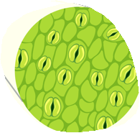

1. Root hair cells are adapted for the efficient uptake of water by osmosis because they have a large surface area
2. Root hair cells are adapted for the efficient uptake mineral ions by active transport because they have a large surface area and many mitochondria
3. Active transport moves substances from a more dilute solution to a more concentrated solution, requiring energy from respiration

**Microscopes (prior knowledge review)**

1. Microscopy is the field of using microscopes to view samples that cannot be seen with the naked eye
2. Light microscopes allow us to see the largest organelles, including the nucleus, cell membrane, cell wall and cytoplasm. A stain is often used to make the organelles clearer
3. The parts of a light microscope include the eyepiece lens, objective lenses, stage, coarse focusing wheel, fine focusing wheel, light/mirror
4. A sample used with a light microscope must be very thin to allow light to pass through
5. The specimen to be viewed under a microscope is placed on the stage and secured with stage clips
6. The eyepiece lens and objective lens are used to increase the size of the image
7. The coarse focusing wheel is used to move the stage and get the cells into frame
8. The fine focusing wheel is used to sharpen an image
9. The total magnification of a microscope can be calculated using the following equation: Total magnification = Objective lens x eyepiece lens
10. Electron microscopes have a greater magnification and resolution than light microscopes. They are much more expensive than light microscopes
11. Magnification is the number of times larger an image is than the object
12. Resolution is the ability to distinguish between two points
13. Electron microscopes allow are to see more organelles and study cells in greater detail
14. A scale bar can be used to calculate the magnification of an irregular object
15. Magnification does not have a unit because it is a ratio
16. Magnification = size of image/size of object

**Transpiration**

1. The roots, stem and leaves form a plant organ system for transport of substances around the plant.

1. Transpiration is the process of water moving through a plant and its evaporation from parts such as through the stomata on the underside of leaves.
2. Changing temperature, humidity, air movement and light intensity affect the rate of transpiration.
3. Xylem tissue transports water and mineral ions from the roots to the stems and leaves

1. It is composed of hollow tubes strengthened by lignin adapted for the transport of water in the transpiration stream.
2. Stomata and guard cells control gas exchange and water loss.

**Translocation**

1. Phloem tissue transports dissolved sugars from the leaves to the rest of the plant for immediate use or storage.
2. The movement of food molecules through phloem tissue is called translocation.
3. Phloem is composed of tubes of elongated cells.

1. Cell sap can move from one phloem cell to the next through pores in the end walls.

**Photosynthesis and Uses of Glucose**

1. Photosynthesis is represented by the word equation:

carbon dioxide + water 🡪 glucose + oxygen

1. Photosynthesis is represented by the symbol equation:

6CO2 + 6H2O 🡪 C6H12O6 + 6O2

1. Photosynthesis is a chemical reaction in which energy is transferred from the environment to the chloroplasts by light
2. Photosynthesis is carried out in chloroplasts
3. Chlorophyll is a green pigment found in chloroplasts that absorbs the sunlight required for photosynthesis
4. The glucose produced in photosynthesis may be used as a reactant for respiration
5. The glucose produced in photosynthesis may be converted into insoluble starch for storage
6. The glucose produced in photosynthesis may be used to produce fat or oil for storage
7. The glucose produced in photosynthesis may be used to produce cellulose, which strengthens the cell wall
8. The glucose produced in photosynthesis may be used to produce amino acids for protein synthesis
9. To produce proteins, plants also use nitrate ions that are absorbed from the soil

**Limiting Factors in Photosynthesis**

1. Temperature, light intensity, carbon dioxide concentration, and the amount of chlorophyll affect the rate of photosynthesis
2. A limiting factor of photosynthesis is something that, when in limited supply, stops the maximum rate of photosynthesis
3. Increasing the carbon dioxide concentration or the intensity of light increases the rate of photosynthesis proportionally until there is a limiting factor that causes the rate to become constant

1. Increasing the temperature increases the rate of photosynthesis proportionally until it reaches the optimal temperature for enzymes then the rate decrease

1. (HT Only) Limiting factors of photosynthesis interact and any one of them may be the factor that limits photosynthesis
2. (HT Only) Explain graphs of photosynthesis rate involving two or three factors and decide which is the limiting factor
3. (HT Only) Limiting factors are important in the economics of enhancing the conditions in greenhouses to gain the maximum rate of photosynthesis while still maintaining profit

**RP: The Effect of Light Intensity on Photosynthesis**

1. Changing the distance between a lamp and pondweed and then counting the number of oxygen bubbles produced per minute allows us to investigate how light intensity affected photosynthesis

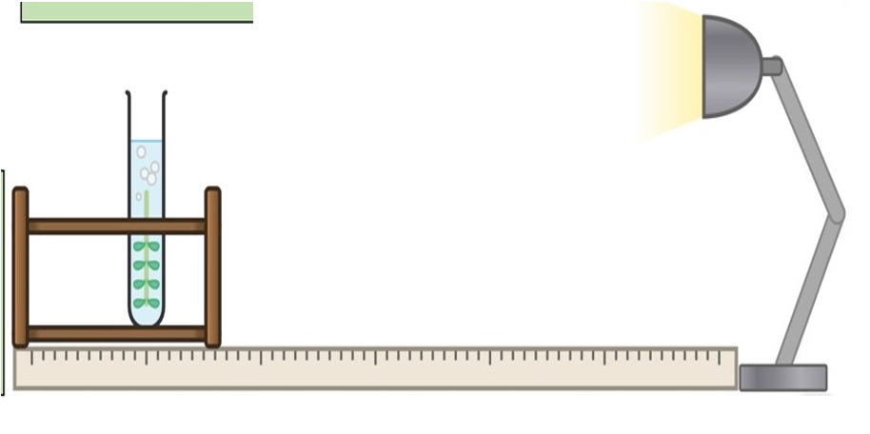

1. (HT Only) The relationship between light intensity and distance squared is inversely proportional
2. (HT Only) The relationship between light intensity and the inverse of distance squared is a directly proportional relationship.

**TIF: Plant Diseases and Defences**

1. Tobacco mosaic virus (TMV) infects many plants including tomato plants
2. TMV causes a distinct ‘mosaic’ pattern of discolouration on leaves. This means that leaves cannot absorb light for photosynthesis so the plant does not grow normally
3. Rose black spot is a fungal disease where purple/black spots form on leaves. This means that leaves cannot absorb light for photosynthesis so the plant does not grow normally
4. Fungal infections are treated using fungicide chemicals
5. Plants have to defend themselves; they can be infected by a range of viral, bacterial and fungal pathogens as well as by insects and animals.
6. **Physical defence responses** which resist invasion of microorganisms include; Cellulose cell walls, Tough waxy cuticle on leaves, and layers of dead cells around stems (bark on trees) which fall off.
7. **Chemical defence** **responses** include antibacterial chemicals and poisons to deter herbivores.
8. Mechanical **defence** **responses** include thorns and hairs deter animals and leaves which droop or curl when touched.
9. (HT Only) Plant diseases can be detected by stunted growth, spots on leaves, areas of decay (rot, growths, malformed stems or leaves, discolouration, the presence of pests.
10. (HT Only) Identification can be made by: reference to a gardening manual or website, taking infected plants to a laboratory to identify the pathogen, using testing kits that contain monoclonal antibodies

**Material Cycling: Decay**

1. Many different materials cycle through the abiotic and biotic components of an ecosystem.
2. All materials in the living world are recycled to provide the building blocks for future organisms.
3. Microorganisms help to cycle materials through an ecosystem by returning carbon to the atmosphere as carbon dioxide and mineral ions to the soil.
4. Decomposers are organisms that break down dead organisms using enzymes
5. Types of bacteria and fungi are decomposers

**Material Cycling: The Carbon Cycle**

1. The carbon cycle is important for the survival of living organisms.
2. In the carbon cycle:

* carbon dioxide is absorbed by plants for photosynthesis
* carbon dioxide is released by animals and plants during respiration
* carbon is transferred to consumers in the food chain

1. Microorganisms help to cycle materials through an ecosystem by returning carbon from dead organisms to the atmosphere as carbon dioxide as they respire

**Material Cycling: The Water Cycle**

1. The water cycle is important for the survival of living organisms.
2. Water is continuously evaporated and precipitated.
3. The water cycle provides fresh water for plants and animals on land before draining into the seas.

**TIF Investigating the Rate of Decay**

1. Decreasing the temperature lowers the rate of decay because decomposing microorganisms are less active
2. Decreasing the availability of oxygen lowers the rate of decay because decomposing microorganisms cannot respire
3. Decreasing the availability of water lowers the rate of decay because decomposing microorganisms cannot survive
4. Gardeners and farmers try to provide optimum conditions for rapid decay of waste biological material. The compost produced is used as a natural fertiliser for growing garden plants or crops.

**TIF Biogas Generators**

1. Anaerobic decay produces methane gas.
2. Biogas generators can be used to produce methane gas as a fuel.

