Exothermic and Endothermic Reactions

- A chemical reaction involves the formation of a new substance.
- Mass is conserved in a chemical reaction.
- Chemical equations must be balanced because atoms are not created or destroyed in a chemical reaction.
- Energy is conserved in chemical reactions. The amount of energy in the universe at the end of a chemical reaction is the same as before the reaction takes place.
- An exothermic reaction is one that transfers energy to the surroundings so the temperature of the surroundings increases.
- Exothermic reactions include combustion, many oxidation reactions and neutralisation.
- Everyday uses of exothermic reactions include self-heating cans and hand warmers.
- An endothermic reaction is one that takes in energy from the surroundings so the temperature of the surroundings decreases.
- Endothermic reactions include thermal decompositions and the reaction of citric acid and sodium hydrogencarbonate.
- Some sports injury packs are based on endothermic reactions.
- Photosynthesis is represented by the equation:

carbon dioxide + water glucose + oxygen

- Photosynthesis is an endothermic reaction in which energy is transferred from the environment to the chloroplasts by light.
- Respiration is an exothermic reaction that is continuously occurring in living cells.
- The energy transferred during respiration supplies all the energy needed for living processes.

Energy in Chemical Reactions

- Chemical reactions can occur only when reacting particles collide with each other and with sufficient energy.
- The minimum amount of energy that particles must have to react is called the activation energy.
- Energy needs to be supplied before a fuel burns.
- Reaction profiles can be used to show the relative energies of reactants and products, the activation energy and the overall energy change of a reaction.
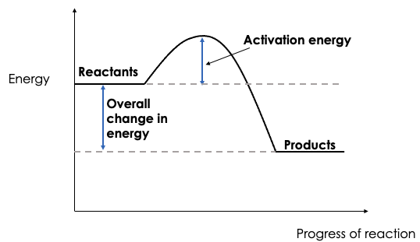
- The reaction profile for an exothermic reaction is:

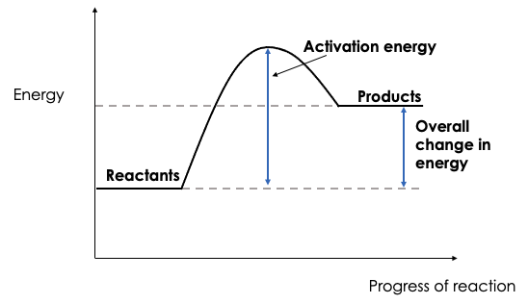
- The reaction profile for an endothermic reaction is:
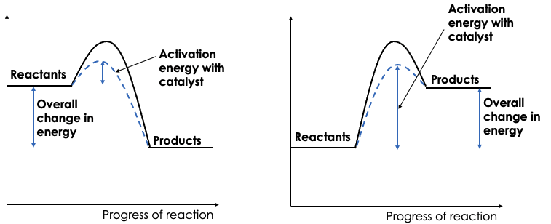
- The use of a catalyst decreases the activation energy required for the reaction to occur.

- If a reaction transfers energy to the surroundings the product molecules must have less energy than the reactants, by the amount transferred.
- The temperature change of chemical reactions can be investigated, using reactions such as acids + metals, acids + alkalis or acids + metal carbonates
- The greater the temperature change, the more energy is released or absorbed

Bond Energy (HT only)

- During a chemical reaction energy must be supplied to break bonds in the reactants and energy is released when bonds in the products are formed.
- The energy needed to break bonds and the energy released when bonds are formed can be calculated from bond energies.
- The difference between the sum of the energy needed to break bonds in the reactants and the sum of the energy released when bonds in the products are formed is the overall energy change of the reaction.
- In an exothermic reaction, the energy released from forming new bonds is greater than the energy needed to break existing bonds.
- In an endothermic reaction, the energy needed to break existing bonds is greater than the energy released from forming new bonds.
- Bond energies can be used to calculate the energy transferred in reactions.

Percentage Yield and Atom Economy (Chemistry only)

- Atoms are not gained or lost in a chemical reaction but it is not always possible to obtain the theoretical amount of a product.
- This can be because:
- the reaction does not go to completion because it is a reversible reaction
- some of the product is lost when separated from the reaction mixture
- some of the reactants react differently to the expected reaction
- The amount of product obtained is called the yield.
- The percentage yield is a measure of how much yield is actually obtained compared to how much yield should theoretically be obtained.
- The equation to calculate percentage yield is:
$$\% yield= \frac{actual yield}{theoretical yield} ×100$$

- Atom economy can also be called atom utilisation.
- Atom economy is a measure of the amount of the starting materials that end up as useful products.
- It is important economically and for sustainable development reasons to use chemical reactions with high atom economy.
- Percentage atom economy is calculated using:

$$\% atom economy= \frac{Mr of desired product}{Total Mr of reactants} ×100$$

Cells, Batteries and Fuel Cells (Chemistry only)

- Cells contain chemicals which react to produce electricity.
- The voltage produced by a cell is dependent upon a number of factors including the type of electrode and electrolyte.
- A simple cell can be made by connecting two different metals in contact with an electrolyte.
- The greater the difference in reactivity of the metals used for the electrodes, the greater the voltage.
- Batteries consist of two or more cells connected together in series to provide a greater voltage.
- In non-rechargeable cells and batteries the chemical reactions stop when one of the reactants has been used up.
- Alkaline batteries are non-rechargeable.
- Rechargeable cells and batteries can be recharged because the chemical reactions are reversed when an external electrical current is supplied.
- Fuel cells are supplied by an external source of fuel (e.g. hydrogen) and oxygen or air.
- The fuel is oxidised electrochemically within the fuel cell to produce a potential difference.
- The overall reaction in a hydrogen fuel is:
hydrogen + oxygen water
- The balanced symbol equation for the reaction is:
2H₂ + O₂ 2H₂O

- The half equation for the reaction at the negative electrode is:
2H₂ 4H⁺ + 4e⁻

- The half equation for the reaction at the positive electrode is:
O₂ + 4H⁺ + 4e⁻ 2H₂O

- Hydrogen fuel cells offer a potential alternative to rechargeable cells and batteries.
- Hydrogen fuel cells and rechargeable chemical cells both have advantages and disadvantages.

