Particles and Density
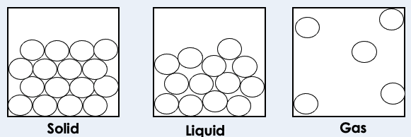
- Particle diagrams can be used to represent the arrangement and movement of particles in solids, liquids and gases.

- Solids are the most dense state of matter as the particles are held most closely together due to the forces of attraction.
- Density is the mass per unit volume.
- Density can be calculated using the equation:

Density = mass/volume
⍴ = m/V

with density, ⍴, in kilograms per metre cubed, kg/m³; mass, m, in kilograms, kg; volume, V, in metres cubed, m³
- The density of a regular shaped solid can be calculated by measuring its mass and volume, then using the equation.
- The density of an irregular solid or liquid can be determined using its mass and displacement of liquid.
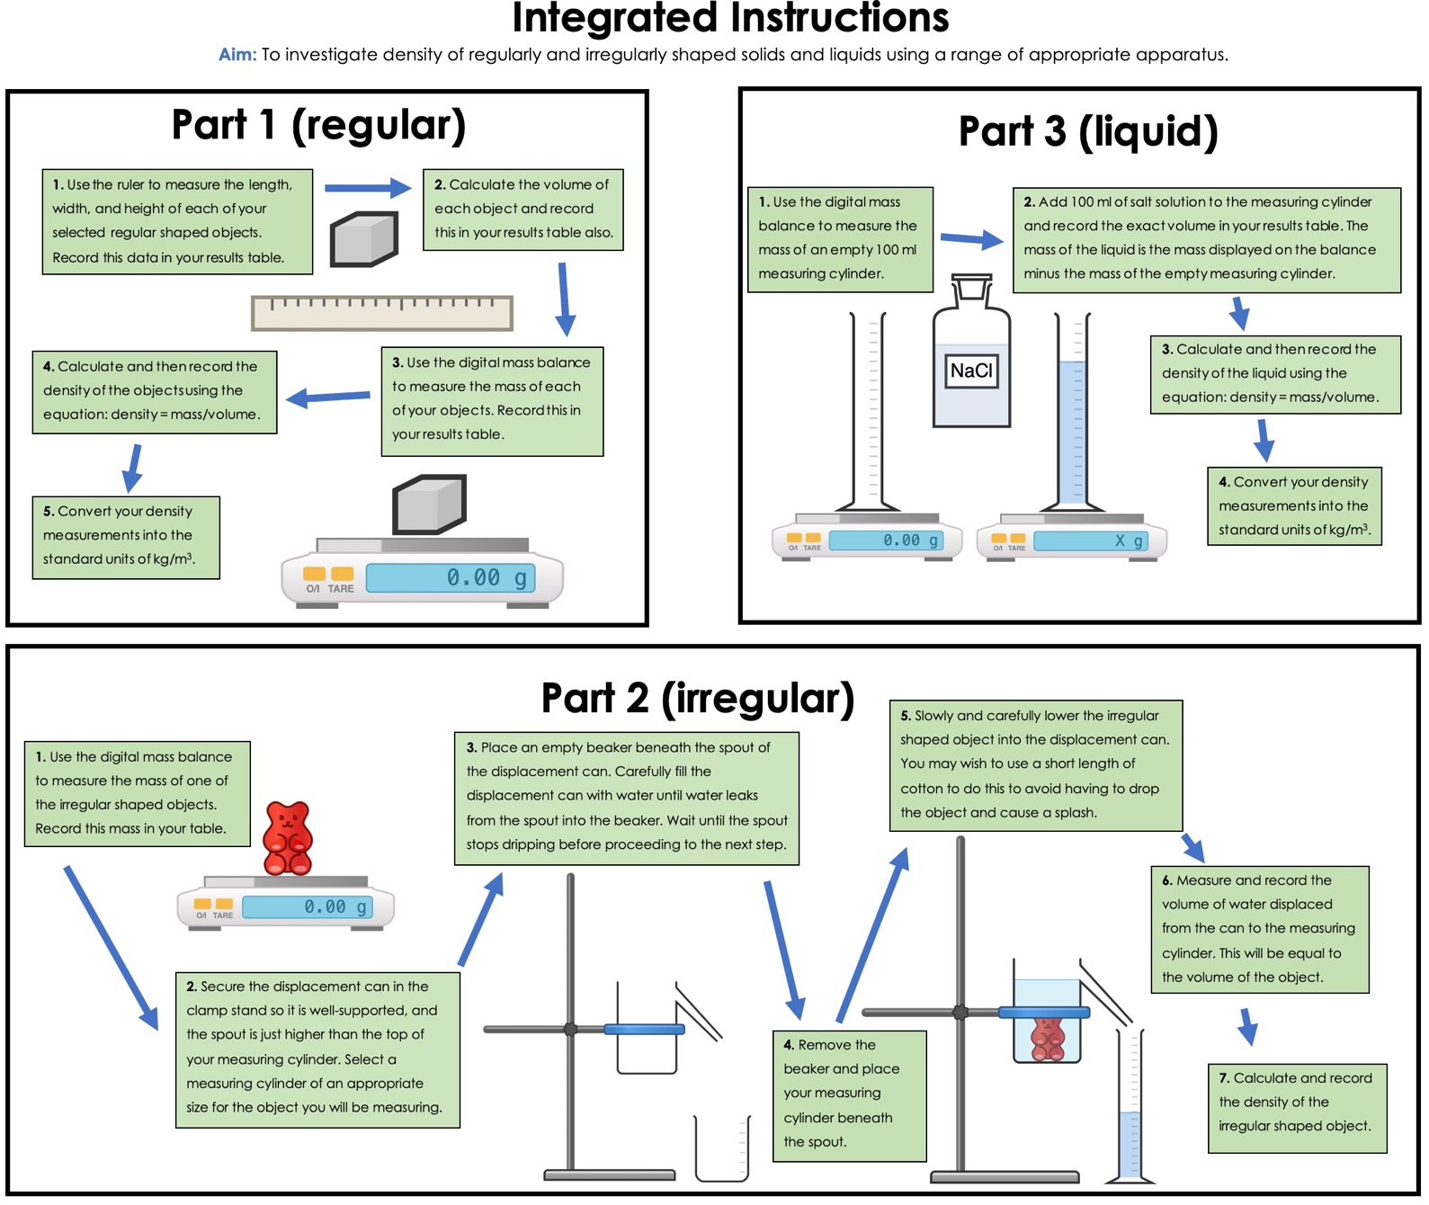

Gas Pressure
- A fluid is a substance with no fixed shape - a liquid or a gas
- Gas pressure is caused by collisions of particles with the walls of a container
- Pressure is measured in Pascals (Pa)
- Changing the temperature of a gas at constant volume changes the pressure exerted by the gas
- Particles at higher temperatures, have higher thermal energy and move more quickly, so they have a higher pressure

Physics Only: Pressure
- In a sealed container, with the same number of particles at constant temperature, decreasing the volume of a gas increases the pressure of the gas
- The pressure of the gas is inversely proportional to its volume. This is because when the volume is decreased, the gas particles will collide more frequently with the walls of the container. More collisions mean more force, so the pressure increases
- Work is the transfer of energy by a force.
- Doing work on a gas increases the internal energy of the gas and can cause an increase in the temperature of the gas.
- Increasing the volume in which a gas is contained, at constant temperature, can lead to a decrease in pressure.
- p₁V₁=p₂V₂, where p₁ and V₁ are the initial pressure and volume values, and p₂ and V₂ are the pressure and volume values after change
- Fluid particles exert a force on any surface they collide with. This force is always at right angles to the surface
- Pressure exerted on a solid is calculated using the equation:

pressure= force/area
- Liquids are incompressible so can be used to transmit forces through hydraulic systems
- The pressure remains constant in the system so if the area increases, the force is multiplied, which is how heavy objects can be lifted or controlled
- The deeper you go in water the greater the pressure becomes, because the greater the weight of water above you
- The pressure due to a column of liquid can be calculated using the equation:

pressure = height of the column × density of the liquid × gravitational field strength
$$p = hρg$$

- pressure, p, in Pascals, Pa; height of the column, h, in metres, m; density, ⍴, in kilograms per metre cubed, kg/m³; gravitational field strength, g, in newtons per kilogram, N/kg
- In a liquid, pressure at a point increases with the height of the column of liquid above that point and with the density of the liquid because there are more particles exerting a downward force
- A partially (or totally) submerged object experiences a greater pressure on the bottom surface than on the top surface. This creates a resultant force upwards. This force is called the upthrust
- The atmosphere is a thin layer (relative to the size of the Earth) of air round the Earth. The atmosphere gets less dense with increasing altitude
- Air molecules colliding with a surface create atmospheric pressure
- The number of air molecules (and so the weight of air) above a surface decreases as the height of the surface above ground level increases. So as height increases there is always less air above a surface than there is at a lower height. So atmospheric pressure decreases with an increase in height

