Isotopes

- All atoms of a particular element have the same number of protons
- Isotopes of a particular element have the same number of protons but a different number of neutrons
- Some isotopes are stable and some isotopes are unstable

Radioactivity

- Radioactive decay is a random process by which the nucleus of an unstable isotope emits radiation to become more stable
- The radiation emitted is ionising – it is able to knock electrons from atoms in its path
- Ionising radiation can kill cells or cause cells to mutate, causing cancer

Radioactive emissions

- There are three types of radiations emitted; alpha, beta and gamma
- An alpha particle consists of two neutrons and two protons
- A beta particle consists of a high speed electron, emitted from the nucleus
- A gamma ray is electromagnetic radiation
- Relative charges and masses:

 | Relative mass | Charge
Alpha | 4 | +2
Beta | 1/2000 (negligible) | -1
Gamma | No Mass | No charge

- Alpha is the least penetrating. I tis stopped by around 5 cm of air or a thin sheet of paper
- Gamma is the most penetrating. It is absorbed by several cm of lead or 1 m concrete
- Beta is absorbed by around 5 mm of aluminium sheet
- Alpha and beta both deflect in an electrical field as they are both charged
- Alpha is the most ionising, gamma is the least ionising.

Transmutation

- Transmutation is the changing of one chemical element into another
- When a radioactive element decays by alpha or beta decay, it transmutes or decays into a different element
- This can be represented by a decay equation, where an alpha particle can be represented by ${}_{2}^{4}α$
and a beta particle can be represented by a ${}_{-1}^{0}β$
- When alpha decay occurs, two protons and two neutrons are emitted from the nucleus
${}_{92}^{238}U$ ${}_{90}^{234}{Th}$ + ${}_{2}^{4}α$

- When beta decay occurs, a neutron changes into a proton and emits an electron from the nucleus
${}_{90}^{234}{Th}$ ${}_{91}^{234}{Pa}$ + ${}_{-1}^{0}β$

- When gamma decay occurs, there is no change in the nucleus.

Detecting ionising radiation

- A Geiger-Mueller counter or tube is used to detect ionising radiation.
- The activity is the rate at which a source of unstable nuclei decays
- The count rate is the number of decays (counts) recorded each second by a detector

Half life

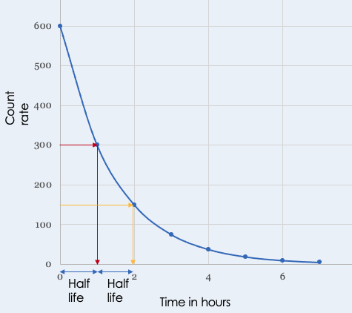
- The half-life of a radioactive isotope is the time it takes for the number of nuclei of the isotope in a sample to halve, or the time it takes for the count rate (or activity) from a sample containing the isotope to fall to half its initial level
- Half-life can be determined from a graph of count rate of number of radioactive nuclei, or from data

Exposure to radiation

- Irradiation is the process of exposing an object to nuclear radiation. The irradiated object does not become radioactive.
- Radiation dose – a measure of the amount of exposure to radiation measured in sieverts or millisieverts (1000 millisieverts = 1 sievert)
- People protect themselves by monitoring their exposure and minimising their exposure
- People can minimise their exposure by moving away from the source, spending as little time as possible in at-risk areas, shielding themselves by staying behind protective barriers made out of thick concrete or thick lead
- Radioactive contamination is the unwanted presence of materials containing radioactive atoms on other materials

Uses of isotopes

- A medical tracer is a gamma emitting isotope, which is used for medical diagnosis. The patient ingests the tracer and the doctor can track the isotope as it moves through the system
- Gamma radiation in a narrow beam can be used to target and destroy cancerous cells
- An alpha emitting isotope is used in smoke alarms. The source ionises the air between two charged plates and causes a current to flow. When there is smoke, the smoke absorbs the alpha particles, the current stops and an alarm sounds
- A gamma emitting isotope is used to irradiate food and kill bacteria.
- A beta emitting source is used to monitor the thickness of aluminium as it is made

Background radiation (Physics Only)

- Background radiation is a measure of ionising radiation present in the environment at a particular location which is not due to the deliberate introduction of radiation sources
- Natural sources contribute the most to background radiation; radon gas (48%), rocks (13%) and cosmic rays (12%)
- The rest is made up of manmade resources (medical 16%, nuclear weapons 0.2%)

Fission (Physics Only)
- Nuclear fission is a reaction in which the nucleus of an atom splits into two or more smaller nuclei and energy is release
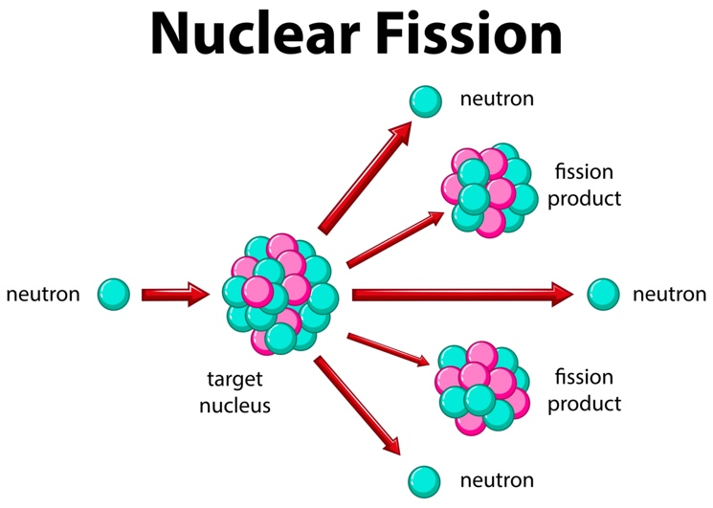
- In induced fission, neutrons hit and are absorbed by atomic nuclei, which causes them to become unstable and split, which then releases further neutrons. These neutrons then go on to hit more nuclei, causing a chain reaction
- A chain reaction is a sequence of reactions where a reactive product or by-product causes additional reactions to take place. The products become the reactants to initiate the next reaction
Fusion (Physics Only)
- Nuclear fusion is the joining or fusing together of two smaller nuclei to form a single larger nucleus
- This happens in the middle of stars, where isotopes of hydrogen nuclei fuse to form helium
- Fusion needs very high temperatures and very high pressures to happen
- Nuclear fusion could fulfil our energy needs, but there are many technical difficulties in replicating the conditions for fusion to happen on earth.
