Homeostasis

- Homeostasis is the regulation of the internal conditions of a cell or organism to maintain optimum conditions for function in response to internal and external changes
- Homeostasis maintains optimal conditions for enzyme action and all cell functions
- Conditions that need to be controlled in the human body include: blood glucose concentration, body temperature and water levels
- Homeostasis is controlled automatically so does not involve the conscious part of the brain
- Automatic control systems may involve nervous or chemical responses
- All control systems include: receptors, coordination centres, and effectors
- Stimuli are changes in the environment that are detected by an organism
- Receptors are cells which detect stimuli
- Receptors are found in our sense organs. These include our eyes, skin, nose, mouth and ears.
- Coordination centres, such as the brain, spinal cord and pancreas, receive and process information from receptors
- Effectors, such as muscles or glands, bring about responses which restore optimum levels

Structure of the Nervous System
- The nervous system enables animals to react to their surroundings and to coordinate their behaviour
- The nervous system is made from the central nervous system (CNS) and the peripheral nervous system
- The CNS includes the brain and spinal cord
- The PNS includes the nerves that branch out from the brain and spinal cord

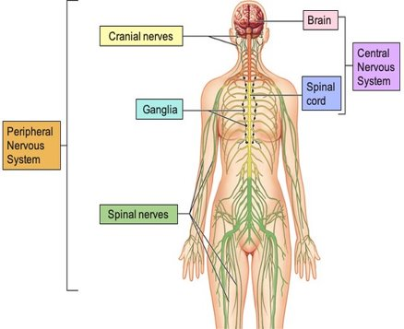
- The sequence of events in the nervous system can be summarised as: stimulus --> receptor --> coordinator --> effector --> response
- Information from receptors passes along neurones as electrical impulses to the CNS
- The CNS coordinates the response of effectors which may be muscles contracting or glands secreting hormones
- The nervous system is made of nervous tissues
- Nervous tissue is made of specialised cells called neurones
- Neurones are adapted to carry electrical impulses from one place in the body to another
- Neurones consist of a cell body, axon and dendrites
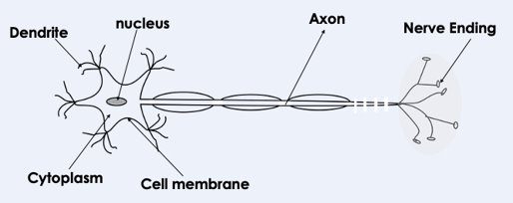
- Neurones are well adapted to their function because they have long axons insulated by a fatty sheath, so that the electrical impulses can be carried long distances quickly

The Reflex Arc
- Reflex actions are important for protecting the body from harm
- Reflex actions are automatic and rapid; they do not involve the conscious part of the brain.
- Reflex actions include: pupils constricting in response to bright light, moving in response to touching a hot object.
- Reflex actions are controlled by three types of neurone: sensory, relay and motor
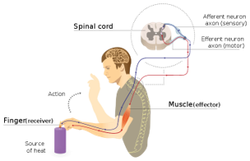
- Sensory neurones allow electrical impulses to travel from a receptor to the CNS
- Relay neurones are found in the organs of the CNS
- Relay neurones transfer the electrical impulse from the sensory neurone to the motor neurone
- Motor neurones allow electrical impulses to travel from the CNS to an effector
- An effector is a muscle or gland which brings about a response
- A muscle can contract and shorten or relax and lengthen
- A gland is an organ that secretes a chemical substance

Synapses
- A synapse is a junction between two neurones
- When an electrical impulse reaches the end of one neurone, chemicals (called neurotransmitters) are released
- Chemicals diffuse across the synapse
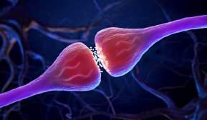
- Chemicals trigger an electrical impulse in the next neurone
- Synapses slow down the speed of nervous transmission
- The more synapses in a reflex arc, the slower the speed of the nervous response
- Drugs, such as alcohol, can slow down the speed of impulse transmission in the nervous system

Required Practical: Human Reaction Time
- Factors including practice, tiredness, alcohol consumption and caffeine consumption can affect human reaction time.
- The ruler drop test is one method of measuring human reaction time

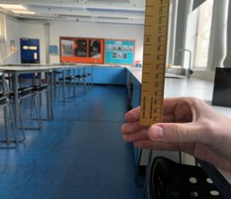
- The ruler drop test is not a reflex action because it involves the conscious part of the brain
- When human reaction time is being investigated, many repeats need to be taken to identify anomalies as there is often variation in the results. This increases repeatability.
- Variables need to be controlled to make the ruler drop test valid. The ruler should be dropped from the same height each time, the same hand should be used to catch the ruler and the hand should be stationary
- To keep the hand stationary, the test subject should rest their arm on a table
- To make the results more precise, a ruler with smaller scale intervals (e.g. mm) should be used
- Distance before being caught can be converted into a reaction time using a conversion table
- Computer programmes that test reaction time are more accurate than the ruler drop test because they can measure in milliseconds

The Endocrine System
- The endocrine system is composed of glands which secrete chemicals called hormones directly into the bloodstream. The blood carries the hormone to a target organ where it produces an effect.
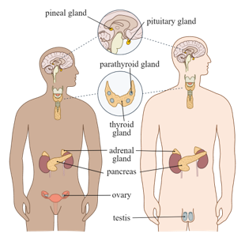
- A hormone is a chemical messenger, produced by a gland and carried in the bloodstream
- Hormones alter the activity of specific target organs
- Compared to the nervous system the effects are slower but act for longer.
- The pituitary gland in the brain is a ‘master gland’ which secretes several hormones into the blood in response to body conditions. These hormones in turn act on other glands to stimulate other hormones to be released to bring about effects.
- Adrenaline is produced by the adrenal glands in times of fear or stress. It increases the heart rate and breathing rate and boosts the delivery of oxygen and glucose to the brain and muscles (by increasing flow of blood), preparing the body for ‘flight or fight’.
- ADH (anti-diuretic hormone) is produced by the pituitary gland and acts on the kidneys to help control water content of blood by increasing reabsorption of water
- Insulin is produced by the pancreas and acts on the liver to control blood glucose levels by converting excess glucose into glycogen for storage
- Thyroxine from the thyroid gland stimulates the basal metabolic rate. It plays an important role in growth and development.
- The endocrine system also includes the reproductive hormones that are responsible for the changes to the body that occur during puberty
- Puberty is the stage in life where a child's body develops into an adult
- Puberty takes place gradually, usually between the ages of 10-17
- Secondary sexual characteristics appear during puberty as a result of sex hormones
- Testosterone is produced by the testes and controls the development of male secondary sexual characteristics
- Oestrogen is produced by the ovaries and controls the development of female secondary sexual characteristics

Control of Blood Glucose
- Glucose is needed by cells for respiration to release energy
- Blood glucose concentration is monitored and controlled by the pancreas and the hormones insulin and glucagon, in a negative feedback loop
- A negative feedback mechanism responds when conditions change from the ideal or set point
- If the level of something is too high, the control system works to reduce it
- If the level of something is too low, the control system works to increase it
- Insulin is a hormone that regulates blood glucose concentration
- If the blood glucose concentration is too high, the pancreas produces insulin that causes glucose to move from the blood into the cells. In liver and muscle cells excess glucose is converted to glycogen for storage.
- This glycogen can be converted back into glucose when it is needed
- If the blood glucose concentration is too low, the pancreas produces glucagon (another hormone) that causes glycogen to be converted into glucose and released into the blood.

- Insulin plays a key role in the regulation of blood glucose levels
- When blood glucose levels rise, insulin signals to the liver and muscles to store excess glucose
- Some is stored as glycogen, some is stored as body fat
- When blood glucose levels are too low, the liver is instructed by glucagon to release some stored glucose into the blood
Diabetes
- Diabetes is a condition where blood glucose levels are too high
- Diabetes is treated by injecting insulin, causing the liver to convert glucose into glycogen for storage, reducing blood glucose levels
- There are two types of diabetes
- Type 1 diabetes is a disorder in which the pancreas does not produce enough insulin.
- Type 1 diabetes is characterised by uncontrolled high blood glucose levels and is normally treated with insulin injections.
- People with type 1 diabetes have to monitor their blood glucose levels regularly throughout the day
- The amount of insulin they need is affected by their diet and their levels of physical activity
- People with type 1 diabetes can help keep their blood glucose levels controlled by eating a careful diet that does not cause spikes in blood glucose levels and by exercising regularly
- Exercise lowers blood glucose levels because glucose is used in increased respiration in the muscles to release more energy
- In Type 2 diabetes the body cells no longer respond to insulin produced by the pancreas.
- Type 2 diabetes is more common in older people
- Increasing levels of type 2 diabetes in the population are linked to rising levels of obesity, so obesity is a risk factor for type 2 diabetes
- A carbohydrate controlled diet and an exercise regime are common treatments for type 2 diabetes

Treating Diabetes
- People with type 1 diabetes can help keep their blood glucose levels controlled by eating a careful diet that does not cause spikes in blood glucose levels and by exercising regularly
- A carbohydrate controlled diet and an exercise regime are common treatments for type 2 diabetes

Negative Feedback: Thyroxine and Adrenaline (HT Only)

- Thyroxine is produced by the thyroid gland and controls the speed at which respiration occurs to release energy for the body to use
- Thyroxine levels are controlled by negative feedback.
- The hypothalamus and pituitary gland are involved in the negative feedback mechanism for thyroxine
- If low thyroxine levels are detected, the hypothalamus releases TRH
- This causes the pituitary gland to release TSH so that the thyroid releases more thyroxine
- When thyroxine levels in the blood are normal, TRH release from the hypothalamus is inhibited, meaning that TSH from the pituitary is also inhibited, maintaining normal thyroxine levels

- Adrenaline is produced by the adrenal glands in times of fear or stress.
- It increases the heart rate and boosts the delivery of oxygen and glucose to the brain and muscles, preparing the body for ‘flight or fight’. It diverts blood from areas such as the digestive system
- Adrenaline is not controlled by negative feedback

The Brain (Biology Only)
- The brain is a coordinator as part of the central nervous system
- The brain controls complex behaviour. It is made of billions of interconnected neurones and has different regions that carry out different functions
- The brain is made of many parts including the cerebellum, cerebral cortex, medulla and hypothalamus
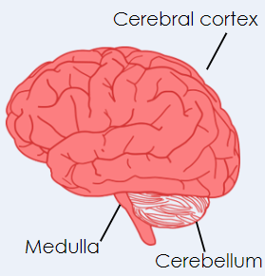

- The medulla controls unconscious actions including heart rate
- The cerebellum controls balance, physical coordination and movement
- The cerebral cortex is responsible for actions requiring conscious thought, including decision-making and memory
- The cerebral cortex is made of two parts and is highly folded. It is sometimes known as the cerebrum.
- Humans have a large cerebral cortex so are capable of many high-level functions, e.g. language
- The hypothalamus is involved in homeostasis. It coordinates the secretion of hormones from the pituitary gland
- Scientists that study the brain are called neuroscientists
- It is difficult to investigate brain function and treat brain damage and disease because the brain is complex and delicate
- Neuroscientists have been able to map the regions of the brain to particular functions by studying patients with brain damage, electrically stimulating different parts of the brain and using MRI scanning techniques.
- Magnetic Resonance Imaging (MRI) is a technology that allows for brains to be scanned
- An MRI requires a person to be completely still. This is different for children and patients with certain diseases, e.g. Parkinson's
- A functional MRI (fMRI) allows a person to move while the scanner makes images of brain activity
- An fMRI is useful because scientists and doctors can see which part of the brain becomes active during different tasks

The Eye (Biology Only)
- The eye is a sensory organ containing receptors sensitive to light intensity and colour
- The eye allows for unconscious reflex action in response to changing light levels
- The eye is made up of the retina, optic nerve, sclera, cornea, iris, pupil, lens, ciliary muscles and suspensory ligaments.

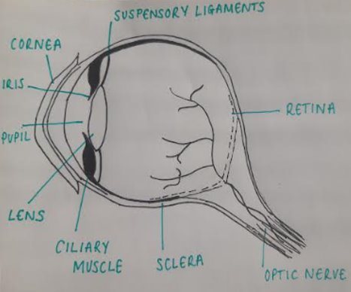
- The retina contains rod and cone cells that are sensitive to light
- Rod cells are sensitive to low levels of light. Cone cells are more sensitive so allow us to see in colour
- The optic nerve contains sensory neurones which transmits electrical impulses from the eye to the brain
- The sclera is the tough, white outer layer of the eye that protects the eye from injury
- The cornea covers the eye and causes light to refract as it enters
- The iris is the coloured part of the eye. It contains circular and radial muscles that work as an antagonistic pair to control the size of the pupil
- The pupil allows light to enter the eye
- The lens refracts light rays so they focus onto the retina
- The lens of the eye is an example of a convex lens
- The ciliary muscles are connected to suspensory ligaments. They can contract or relax, indirectly changing the shape of the lens
- The suspensory ligaments are loosened or tightened by the ciliary muscles, causing the shape of the lens to change
- Accommodation is a process that allows the eye to focus on near or distant objects and adaptation to dim light.
- To view a near object, the ciliary muscles contract and the suspensory ligaments loosen. This causes the lens to thicken and become more convergent, focusing light rays on the retina
- To view a distant object, the ciliary muscles relax and the suspensory ligaments tighten. This causes the lens to become thinner and less convergent, focusing light rays on the retina
- To adapt to dim light, circular muscles of the iris relax and the radial muscles contract. This causes the pupil to dilate so more light enters the eye
- To adapt to bright light, circular muscles of the iris contract and the radial muscles relax. This causes the pupil to constrict so less light enters the eye. This protects the retina from damage
- To adapt to dim light, circular muscles of the iris relax and the radial muscles contract. This causes the pupil to dilate so more light enters the eye
- Two common defects of the eyes are myopia (short sightedness) and hyperopia (long sightedness) in which rays of light do not focus on the retina. Generally these defects are treated with
- Blurred vision occurs when light rays do not focus on the retina
- Myopia is a common eye defect that causes distant objects to appear out of focus (short-sightedness)
- Hyperopia is a common eye defect that causes close objects to appear out of focus (long-sightedness)
- Spectacle lenses (glasses) can be used to refract the light rays so that they do focus on the retina, allowing the wearer to see clear images
- Laser surgery can be use to change the shape of the cornea, removing the need for a person to wear glasses
- Hard or soft contact lenses can also be used to produce a clear image on the retina

Control of Temperature (Biology Only)
- The human body maintains the temperature at which enzymes work best, around 37 ºC
- Body temperature is monitored and controlled by the thermoregulatory centre in the brain by a negative feedback mechanism
- The thermoregulatory centre contains receptors sensitive to the temperature of the blood.
- The skin contains temperature receptors and sends nervous impulses to the thermoregulatory centre.
- If the body temperature is too high, blood vessels dilate (vasodilation) and sweat is produced from the sweat glands. Both these mechanisms cause a transfer of energy from the skin to the environment, working to reduce body temperature
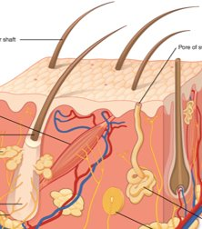
- If the body temperature is too low, blood vessels constrict (vasoconstriction), sweating stops and skeletal muscles contract (shiver), working to increase body temperature.
- The hairs on skin are also involved in controlling body temperature
- When we are warm the hairs lie flat, when we are cold, the hair rise
- Nerve impulses are sent to the hair erector muscles when we are cold, which contract and raise the skin hairs, trapping a layer of insulating air next to the skin

Control of Water (Biology Only)
- Osmoregulation is the control of water levels and mineral salts in the blood
- These need to be controlled to prevent too much water entering or leaving the cells by osmosis
- If body cells lose or gain too much water by osmosis they do not function efficiently.
- If concentration of water is the same inside and outside of cells, they remain in their normal state
- If concentration of water is higher outside the cells, water will enter the cells by osmosis and could lead to bursting
- If concentration of water is lower outside the cells, water will leave the cells by osmosis and could lead to shrivelling
- Water leaves the body via the lungs during exhalation.
- Water, ions and urea are lost from the skin in sweat.
- There is no control over water, ion or urea loss by the lungs or skin.
- Excess water, ions and urea are removed via the kidneys in the urine.
- The digestion of proteins from the diet results in excess amino acids which need to be excreted safely as the body is unable to store proteins or amino acids
- In the liver these amino acids are deaminated to form ammonia. Ammonia is toxic and so it is immediately converted to urea for safe excretion.
- Urea and water are released from the liver into the bloodstream then transported to the kidneys where the blood is filtered and urea is passed out of the body

Kidney Structure (Biology Only)
- The kidneys are organs of the urinary (or excretory) system
- Blood is transported to the kidney via the renal artery
- The kidneys produce urine by filtration of the blood and selective reabsorption of useful substances such as glucose, some ions and water.
- Urine contains water, urea and salts
- Urea is produced in the liver when excess amino acids are broken down
- Urea is not reabsorbed by the kidneys, it is the main waste product removed in urine
- After it has been purified, blood returns to the circulatory system via the renal vein
- Urine is taken from the kidneys to the bladder by the ureters
- The bladder stores the urine until it is released through the urethra, which is the tube that carries urine out of the body
- Each kidney contains over one million filtering units called nephrons
- Each nephron has a tubule
- There are three stages involved in the function of the kidneys: filtration, selective reabsorption and formation of urine
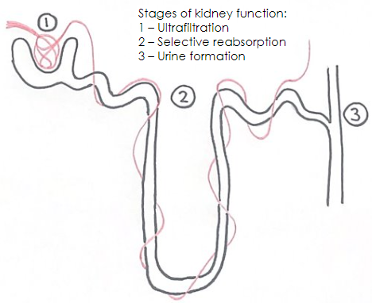
- Filtration: Firstly, blood is filtered through the nephron under high pressure. Small molecules (such as water, ions and glucose) are filtered out and pass into the tubule. Large molecules (such as proteins) cannot pass through and remain in the blood
- Selective Reabsorption: Once these small molecules have entered the tubule, the kidneys reabsorb molecules that are useful, while allowing those that are not useful to pass out of the body in the urine
- All glucose is selectively reabsorbed
- Water is selectively reabsorbed at a rate that maintains constant blood water levels
- Mineral ions are selectively reabsorbed at a rate that maintains the blood ion levels
- Formation of urine: molecules that are not reabsorbed (urea and some water) continue through the kidney tubule as urine, which eventually passes to the bladder
- The water level in the body is controlled by the hormone ADH which acts on the kidney tubules.
- ADH is released by the pituitary gland when the blood is too concentrated and it increases the permeability of the kidney tubules, causing more water to be reabsorbed back into the blood from the kidney tubules. This is controlled by negative feedback.
- If a person has not consumed enough water or has lost too much water through sweat, the water levels in the blood are detected as being too low. ADH is released, causing more water to be reabsorbed. This results in a smaller volume of concentrated urine being produced
- If a person has consumed lots of water and not lost much water through sweat, the water levels in the blood are too high. In this case, less ADH would be produced so less water is reabsorbed and more passes out in a larger volume of dilute urine

Treating Kidney Disease (Biology Only)

- The kidneys are responsible for the removal of waste products from the blood
- Damage or disease can lead to the build up of poisonous waste products in the blood
- Humans can survive with one kidney
- People who suffer from kidney failure may be treated by organ transplant or by using kidney dialysis.
- Dialysis involved connecting a patient to a dialysis machine, which acts as an artificial kidney to remove the urea and waste products and restore water and ion balance in the blood
- Unfiltered blood (high in urea) is taken from a blood vessel in the arm and mixed with blood thinners or an anti-coagulant to prevent clotting
- The dialysis machine contains dialysis fluid, which flows in the opposite direction the blood so that exchange of substances can occur
- Dialysis fluid contains no urea so there is a large concentration gradient and urea will leave the blood by diffusion
- It also contains a glucose concentration similar to blood levels, so that there is no (or a very small) concentration gradient and glucose will not leave the blood by diffusion
- It also contains a concentration of ions similar to normal or expected blood levels, so that if the patient is lacking in ions, there is a concentration gradient and ions will flow into the blood, but if the patient has normal ion levels, there will be no net movement of ions
- The disadvantages of dialysis are that the machines are expensive, the patient must be connected to the machine for several hours a week, they must follow a rigid diet to avoid problems and they only work for a patient for a limited time
- The advantages of dialysis are that it allows a person with kidney failure to remain healthy, by 'cleaning' their blood, there is no overall change in blood glucose, water and ion balance
- The other method for treating kidney failure is transplant, where a kidney from an organ donor is implanted into the patient's body to replace the damaged kidney
- The main advantage of transplant is that is allows the patient to have a normal lifestyle without having to go to hospital for dialysis treatment for hours every week
- This involves a risk of organ rejection, where the patient's immune system forms antibodies to attack the antigens on the surface of the new kidney (as they would be different from the patient's) and ultimately destroy the kidney
- Tissue-typing is a method of reducing the risk of rejection, whereby the donor and patient have similar antigens. This can lead to long waits until a suitable donor kidney is available
- Immuno-suppressant drugs are also taken by transplant patients, to suppress the immune respone against the 'foreign' kidney. This means that the patient is immuno-compromised and can be at risk from other pathogens that may enter the body

Auxins, Gibberelins and Ethene (Biology Only)
- Plants produce hormones to coordinate and control growth and responses to light (phototropism) and gravity (gravitropism or geotropism).
- Positive tropisms are where the plant grows towards the stimulus
- Negative tropisms are where the plant grows away from the stimulus
- Phototropism is the response to the stimulus of light and is caused by an unequal distribution of auxin
- Auxins are a family of plant hormones that control growth of plants
- In the plant stem, positive phototropism occurs so the stem grows towards the light
- In the plant root, negative phototropism occurs so the roots grow away from the light
- Unequal distributions of auxin cause unequal growth rates in plant roots and shoots.
- Auxins cause cells in stems to grow more
- Auxins cause cells in roots to grow less
- Gibberellins are another family of plant hormones and are important in initiating seed germination.
- Gibberellins can also be used to end seed dormancy, promote flowering, and increase fruit size.
- Ethene is a hydrocarbon gas and can be used to control cell division and ripening of fruits
- In the food industry, food can be picked unripe and then transported so that it does not overripen on the journey. It can be ripened during storage using ethene
- Ethene is released by bananas and can cause other fruits to ripen more quickly if they are stored in the same fruit bowl
- Plant growth hormones are used in agriculture and horticulture. Auxins are used as weed killers, as rooting powders, and for promoting growth in tissue culture.
- Selective weedkillers kill some plants but not others, which is useful for ridding dandelions on a lawn without killing grass, or for removing weeds in a crop field without destroying the crops
- Plant cuttings can be dipped in hormone rooting powder before they are planted, which helps stem cuttings develop roots very quickly
- Tissue culture is the growth of whole new plants from sections of a parent plant. Plant hormones are used to stimulate cell division and growth of the new plant

Germinating Seedlings (Biology Only)
- Seeds need water, light and warmth to germinate
- Germination is the start of plant growth from a seed
- The mean height of a plant is affected by light intensity

