Crude Oil and Hydrocarbons

- Crude oil is a finite resource found in rocks.
- Crude oil is the remains of an ancient biomass consisting mainly of plankton that was buried in mud.
- Crude oil is a mixture of a very large number of compounds. Most of the compounds in crude oil are hydrocarbons.
- Hydrocarbons are molecules made up of hydrogen and carbon atoms only.
- Most of the hydrocarbons in crude oil are hydrocarbons called alkanes.
- The general formula for the homologous series of alkanes is C_{n}H2_{n+2}
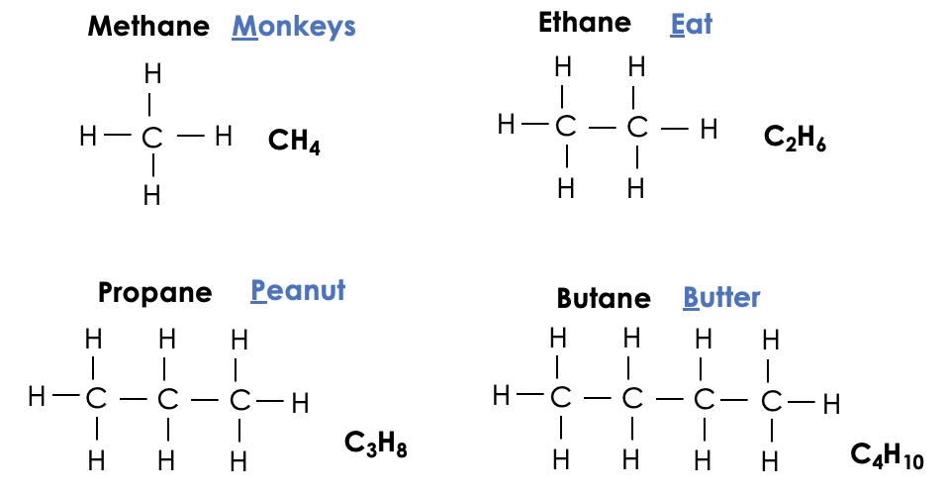
- The first four members of the alkanes are methane, ethane, propane and butane.

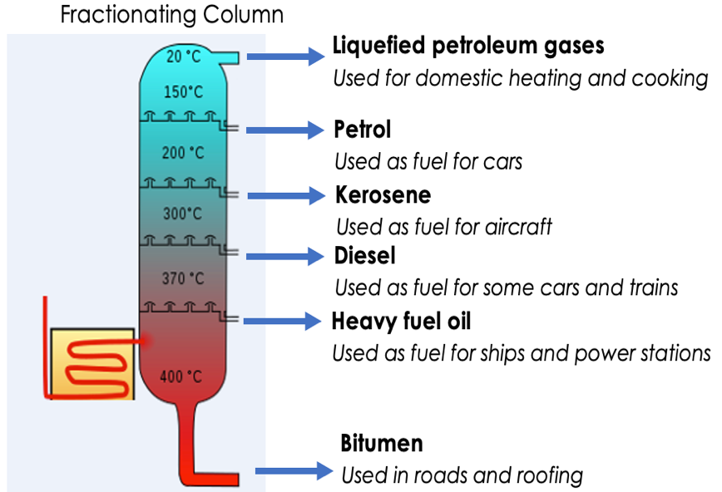
- Many useful materials on which modern life depends are produced by the petrochemical industry, such as solvents, lubricants, polymers, detergents.
- The vast array of natural and synthetic carbon compounds occur due to the ability of carbon atoms to form families of similar compounds.

Fractional Distillation

- The many hydrocarbons in crude oil may be separated into fractions, each of which contains molecules with a similar number of carbon atoms, by fractional distillation.
- The fractions can be processed to produce fuels and feedstock for the petrochemical industry.
- Many of the fuels on which we depend for our modern lifestyle, such as petrol, diesel oil, kerosene, heavy fuel oil and liquefied petroleum gases, are produced from crude oil.
- During fractional distillation, a fractionating column is used. This column has condensers at varying heights.
- A fractionating column is hot at the bottom and cooler at the top
- Substances with high boiling points condense at the bottom and those with low boiling points condense at the top
- During fractional distillation, crude oil is evaporated. It's vapours condense at different temperatures in the fractionating column.
- Each fraction produced during fractional distillation has a similar number of carbons (or size of hydrocarbons)
- Some properties of hydrocarbons depend on the size of their molecules, including boiling point, viscosity and flammability. These properties influence how hydrocarbons are used as fuels.
- Boiling point, viscosity and flammability change with increasing molecular size.
Combustion of Hydrocarbons

- The combustion of hydrocarbon fuels releases energy.
- During combustion, the carbon and hydrogen in the fuels are oxidised.
- The complete combustion of a hydrocarbon produces carbon dioxide and water.
- The general word equation that describes the complete combustion of an alkane is:

alkane + oxygen carbon dioxide + water

- Complete combustion reactions of alkanes can be represented by balanced symbol equations, for example:

CH₄ + 2 O₂ CO₂ + 2 H₂O

- Incomplete combustion can occur if there is not enough oxygen. In this case, carbon, carbon monoxide are produced.

Cracking
- Hydrocarbons can be broken down (cracked) to produce smaller, more useful molecules.
- Cracking can be done by various methods including catalytic cracking and steam cracking.
- The products of cracking include alkanes and another type of hydrocarbon called alkenes.
- Alkenes are more reactive than alkanes and react with bromine water, which is used as a test for alkenes.
- If alkenes are present, the bromine water will turn from orange to colourless.
- Alkenes are used to produce polymers and as starting materials for the production of many other chemicals.
- There is a high demand for fuels with small molecules and so some of the products of cracking are useful as fuels.

Polymers
- Polymers have very large molecules. The atoms in the polymer molecules are linked to other atoms by strong covalent bonds.
- Polymers can be represented in the form:
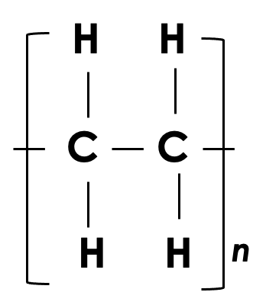

where n is a large number

- The intermolecular forces between polymer molecules are relatively strong and so these substances are solids at room temperature.
- The properties of polymers depend on what monomers they are made from and the conditions under which they are made. For example, low density (LD) and high density (HD) poly(ethene) are produced from ethene.
- Thermosoftening polymers melt when they are heated.
- Thermosetting polymers do not melt when they are heated.

Alkenes (Chemistry only)

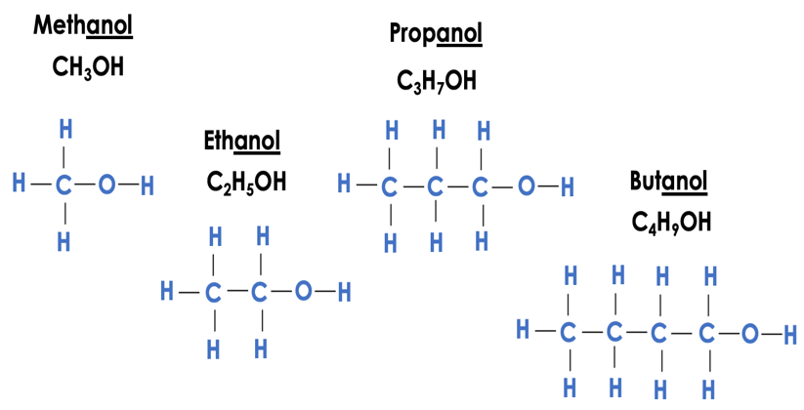
- Alkenes are hydrocarbons with a double carbon-carbon bond.
- The general formula for the homologous series of alkenes is C_{n}H_{2n}
- Alkene molecules are unsaturated because they contain two fewer hydrogen atoms than the alkane with the same number of carbon atoms.
- The first four members of the homologous series of alkenes are ethene, propene, butene and pentene.

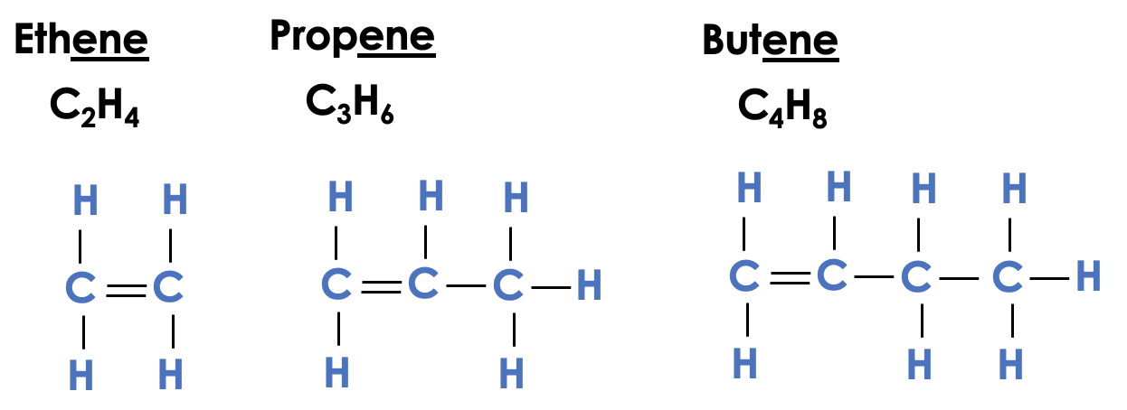

- Alkenes can be represented with a chemical formula or a displayed formula
- Alkenes react with oxygen in combustion reactions in the same way as other hydrocarbons, but they tend to burn in air with smoky flames because of incomplete combustion.
- Alkenes react with hydrogen, water and the halogens, by the addition of atoms across the carbon-carbon double bond so that the double bond becomes a single carbon-carbon bond.
- Alkenes are hydrocarbons with the functional group C=C.

Alcohols (Chemistry only)

- It is the generality of reactions of functional groups that determine the reactions of organic compounds.
- Alcohols contain the functional group –OH (a hydroxyl group)
- Methanol, ethanol, propanol and butanol are the first four members of a homologous series of alcohols.

- Methanol is used as a chemical feedstock.
- Ethanol is the alcohol present in alcoholic drinks
- Ethanol is used as a solvent.
- Propanol is used as a fuel and a solvent.
- If a small piece of sodium is dropped into ethanol, bubbles of hydrogen gas are produced and the liquid contains sodium ethoxide
- The reaction between sodium and ethanol can be represented by the equation:

sodium + ethanol sodium ethoxide + hydrogen gas

- This reaction can be represented by the balanced symbol equation:

2 Na + 2 C₂H₅OH 2 C₂H₅ONa + H₂

- Ethanol can be produced by fermentation or from ethene
- Ethanol is concentrated by distillation.
- Fermentation is an anaerobic process.
- The equation for the production of ethanol by fermentation is:

glucose ethanol + carbon dioxide
- Yeast provides the enzymes that are needed for fermentation
- The typical conditions required for fermentation are
- anaerobic conditions (no oxygen present)
- sugar dissolved in water, with yeast mixed in
- a warm temperature (25-35 degrees Celsius)

- Fermentation is a slow reaction which may take days or weeks to finish.
- Alcohols with short hydrocarbon chains mix with water easily to form a solution
- The solubility of alcohols decreases as the size of the hydrocarbon chain increases
- Alkenes can be hydrated to produce alcohols according to the equation:

Alkene + water (steam) alcohol

- This is called hydration, and it needs a temperature of approximately 300°C and a catalyst.
- For example:
Butene + water → butanol

- Ethanol can be manufactured by the hydration of ethene
- The ethene for this reaction comes from cracking crude oil fractions
- In this process, ethene is heated with steam in the presence of a catalyst of phosphoric acid
- The catalyst speeds up the reaction
- The word equation for this reaction is:

ethene + steam ethanol

- The chemical equation for this reaction is:
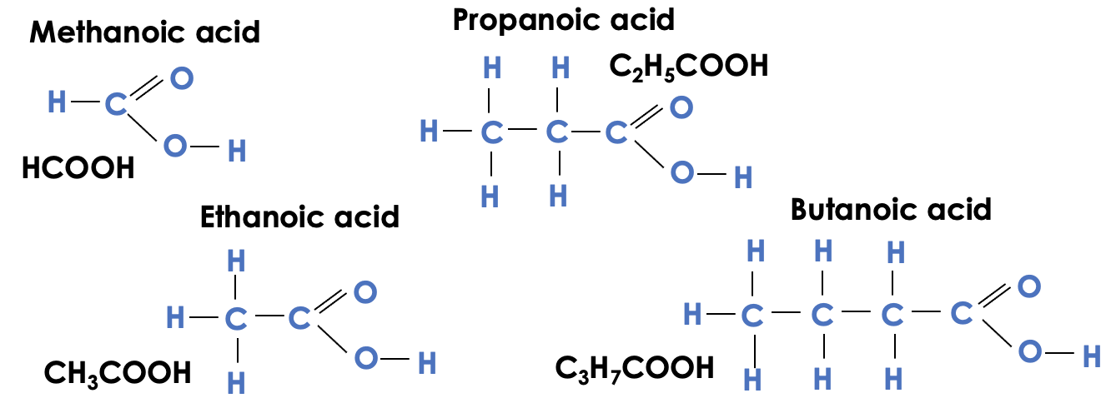
C₂H₄ + H₂O C₂H₅OH

- The conditions for this reaction are
- a high temperature (around 300 ºC)
- a pressure of 60-70 atmospheres

- Ethanol is the only product of this reaction
- This is a continuous reaction, which means that as long as ethene and steam are fed into the reaction, ethanol will be produced continually. This makes it an efficient process.
- Ethene is made from crude oil which is a non-renewable resource.
- The reaction of ethene with steam can be reversed, allowing ethanol to be converted back to ethene.
- A catalyst called aluminium oxide can speed up this reaction
- The word equation for this reaction is:

ethanol ethene + steam

- The chemical equation for this reaction is:

C₂H₅OH C₂H₄ + H₂O

Carboxylic Acids and Esters (Chemistry only)

- Carboxylic acids have the functional group –COOH.
- The functional group -COOH is also called the carboxyl group
- Carboxylic acids can be represented using a chemical formula or a displayed formula
- Carboxylic acids have the same general formula: C_{n}H_{2n+1}COOH, where n is the number of carbon atoms in the molecule minus 1 (or C_{n}H_{2n}O₂)
- The first four members of a homologous series of carboxylic acids are methanoic acid, ethanoic acid, propanoic acid and butanoic acid.
- Carboxylic acids are weak acids, which have the typical properties of acids.
- Carboxylic acids dissolve in water to form acidic solutions with pH values of less than 7
- Vinegar is a dilute solution of ethanoic acid
- Carboxylic acids react with carbonates to form a salt, water and carbon dioxide
- Because carboxylic acids are weak acids, their solutions do not contain many hydrogen ions compared to a strong acid of the same concentration
- Carboxylic acids can react with alcohols to make esters
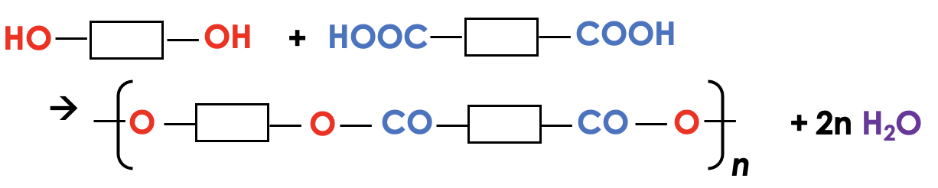
- Esters contain the functional group -COO-
- Esters have fruity smells and can be used as solvents
- The general equation for the formation of an ester is:

alcohol + carboxylic acid ester + water

- For example:

ethanol + ethanoic acid ethyl ethanoate + water

Polymerisation (Chemistry only)

- Alkenes can be used to make polymers such as poly(ethene) and poly(propene) by addition polymerisation.
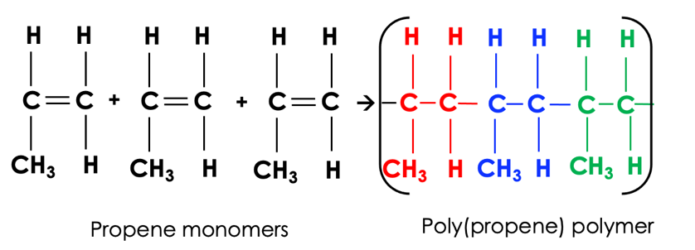
- In addition polymerisation reactions, many small molecules (monomers) join together to form very large molecules (polymers).
- In addition polymers the repeating unit has the same atoms as the monomer because no other molecule is formed in the reaction.
- Condensation polymerisation involves monomers with two functional groups.
- When these types of monomers react they join together, usually losing small molecules such as water, and so the reactions are called condensation reactions.
- The simplest polymers are produced from two different monomers with two of the same functional groups on each monomer.

- Amino acids have two different functional groups in a molecule.
- Amino acids react by condensation polymerisation to produce polypeptides.
- Different amino acids can be combined in the same chain to produce proteins.
- DNA (deoxyribonucleic acid) is a large molecule essential for life.
- DNA encodes genetic instructions for the development and functioning of living organisms and viruses.
- Most DNA molecules are two polymer chains, made from four different monomers called nucleotides, in the form of a double helix.
- Other naturally occurring polymers important for life include proteins, starch and cellulose.

