Collision Theory
- Chemical reactions can occur only when reacting particles collide with each other and with sufficient energy.
Reactants

- The minimum amount of energy that particles must have to react is called the activation energy.
- The rate of a chemical reaction can be measured using the quantity of product produced in a given time or the quantity of reactant used up in a given time.
- The rate of a chemical reaction is affected by:
  - concentration
  - pressure
  - surface area
  - temperature
  - the presence of a catalyst

Rate of Reaction
- Increasing the concentration of reactants in solution increases the frequency of collisions and so increases the rate of reaction.
- Increasing the temperature increases the frequency of collisions and makes the collisions more energetic, and so increases the rate of reaction.
- Increasing the surface area of solid reactants increases the surface area to volume ratio of the reactant, meaning that more reactant particles are exposed at the surface.
- This increases the frequency of collisions and so increases the rate of reaction.
- Increasing the pressure of reacting gases increases the frequency of collisions and so increases the rate of reaction.
- A catalyst is a substance that:
- increases the rate of a reaction
- does not alter the products of the reaction
- is not chemically changed or used up at the end of the reaction
Products
- Only a very small mass of catalyst is needed to increase the rate of a reaction.
- Not all reactions have suitable catalysts.
- Biological catalysts are called enzymes.
- Using a catalyst provides an alternative reaction pathway, with a lower activation energy.
- The frequency of collisions is not affected but the frequency of successful collisions is increased because more particles have energy greater than the activation energy, so using a catalyst increases the rate of reaction.
- The effect of a catalyst on the activation energy is shown on a reaction profile:
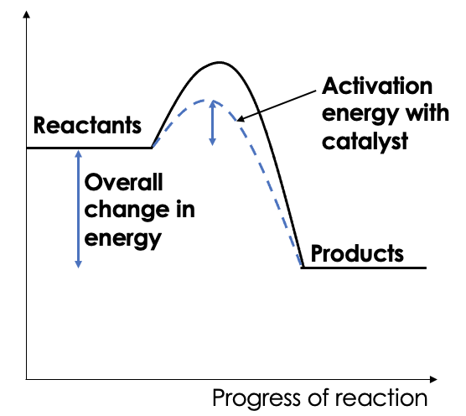

- The rate of a chemical reaction can be determined using:
  - the quantity of product formed in a given time
  - the quantity of a reactant used up in a given time
- $Mean rate of reaction = \frac{quantity of reactant used}{time taken}$

- $Mean rate of reaction = \frac{quantity of product made}{time taken}$

- The quantity of reactant or product can be measured by the mass in grams or by a volume in cm³.
- The units of rate of reaction may be g/s or cm3/s.
- Rate of reaction can be determined from a graph. 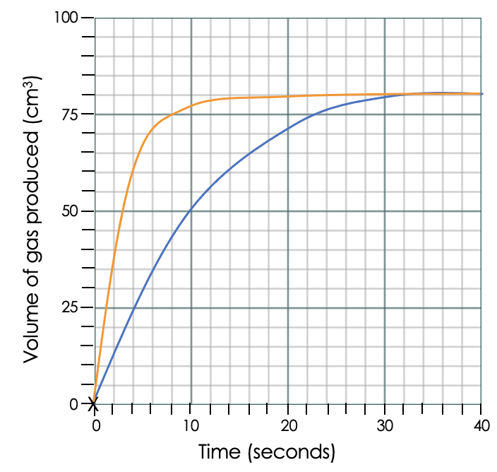
- The steeper the gradient, the greater the rate of reaction.
- Quantity of reactant or product can also be determined in moles and rate of reaction in mol/s.
- The rate of reaction at a point in time can be determined by calculating the gradient of a tangent.

- The volume of a gas produced in a given time can be used to determine rate of reaction.
- The time taken for a change in colour or turbidity to occur can be used to determine rate of reaction.

Reversible Reactions and Equilibrium
- In some chemical reactions, the products of the reaction can react to produce the original reactants.
- Such reactions are called reversible reactions and are represented:
A + B ⇌ C + D

- The direction of reversible reactions can be changed by changing the conditions.
- Even though no atoms are gained or lost in a chemical reaction, it is not always possible to obtain the calculated amount of a product because:
- the reaction may not go to completion because it is reversible
- some of the product may be lost when it is separated from the reaction mixture
- some of the reactants may react in ways different to the expected reaction.

- If a reversible reaction is exothermic in one direction, it is endothermic in the opposite direction.
- The same amount of energy is transferred in each case.
- When a reversible reaction occurs in apparatus which prevents the escape of reactants and products, equilibrium is reached when the forward and reverse reactions occur at exactly the same rate.

- The relative amounts of all the reactants and products at equilibrium depend on the conditions of the reaction.
- If a system is at equilibrium and a change is made to any of the conditions, then the system responds to counteract the change.
- The effects of changing conditions on a system at equilibrium can be predicted using Le Chatelier’s Principle.
- If the concentration of one of the reactants or products is changed, the system is no longer at equilibrium and the concentrations of all the substances will change until equilibrium is reached again.
- If the concentration of a reactant is increased, more products will be formed until equilibrium is reached again.
- If the concentration of a product is decreased, more reactants will react until equilibrium is reached again.
- If the temperature of a system at equilibrium is increased:
- the relative amount of products at equilibrium increases for an endothermic reaction
- the relative amount of products at equilibrium decreases for an exothermic reaction.
- If the temperature of a system at equilibrium is decreased:
- the relative amount of products at equilibrium decreases for an endothermic reaction
- the relative amount of products at equilibrium increases for an exothermic reaction.

- For gaseous reactions at equilibrium:
- an increase in pressure causes the equilibrium position to shift towards the side with the smaller number of molecules as shown by the symbol equation for that reaction
- a decrease in pressure causes the equilibrium position to shift towards the side with the larger number of molecules as shown by the symbol equation for that reaction.

Chemistry Only

The Haber Process and Fertilisers

- The Haber process is used to manufacture ammonia, which can be used to produce nitrogen-based fertilisers.
- The raw materials for the Haber process are nitrogen and hydrogen.
- Nitrogen can be obtained from air and hydrogen can be obtained from natural gas.
- The purified gases are passed over a catalyst of iron at a high temperature (about 450°C) and a high pressure (about 200 atmospheres).
- Some of the hydrogen and nitrogen reacts to form ammonia.
- The reaction is reversible so some of the ammonia produced breaks down into nitrogen and hydrogen:
nitrogen + hydrogen ⇌ ammonia

- On cooling, the ammonia liquefies and is removed.
- The remaining hydrogen and nitrogen are recycled.

- Compounds of nitrogen, phosphorus and potassium are used as fertilisers to improve agricultural productivity.
- NPK fertilisers contain compounds of all three elements.
- Industrial production of NPK fertilisers can be achieved using a variety of raw materials in several integrated processes.
- NPK fertilisers are formulations of various salts containing appropriate percentages of the elements.
- Ammonia can be used to manufacture ammonium salts and nitric acid.
- Potassium chloride, potassium sulfate and phosphate rock are obtained by mining, but phosphate rock cannot be used directly as a fertiliser.
- Phosphate rock is treated with nitric acid or sulfuric acid to produce soluble salts that can be used as fertilisers.

