Properties of Waves
- Waves may be either transverse or longitudinal.
- Sound travels in waves.
- Sound is made when an object causes air particles to vibrate.
- A wave is a way of transferring information or energy.
- Waves can cause matter to oscillate.
- Energy moves perpendicular to matter in transverse waves (e.g. water and light waves)
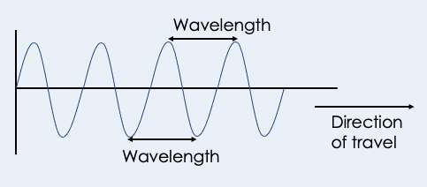

- Energy moves parallel to matter in longitudinal waves (e.g sound).
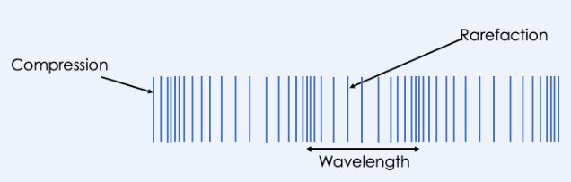
- Longitudinal waves show areas of compression and rarefaction.
- Waves can be reflected or refracted.
- Wave frequency is the number of waves that pass each second.
- The unit of frequency is hertz (Hz).
- Increasing the frequency causes a higher pitch sound.
- Humans can hear a range of 20-20000 Hz. Ultrasound has a frequency higher than 20000 Hz.
- The period is the length of time it takes one second to pass a given point.
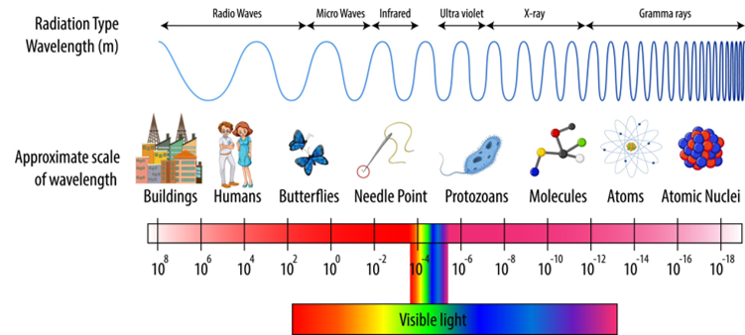
- The wavelength of a wave is the distance from one point one wave to the identical point on the next wave, measured in meters.
- The amplitude of the wave is the maximum distance of a point on the wave from its rest position.
- Increasing the amplitude increases the volume.
- The peak is the highest point on the wave and the trough is the lowest point on the wave.

Observing Waves
- The speed of water waves can be measured using a ripple tank
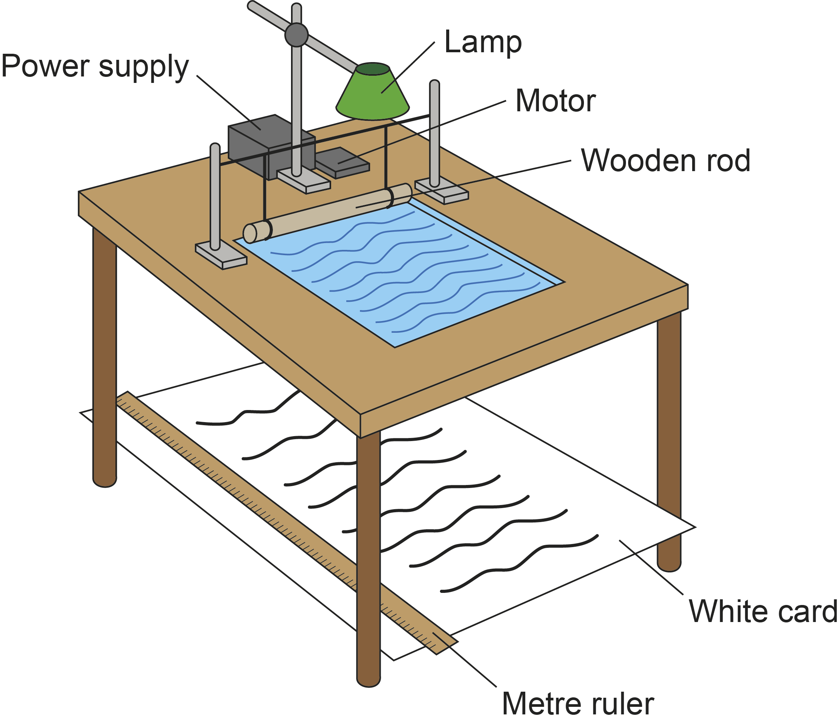
- The speed of a wave on a string can be measured
- The velocity of a wave is the speed of the wave in the direction it is travelling.
- Velocity of the wave = displacement / time, S = d/t
- Velocity of the wave (m/s) = frequency (Hz) x wavelength (m), v = f x λ

The Electromagnetic Spectrum
- Electromagnetic waves are transverse waves that transfer energy from the source of the waves to an absorber.
- Electromagnetic waves form a continuous spectrum and all types of electromagnetic wave travel at the same velocity through a vacuum (space) or air (3x10⁶ m/s)

- The waves that form the electromagnetic spectrum are grouped in terms of their wavelength and their frequency. Going from long to short wavelength (or from low to high frequency) the groups are: radio, microwave, infrared, visible light (red to violet), ultraviolet, X-rays and gamma rays.
- (HT Only) Different substances may absorb, transmit, refract or reflect electromagnetic waves in ways that vary with wavelength.
- (HT Only) Some effects, for example refraction, are due to the difference in velocity of the waves in different substances.
- (HT Only) Wave front diagrams can be used to explain refraction as they show the change of speed that happens when a wave travels from one medium to another.

Uses of Electromagnetic Spectrum
- Our eyes only detect visible light and so detect a limited range of electromagnetic waves.
- The visible spectrum is made of the colours red, orange, yellow, green, blue, indigo and violet
- Red light has the longest wavelength (lowest frequency) and violet has the shortest wavelength (highest frequency)
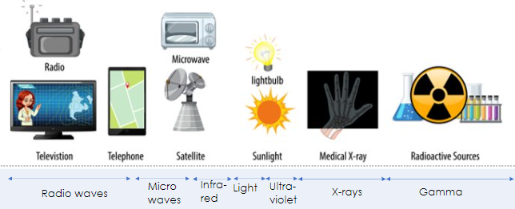
- (HT Only) Radio waves can be produced by oscillations in electrical circuits.
- (HT Only) When radio waves are absorbed they may create an alternating current with the same frequency as the radio wave itself, so radio waves can themselves induce oscillations in an electrical circuit.
- (HT Only) High frequency microwaves are easily absorbed by food molecules, increasing their internal energy
- (HT Only) Microwaves easily pass through the atmosphere so are used between stations on Earth and satellites in orbit
- Changes in atoms and the nuclei of atoms can result in electromagnetic waves being generated or absorbed over a wide frequency range. Gamma rays originate from changes in the nucleus of an atom.
- Ultraviolet waves, X-rays and gamma rays can have hazardous effects on human body tissue. The effects depend on the type of radiation and the size of the dose. Radiation dose (in sieverts) is a measure of the risk of harm resulting from an exposure of the body to the radiation.
- Ultraviolet waves can cause skin to age prematurely and increase the risk of skin cancer. X-rays and gamma rays are ionising radiation that can cause the mutation of genes and cancer.
- Electromagnetic waves have many practical applications. For example:
- radio waves - television and radio
- microwaves - satellite communications, cooking food
- infrared - electrical heaters, cooking food, infrared cameras
- visible light - fibre optic communications
- ultraviolet - energy efficient lamps, sun tanning
- X-rays and gamma rays - medical imaging and treatments

- Each type of electromagnetic wave is suitable for its different practical application because of its wavelength and frequency.

Reflection and Refraction (Physics Only)
- Reflection from a smooth surface in a single direction is called specular reflection. Reflection from a rough surface causes scattering: this is called diffuse reflection.
- Ray diagrams can be used to show the refraction of a wave at the boundary between two different media.
- Refraction is the change of direction of a wave when it moves from one medium to another because it changes speed
- A wave slows down if it moves from a less dense to a more dense medium, causing it to bend towards the normal
- When light reaches a different medium, some light can be reflected and some is refracted.
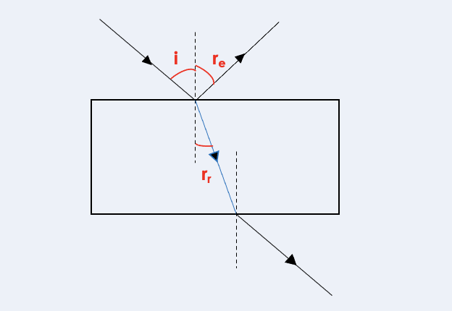

- The incident ray is the incoming ray.
- The normal line is an imaginary line from which angles are measured. It is drawn from the point of incidence at right angles to the surface.
- Angle of incidence is the angle between the normal and the incidence ray.

Visible Light and Lenses (Physics Only)
- Objects that transmit light are either transparent or translucent.
- Translucent objects allow some light to pass through, transparent objects allow most light to pass through
- Objects that do not transmit light are opaque and shadows can form behind them
- A lens forms an image by refracting light. In a convex lens, parallel rays of light are brought to a focus at the principal focus.
- The distance from the lens to the principal focus is called the focal length.

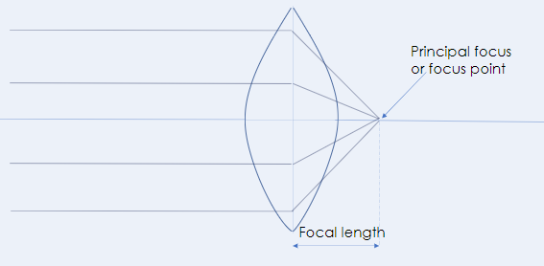

- Ray diagrams are used to show the formation of images by convex and concave lenses.
- A convex lens is thicker in the middle that at the edges and rays of light converge through a convex lens to meet at the principal focus
- The image produced by a convex lens can be either real or virtual.
- A virtual image is one that appears to come from behind the lens
- A concave lens is thinner in the middle than at the edges and rays of light diverge through a concave lens
- The image produced by a concave lens is always virtual.
- Convex lenses are found in cameras, human eyes, projectors and magnifying glasses
- Concave lenses are found in peep holes

Ray Diagrams (Physics Only)
- In ray diagrams a convex lens is represented with two outward facing arrows and a concave lens is represented with two inward facing arrows
- The images formed by a lens can be: upright or inverted, magnified or diminished, real or virtual
- The magnification produced by a lens can be calculated using the equation: magnification = image height/object height
- Magnification is a ratio and so has no units.
- Image height and object height should both be measured in either mm or cm.

Colour (Physics Only)
- Each colour within the visible light spectrum has its own narrow band of wavelength and frequency.

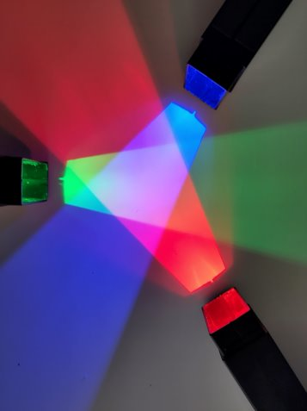
- Waves can be absorbed at the boundary between two different materials
- When waves are absorbed by a surface, the energy of the wave is transferred to the particles in the surface, increasing their internal energy
- Colour filters work by absorbing certain wavelengths (and colour) and transmitting other wavelengths (and colour).
- The colour of an opaque object is determined by which wavelengths of light are more strongly reflected. Wavelengths that are not reflected are absorbed. If all wavelengths are reflected equally the object appears white. If all wavelengths are absorbed the objects appears black.

The Big Bang Theory and Red Shift (Physics Only)
- Light from a star does not contain all the wavelengths of the EM spectrum as elements in the star can absorb some of the wavelengths
- This produces dark lines when the emission spectrum is analysed
- Different elements produce different emission spectra
- There is an observed increase in the wavelength of light from most distant galaxies. The further away the galaxies, the faster they are moving and the bigger the observed increase in wavelength. This effect is called red-shift.
- The observed red-shift provides evidence that space itself (the universe) is expanding and supports the Big Bang theory.
- Scientists use observations to arrive at theories such as the Big Bang theory
- The Big Bang theory suggests that the universe began from a very small region that was extremely hot and dense.
- Since 1998 onwards, observations of supernovae suggest that distant galaxies are receding ever faster.
- Red-shift of light from galaxies that are receding is evidence for the Big Bang model
- The change of each galaxy’s speed with distance is evidence of an expanding universe
- Scientists do not yet understand why the Universe is expanding increasingly quickly but have suggested the idea of dark energy, which is thought
- to account for over 2/3 of the Universe
- Scientists have also discovered that galaxies rotate too quickly for the mass of their stars, leading scientists to think that there is mass that is invisible to current scientific instruments, but has gravity that affects nearby objects. Scientists call this mass dark matter
- Only 5% of the Universe is made of matter that we currently understand

RPA: Infrared Radiation
- An infrared thermometer can be used to measure emission of infrared radiation
- White, silver, shiny surfaces are poor absorbers/ emitters of infrared radiation as they reflect all visible light wavelengths
- Radiators are often painted white to release infrared radiation steadily
- Dark, matte surfaces are good emitters of infrared radiation
- A Leslie cube can be used to investigate emission of infrared radiation
- A Leslie cube is a metal cube with four different types of surface, and can be filled with hot water
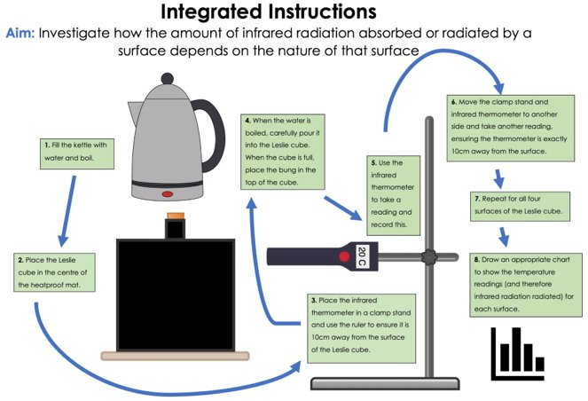

Black Bodies and Radiation (Physics Only)
- All bodies (objects), no matter what temperature, emit and absorb infrared radiation. The hotter the body, the more infrared radiation it radiates in a given time.
- There are no known objects that are perfect at absorbing or emitting all radiation, but objects that come close are called black bodies
- A perfect black body is an object that absorbs all of the radiation incident on it. A black body does not reflect or transmit any radiation. Since a good absorber is also a good emitter, a perfect black body would be the best possible emitter.
- A perfect black body is a theoretical object
- Stars are considered to be black bodies because they are good emitters (and therefore absorbers) of most wavelengths in the EM spectrum. Planets and black holes are also nearly perfect black bodies
- A body at constant temperature is absorbing radiation at the same rate as it is emitting radiation. The temperature of a body increases when the body absorbs radiation faster than it emits radiation.

Earth and Radiation (Physics Only)
- The temperature of the Earth depends on many factors including: the rates of absorption and emission of radiation, reflection of radiation into space, and the concentration of greenhouse gases in its atmosphere
- The temperature of a body is related to the balance between incoming radiation absorbed and radiation emitted, using everyday examples to illustrate this balance, and the example of the factors which determine the temperature of the Earth.
- The Earth absorbs infrared radiation and visible light, increasing its internal energy
- The Earth transfers energy to the atmosphere via conduction and convection
- The Earth emits infrared radiation, some of which is absorbed by greenhouse gases
- These greenhouse gases then emit infrared radiation in all directions, including back to Earth, where it is then reabsorbed
- The greenhouse effect is caused by natural greenhouse gases which stabilise the surface temperature of the Earth, allowing it to support life
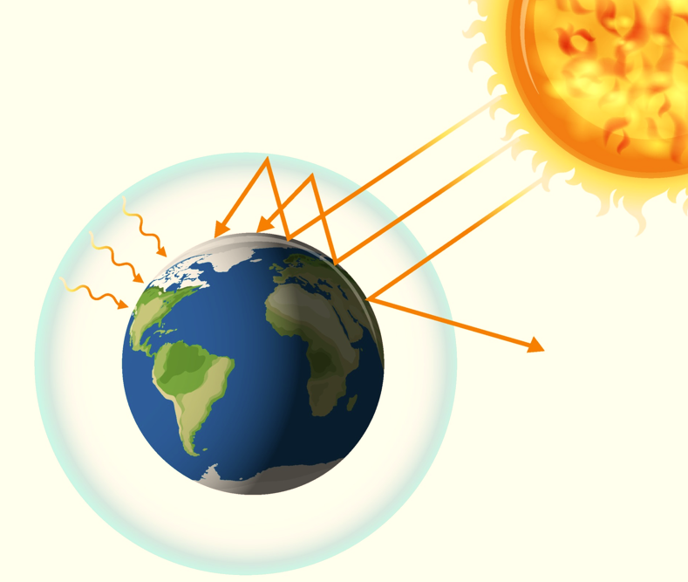
- However, human activities (including burning fossil fuels and deforestation) are increasing the concentration of greenhouse gases in the atmosphere, causing more infrared radiation to be absorbed by the gases and causing an enhanced greenhouse effect"

