Non-contact Forces

- A force is a push or pull that acts on an object due to the interaction with another object.
- All forces between objects are either contact forces or non-contact forces.
- A contact force acts when the objects are physically touching
- A non-contact forces acts when the objects are physically separated.
- Friction, air resistance, tension and normal contact force are examples of contact forces.
- Gravitational force, electrostatic force and magnetic force are examples of non-contact forces.
- Force is a vector quantity, so should have a magnitude and direction.

Gravity, Mass and Weight

- Weight is the force acting on an object due to gravity.
- The force of gravity close to the Earth is due to the gravitational field around the Earth.
- The weight of an object depends on the gravitational field strength at the point where the object is.
- The weight of an object can be calculated using the equation: weight =mass ×gravitational field strength
W =m g

weight, W, in newtons, N
mass, m, in kilograms, kg
gravitational field strength, g, in newtons per kilogram, N/kg

- The weight of an object may be considered to act at a single point referred to as the object’s centre of mass.
- The weight of an object and the mass of an object are directly proportional.
- Weight is measured using a calibrated spring-balance (a Newtonmeter)

Magnetism

- Magnetism is a non-contact force.
- The poles of a magnet are the places where the magnetic forces are strongest.
- When two magnets are brought close together they exert a force on each other.
- Two like poles repel each other.
- Two unlike poles attract each other.
- Attraction and repulsion between two magnetic poles are examples of non-contact force.
- A permanent magnet produces its own magnetic field. An induced magnet is a material that becomes a magnet when it is placed in a magnetic field.
- Induced magnetism always causes a force of attraction.
- When removed from the magnetic field an induced magnet loses most/all of its magnetism quickly.
- The region around a magnet where a force acts on another magnet or on a magnetic material (iron, steel, cobalt and nickel) is called the magnetic field.
- The force between a magnet and a magnetic material is always one of attraction.
- The strength of the magnetic field depends on the distance from the magnet.
- The field is strongest at the poles of the magnet.
- The direction of the magnetic field at any point is given by the direction of the force that would act on another north pole placed at that point.
- The direction of a magnetic field line is from the north (seeking) pole of a magnet to the south(seeking) pole of the magnet.

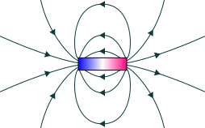

- A magnetic compass contains a small bar magnet.
- The Earth has a magnetic field, which acts like a bar magnet.
- The compass needle points in the direction of the Earth’s magnetic field.

Electromagnets

- When a current flows through a conducting wire a magnetic field is produced around the wire.
- The strength of the magnetic field depends on the current through the wire and the distance from the wire.
- Shaping a wire to form a solenoid increases the strength of the magnetic field created by a current through the wire.
- The magnetic field inside a solenoid is strong and uniform.
- The magnetic field around a solenoid has a similar shape to that of a bar magnet.
- Adding an iron core increases the strength of the magnetic field of a solenoid.
- An electromagnet is a solenoid with an iron core.

The Motor Effect and Fleming’s Left-Hand Rule

- When a conductor carrying a current is placed in a magnetic field the magnet producing the field and the conductor exert a force on each other. This is called the motor effect.
- Fleming's left-hand rule represents the relative orientation of the force, the current in the conductor and the magnetic field.
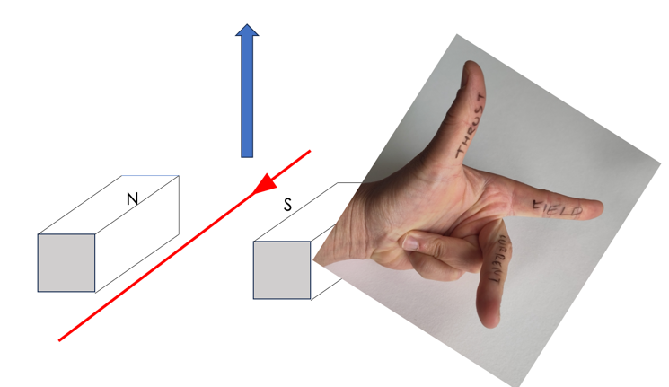

- For a conductor at right angles to a magnetic field and carrying a current:

force = magnetic flux density × current × length

F = BIL

Force, F, in Newtons, N
magnetic flux density, B, in Tesla, T
current, I, in amperes, A
length, l, in metres, m

- A coil of wire carrying a current in a magnetic field tends to rotate. This is the basis of an electric motor.
- The force on a conductor in a magnetic field causes the rotation of the coil in an electric motor.

Physics Only

- Loudspeakers and headphones use the motor effect to convert variations in current in electrical circuits to the pressure variations in sound waves.

The Generator Effect

- If an electrical conductor moves relative to a magnetic field or if there is a change in the magnetic field around a conductor, a potential difference is induced across the ends of the conductor.
- If the conductor is part of a complete circuit, a current is induced in the conductor. This is called the generator effect.
- An induced current generates a magnetic field that opposes the original change, either the movement of the conductor or the change in magnetic field.
- To increase the induced voltage, the magnet can be moved faster, more turns can be added to the coil or the strength of the magnet can be increased.
- The generator effect is used in an alternator to generate ac and in a dynamo to generate dc.
- Microphones use the generator effect to convert the pressure variations in sound waves into variations in current in electrical circuits.

Transformers

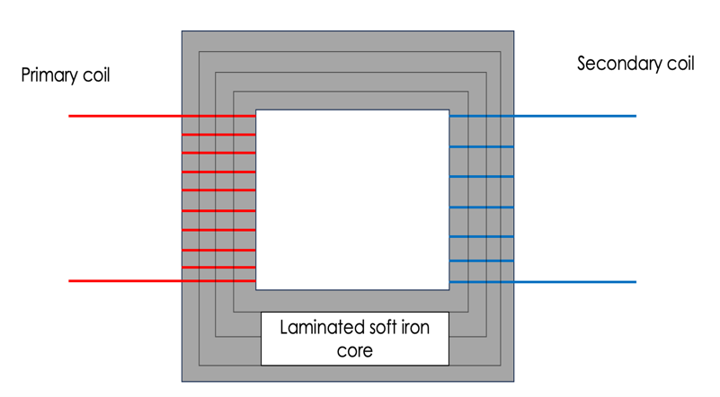
- A transformer is a device that can change the potential difference of an alternating current power supply.
- A basic transformer consists of a primary coil and a secondary coil wound on a laminated iron core.
- Iron is used as it is easily magnetised.
- The iron core is laminated to minimise eddy currents.
- The ratio of the potential differences across the primary and secondary coils of a transformer Vp and Vs depends on the ratio of the number of turns on each coil, np and ns.

- In a step-up transformer Vs > Vp
- In a step-down transformer Vs < Vp
- If transformers were 100% efficient, the electrical power output would equal the electrical power input:

$$\frac{V_{p}}{V_{s}}= \frac{n_{p}}{n_{s}}$$

- Potential difference, Vp and Vs, in Volts, V
- Where Vs x Is is the power output of the secondary coil and Vp x Ip is the power input to the primary coil
- Power input and output in Watts, W

Electric Fields

- When certain insulating materials are rubbed against each other they become electrically charged.
- Negatively charged electrons are rubbed off one material and on to the other.
- The material that gains electrons becomes negatively charged.
- The material that loses electrons is left with an equal positive charge.
- When two electrically charged objects are brought close together they exert a force on each other.
- Two objects that carry the same type of charge repel.
- Two objects that carry different types of charge attract.
- Attraction and repulsion between two charged objects are examples of non-contact force.
- A charged object creates an electric field around itself.
- The electric field is strongest close to the charged object.
- The further away from the charged object, the weaker the field.
- A second charged object placed in the field experiences a force.
- The force gets stronger as the distance between the objects decreases.

Space

- Within our solar system there is one star, the Sun, plus the eight planets and the dwarf planets that orbit around the Sun.
- Natural satellites, the moons that orbit planets, are also part of the solar system.
- Our solar system is a small part of the Milky Way galaxy.
- The Sun was formed from a cloud of dust and gas (nebula) pulled together by gravitational attraction.
- At the start of a star's life cycle, the dust and gas drawn together by gravity causes fusion reactions.
- Fusion reactions lead to an equilibrium between the gravitational collapse of a star and the expansion of a star due to fusion energy.
- Gravity provides the force that allows planets and satellites (both natural and artificial) to maintain their circular orbits.
- For circular orbits, the force of gravity can lead to changing velocity but unchanged speed
- For a stable orbit, the radius must change if the speed changes.
- A star goes through a life cycle. The life cycle is determined by the size of the star.
- Stars the size of the Sun after their main sequence phase become red giants, then white dwarves, then black dwarves
- Stars much more massive than the Sun after their main sequence phase become red super giants, then supernovae, then either neutron stars or black holes
- Fusion processes in stars produce all of the naturally occurring elements.
- Elements heavier than iron are produced in a supernova.
- The explosion of a massive star (supernova) distributes the elements throughout the universe.

