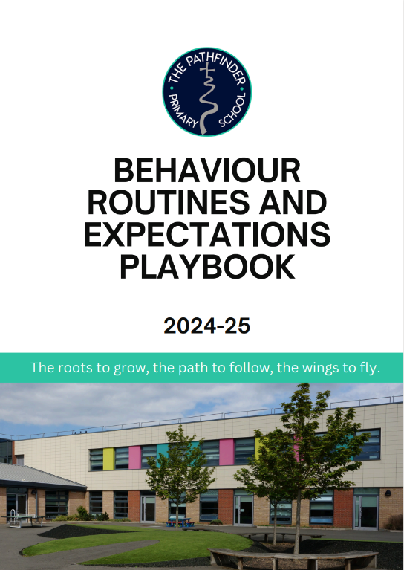
Intent and vision at Pathfinder

At Pathfinder C of E Primary School, our Christian ethos is our foundation and guiding principle. Our values support children's development; academically, personally and spiritually, enabling them to contribute positively to our school community and wider society.

Our vision is:
‘the roots to grow, the path to follow, the wings to fly’.

We know that ensuring pupils feel safe and secure in our school community, and guiding them with consistency and clarity on the correct path to follow, equips them with the wings to fly, both within our school and beyond. To do this, we embrace a relational approach with high expectations of all.

Stage 1: How we build relationships 6m

Building trust and establishing boundaries
We know that individuals thrive when there is a clear expectation of positive behaviour. When we are consistent, pupils feel safe and are ready to learn. Setting and sustaining boundaries ensures all members of Pathfinder feel safe and supports teachers and leaders to secure a fantastic learning experience for our pupils.

In the classroom |   Transitions within School |   SHINE listening |  |   Active Learning
Wider school |   Pathfinder Walking |   Lunchtime Routines |  |   Respectful Play
How we communicate |   Caring community |  |   Restoring after conflict

In the classroom | What is The Pathfinder Way?
In the classroom |  | Pupil Focus | Staff Focus
In the classroom | Transitions within School | Respect- We know that staff will greet us as we enter each space.  Perseverance- We will begin each day afresh, and persevere to be the best we can be.  Wisdom – We have the wisdom to know how to move around school safely. | Respect- We will always greet children when we welcome them into a space.  Perseverance- We begin each lesson with the expectation that all pupils will succeed.  Wisdom – We have the wisdom to know that routines take time to embed and we will give opportunities to practice them often.
In the classroom |   ‘SHINE’  Routines  Sit up and Listen  Hands still  Involved in Learning  Neat tables  Eyes on speaker | Respect- We show peers and staff respect by listening when they speak.  Perseverance- When we find this skill hard, we practice until we master it.  Wisdom – We know that at Pathfinder all pupils must learn, and a quiet learning environment helps this. | Respect- We always model respect to our children, so they know what it looks like and have a clear model to learn from.  Perseverance- We will be patient and provide time for children to listen, think and take part in active discussion.  Wisdom – We know our pupils are individuals and ensure what we ask of them is manageable.
In the classroom | 100%  Active Learning | Respect- We show peers and staff respect by valuing our opportunity to learn, and engaging with tasks set.  Perseverance- We have a ‘can-do’ attitude and know we can solve challenges ourselves without relying on an adult.  Wisdom – We approach each lesson with wonder and curiosity. | Respect- We plan engaging and scaffolded learning tasks to ensure all children can feel success.  Perseverance- We use adaptive planning and responsive teaching, persevering until pupils succeed.  Wisdom – We provide appropriate challenge to all to promote aspiration and success in the future.

Wider School | What is The Pathfinder Way?
Wider School |  | Pupil Focus | Staff Focus
Wider School |   Pathfinder Walking | Respect- We want our school environment to be calm and we walk quietly..  Perseverance- We will begin each day afresh, and persevere to be the best we can be.  Wisdom – We have the wisdom to know how to move around Pathfinder safely and efficiently. | Respect- We will praise pupils who model Pathfinder walking.  Perseverance- We will have high expectations of pupils no matter their background and age.  Wisdom – We have the wisdom to know that routines need to be taught, take time to embed and we will give opportunities to practice them often.
Wider School |   Lunchtime Routines | Respect- We show consideration and care to our lunchtime environment, our fellow pupils and the staff who help us.  Perseverance- We will be open to trying new foods, and aspire to learn new skills such as using a knife and fork correctly.  Wisdom – We understand that lunch times may be tricky for some, and therefore will be considerate of all. | Respect- We will ensure lunch time staff are treated respectfully, and will accommodate children who find lunchtime challenging.  Perseverance- We will take advantage of naturally occurring opportunities to help children develop vital skills.  Wisdom – We know how clear boundaries and expectations support pupils in feeling safe, and we will uphold these in lunchtime spaces.
Wider School |   Respectful Play | Respect- We will treat others with kindness and curiosity and look after our equipment and environment.  Perseverance- We will take ownership of our choices and work with adults, if needed, to navigate friendships.  Wisdom – We will be prepared for the future by having autonomy over our play and free time. | Respect- We will give children the space to share challenges and support them through these.  Perseverance- We will support pupils in having the skills to navigate social challenges.  Wisdom – We will support pupils in practicing these routines so they know our expectations and can succeed in achieving them.

How we communicate | What is The Pathfinder Way?
How we communicate |  | Pupil Focus | Staff Focus
How we communicate |   Caring community | Respect- We know any adult at Pathfinder will respect our thoughts when we speak to them.  Perseverance- We will seek additional opportunities to contribute positively to our school and wider community.  Wisdom –We know that we are in control of our future, and we have a strong network to support us in spreading our wings. | Respect- We always take time to build relationships with our pupils to strengthen their sense of belonging.  Perseverance- We have a wide range of additional opportunities for pupils to take part in.  Wisdom –We will nurture our children to have a strong sense of self and belief they are in control of their outcomes.
How we communicate | Restoring after conflict | Respect- We will be considerate of other people’s feelings and will ask ‘why’ when issues arise to gain the full picture without involving others.  Perseverance- We will actively engage with members of staff during restorative conversations to learn from past mistakes.  Wisdom – We will reflect on our values to move on from issues encountered. | Respect- We will always investigate conflict and will use our behaviour policy to ensure all adults are consistent in their approach.  Perseverance- We will hold restorative conversations to repair relationships and allow children to reflect upon their actions.  Wisdom – We will support children, using our values, to repair relationships and move past the issue which has caused negative feeling.

Positive framing and celebrating success: Relational rewards

The recognition of perseverance, achievement and accomplishment of goals is key to our relational approach. We recognise that individual effort and achievements will look different for each child. This needs to be balanced with consistency of approach, to develop trust and security in our whole school method for recognising and celebrating success. We strive for intrinsic motivation as often as possible, from children and adults in our school community.

We recognise the limitations of overly extrinsic or transactional rewards on pupil motivation, and our practises increasingly offer a more relational approach to celebrating success. Pupil, parent and staff voice is used frequently to support us to review our rewards offer and ensure we are striking an appropriate balance to meet the needs of our community.

Precise Praise | Wherever possible we prioritise giving children specific and meaningful 1:1 praise so we can reflect together on how they accomplished the achievement and the pride we all feel about the effort they put in.
Teacher Communication | Teachers are encouraged to communicate with families (through BromCom, phone, or at the gate) positive messages, multiple times a week, to build relationships and celebrate success.
Values Board | At Pathfinder we value those who consistently showcase our values. Pupils who do so, through achieving their daily class target, have their name recorded on their class ‘Values Board’ for all to celebrate.
Values Champion | Each week, we hold a Celebration Worship. Class teachers will nominate a child who has stood out for demonstrating one of our 3 Values.
Champions Tea | Once a half term, those consistently going above and beyond in showcasing the ‘Pathfinder Way’, are invited to tea with a member of the Senior Leadership Team.

Stage 2: How we regulate and respond

Behaviour that needs intervention and support
Unacceptable behaviour comes in many forms; we have outlined some of the most common types which disrupt our pupils’ feeling of safety and right to learn.

Disruptive Behaviour  Persistent talking, shouting, diverting the attention of other pupils or the teacher. More extreme disruptions include unsafe behaviour. | Swearing  Rudeness, swearing or abuse to another pupil, adult, or in a general conversation.
Fighting  No person is allowed to physically hurt or injure another with a fist, kicking, pushing, or throwing an object with the intention of causing harm. | Bullying (see Anti-Bullying Policy)  Repetitive, intentional hurting of one person or group by another person or group, where the relationship involves an imbalance of power.
Racism  No person is allowed to treat another person unfairly on the basis of their race, language, nationality, skin colour or culture. | Unsafe behaviour  Such as misuse or breaking of equipment, playing in an aggressive or unsafe manner (for self or others), or taking equipment from another pupil without asking. Not responding to requests by adults, or leaving areas of supervision.
Homophobia, sexism, disasblism, transphobia.
No person is allowed to treat another person unfairly on the basis of a protected characteristic.

Interventions and logical Consequences (In conjunction with Appendix 1,2 and 3)

Behaviour Stage | What we do  Action to be taken by school |  | Why we do it
1 | Least invasive correction | Non-verbal intervention  Modelling SHINE while teaching at the front as a reminder to pupils  Standing next to a pupil who is causing low level disruption as a reminder to engage  Positive group correction  ‘The expectation at Pathfinder is we SHINE when somebody is speaking.’  Anonymous individual correction  ‘3.2,1 means we should be quiet.’  Lightening quick public correction  ‘Pupil, pencil down so we can SHINE.’
1 | Private correction | 30 second script, given in a calm neutral voice, to remind pupil of expectations:  “I need you to...”  “The expectation is...”  Logical consequence given if suitable.  “You spilled water, here is a cloth to clean it up.” | To offer a predictable response for pupils  To ensure the most attention goes to pupils showcasing “The Pathfinder Way”  To lessen language used to minimise cognitive load
2 | Reset and regulate | Adult prompts child to change behaviour, or take time to ‘Reset and regulate’.  Options may include: a calming space e.g. book corner, designated zone, movement break with an adult.  ‘Reset and Regulate’ to be managed with a 5-minute sand timer (more time can be used if required).  ‘Reset and Restore’ conversation guided by an adult when child is ready to reflect on what could be done differently next time. Appendix 2 | To support pupils in regulating so they are ready to learn.
3 | Lunchtime Catch-Up | ‘Lunchtime Catch-up' is offered for children who have not completed work to the expectation set. If pupils do not engage, work may be sent to complete at home.  ‘Reset and Restore’ conversation guided by the adult to know what could be done differently next time.  Class teacher to record this on CPOMs as ‘Behaviour Intervention’. | This is a logical consequence for not meeting the expectation set in class in terms of the task set, and to supports pupils to learn a better way.
3 | Playtime or Lunchtime Adaptations | Playtime or lunchtime may be lessened, limited, or altered for those who are finding having a successful or productive breaktime challenging. | This is a logical consequence if disruption within free time is occurring.
4 | Classroom removals | A classroom removal will only occur when the BRE Playbook has been clearly followed, and all other options have been exhausted.  Senior leadership or pastoral support, will be called when:  - A child is a danger themselves  - A child is a danger to others  - Disruption is affecting the learning and/or emotional safety of others  Class teacher will contact parents and record this on CPOMs as ‘Behaviour Intervention’. | In this situation, a child has been unable to respond to the initial adult and therefore a change of face is needed because no progress has been made.  By removing a child from the environment which has caused them stress, and changing the adult, we are de-escalating a scenario and are supporting them to co-regulate.
q 5 | Internal Isolation | An internal isolation occurs when a child demonstrates an unsafe pattern of behaviour which we cannot tolerate.  An internal isolation takes place in SLT offices where a child is away from their peers and usual routines for a set period of time. During this time, they are still expected to complete their work.  A meeting with parents, class teacher and SLT is arranged to establish a ‘Behaviour Contract’ (Appendix 3) with the teacher. These targets are monitored through a ‘Teacher Report’ (Appendix 4) for two weeks, before reviewing. Teacher Report recorded on CPOMs. | An internal isolation occurs as a behaviour system to support a restorative approach and as a logical consequence. An isolation provides the child with needed time away from the environment which has led to harm being caused as well as changing the adult who was involved. It allows the conflict to be explored with a new, impartial adult, who can take steps to repair the relationship.
6 | Headteacher’s Report | ‘Headteacher’s Report’ is used to support pupils further if previous measures have not had the desired effect. The pupil will meet with Headteacher and parents to discuss a bespoke Behaviour Plan, including pastoral support where needed.  Biweekly meetings with parents, class teacher, and a member of SLT.  Report recorded on CPOMs. | By working together with families, staff and the pupil we ensure our approach is tailored to the needs of that individual to give them the greatest chance of success.

Step 1 Correction

Reminder of expectations
Use scripts to guide
Logical consequences given when needed

Step 2
Reset and Regulate

5 minutes to calm
Lunchtime Catch-Up if work is missed
Class teacher informed

Step 3
Lunchtime Catch-Up/Adaptations

Work with SLT to complete missed work
Teacher log on CPOMs

Step 4
Classroom Removals

Collected by SLT
Classteacher contacts parents

Step 5
Internal Isolation

Meeting arranged to put Behaviour Contract in Place
2 Week Teacher Report Begins

Step 6
Headteacher's Report

Bespoke Behaviour Plan in place
Teaching Time:
Regulate and respond -
Logical Consequence Flow Diagram
Teaching Time - Regulate and Respond: Logical consequences flow-diagram

Step 1 Correction

Reminder of expectations
Use scripts to guide
Logical consequences given when needed

Step 2
Reset and Regulate

5 minutes to calm with member of staff on duty

Step 3
Break Time/ Lunchtime Adaptations

Class teacher to work with those on duty to consider how to make breaktime/lunchtime success
Class teacher to share with parents, implement and enforce

Step 4
SLT Behaviour Contract

Class teacher to work with SLT
Meeting with parents
Lunchtime:
Regulate and respond -
Logical Consequence Flow Diagram
Exclusion as a last resort:

We recognise that suspensions and exclusions often have a serious and negative impact on pupils. However, we also recognise that there is an important role for suspensions and exclusions, both in law and in our processes, to ensure the safety, wellbeing and effective education of our children. When considering suspensions or exclusion as a response to a pupil’s behaviour, we will consider a range of factors as advised in the DfE’s Behaviour in Schools guidance and Suspensions and Permanent Exclusions guidance.

Our approach and intent is always relational and restorative in nature, and we will seek to do everything we can to secure inclusion for our most vulnerable learners while also safeguarding the wellbeing and education of the wider school community.

Strategies to reduce suspensions

We aim to reduce suspensions and exclusions through an inclusive universal offer that ensures we support individuals with emotional regulation and restorative approaches. Through our graduated response pathway, we ensure that all pupils are responded to proactively when they need additional support beyond the universal offer, with targeted interventions put into place at every stage.

Permanent exclusions

We recognise that permanent exclusions are serious, and should only be used as a last resort in response to 'serious breaches' or repeated breaches of the Behaviour and Expectations policy or to safeguard the welfare and education of other pupils, after a range of strategies and interventions have been tried.

As such, permanent exclusion is normally the final and most serious step taken in our disciplinary process.

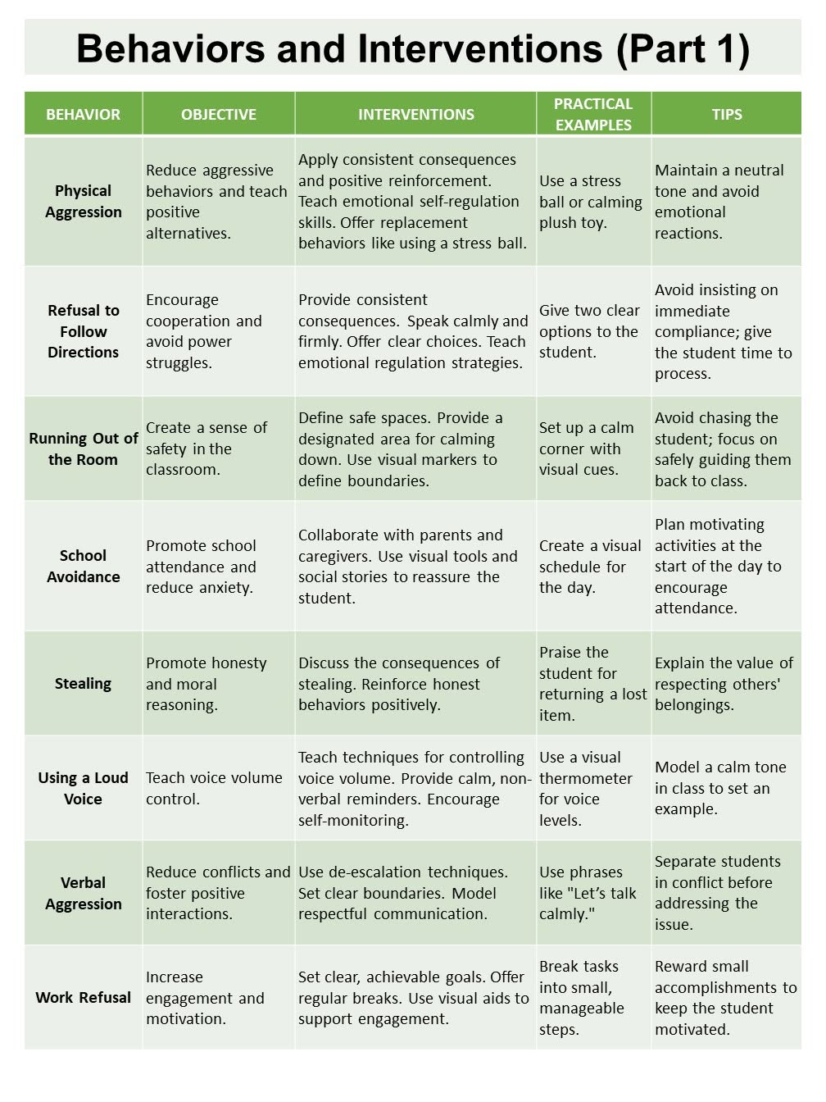
Appendix 1
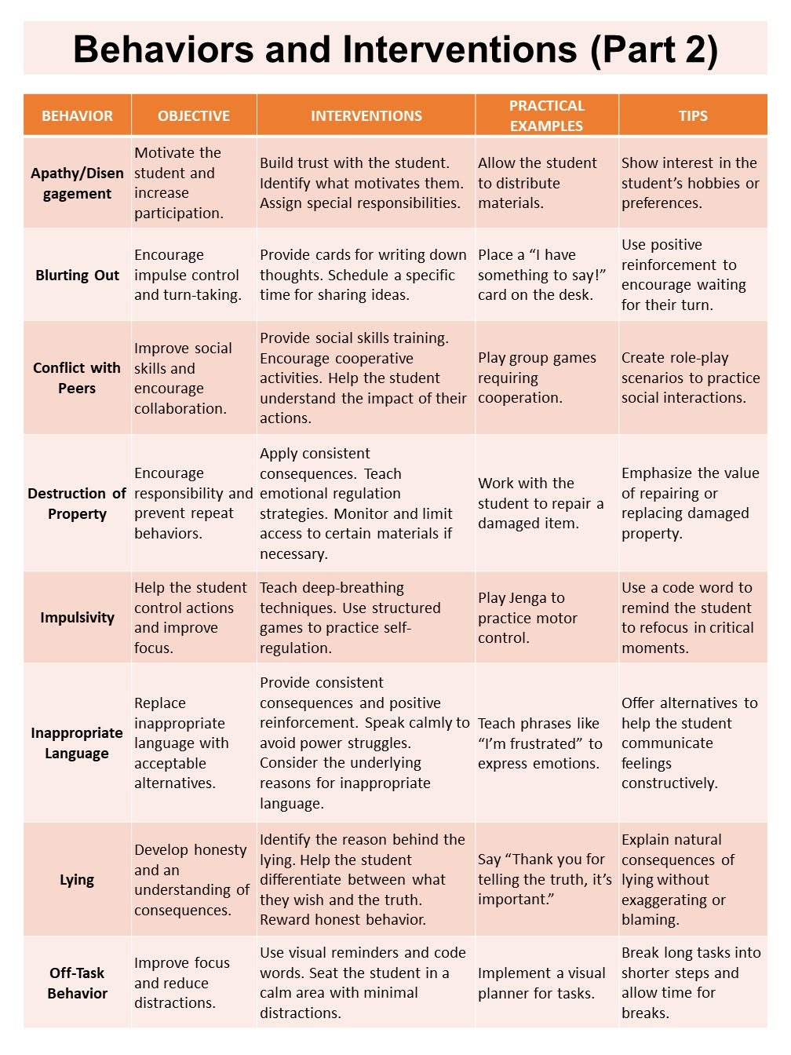

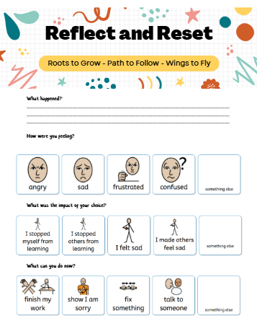
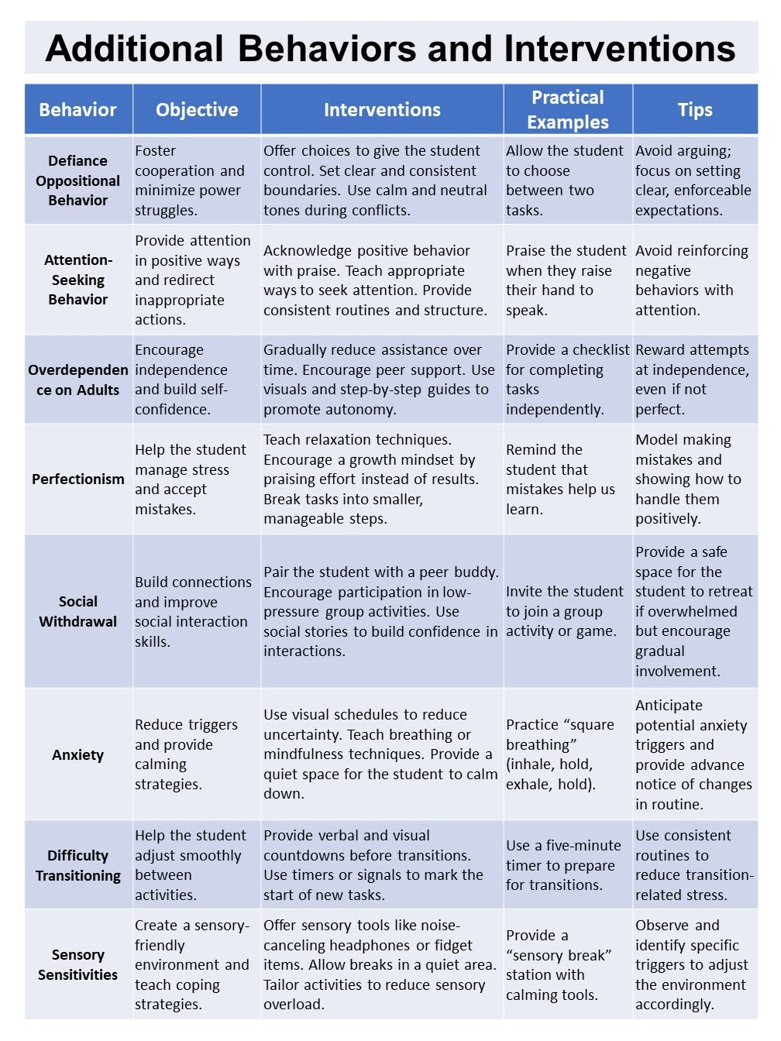
Appendix 2

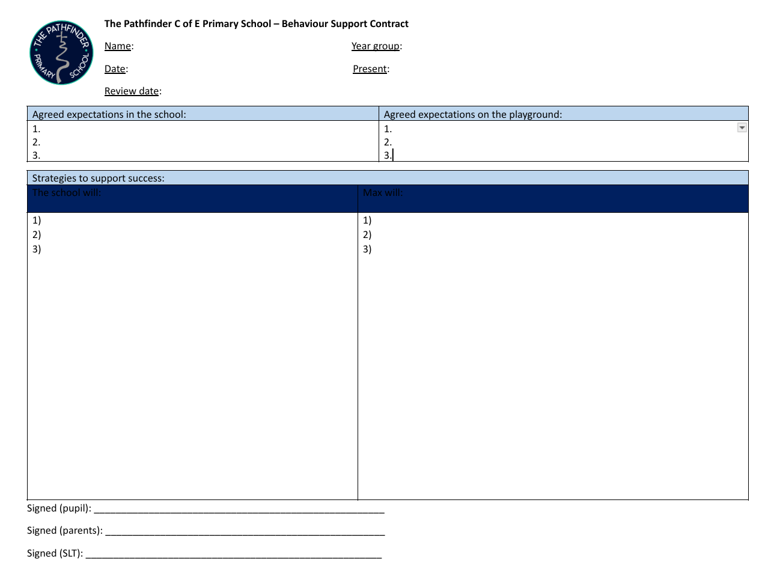
Appendix 3

Appendix 4

Pathfinder C of E Primary School
Behaviour Curriculum
Autumn: The Pathfinder Way
Curriculum intent: Behaviour is explicitly taught as a curriculum. In Autumn, pupils learn what The Pathfinder Way looks and sounds like in classrooms and across the wider school. Adults explain, model, practise, notice, correct and re-practise routines. The values of Respect, Perseverance and Wisdom are the thread through every expectation. Routines are practised frequently because they take time to embed.
RESPECT  Consider others • listen • care | PERSEVERANCE  Begin afresh • keep trying • practise | WISDOM  Make safe, thoughtful choices

Unit 1 - Shared Culture
Teaching focus | Explicit knowledge, routines and expectations to teach and practise
  1. The Pathfinder Way | • Know our vision: 'the roots to grow, the path to follow, the wings to fly'.  • Know that clear expectations and consistent routines help everyone feel safe, secure and ready to learn.  • Understand that behaviour is something we can learn, practise and improve.  • Know that adults will be relational, calm, consistent and have high expectations.
2. Our values | • Respect: consider others, listen, care for people, equipment and spaces.  • Perseverance: begin afresh, keep trying and practise until routines are mastered.  • Wisdom: make safe, thoughtful choices and understand why expectations matter.
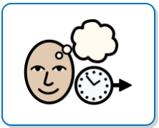  3. Practising expectations | • Watch an adult model the routine.  • Identify what was successful and what needs improving.  • Practise the routine together.  • Receive precise feedback linked to the Pathfinder Way.  • Repeat until fluent; revisit whenever needed.
  4. Success and recognition | • Understand that adults notice effort, improvement and consistency.  • Know that success may be recognised through precise 1:1 praise, family communication, Values Boards, Values Champion and Champions Tea.  • Aim for pride and intrinsic motivation rather than completing routines only for a reward.
Practice cycle for this unit: Explain why → adult model → pupil rehearsal → precise feedback → immediate re-practice → apply in the real context → retrieve and revisit later.
Values check: Adults explicitly name how Respect, Perseverance and Wisdom are demonstrated through the routines above.

Unit 2 - In the Classroom
Teaching focus | Explicit knowledge, routines and expectations to teach and practise
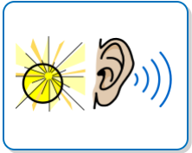  1. SHINE listening | • Sit up and Listen.  • Hands still.  • Involved in Learning.  • Neat tables.  • Eyes on speaker.  • Practise SHINE when an adult or pupil is speaking and after an attention reset.
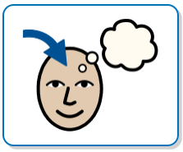  2. Active Learning | • Engage with the task set.  • Approach learning with wonder and curiosity.  • Use a can-do attitude and persevere with challenge.  • Try appropriate strategies before relying on an adult.  • Take part in partner/group discussion as directed.
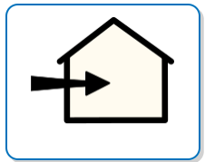  3. Entering a learning space | • Enter calmly and follow the adult's direction.  • Greet the adult welcoming you into the space.  • Move directly to the expected place.  • Prepare promptly for learning.  • Practise again if the entry does not meet the expectation.
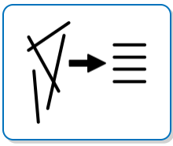  4. Classroom organisation | • Keep tables neat so learning can happen.  • Use resources for their intended purpose.  • Return resources when directed.  • Look after books and equipment.  • Leave the learning space ready for the next lesson.
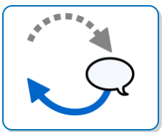  5. Responding to correction | • Listen to the reminder without arguing.  • Respond to 'I need you to...' and 'The expectation is...' promptly.  • Understand a logical consequence helps put something right.  • Reset and return to learning.
Practice cycle for this unit: Explain why → adult model → pupil rehearsal → precise feedback → immediate re-practice → apply in the real context → retrieve and revisit later.
Values check: Adults explicitly name how Respect, Perseverance and Wisdom are demonstrated through the routines above.

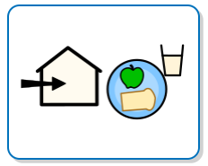
Unit 3 - Transitions
Teaching focus | Explicit knowledge, routines and expectations to teach and practise
  1. Pathfinder Walking | • Walk without talking so the environment remains calm.  • Move safely and efficiently.  • Follow the expected route.  • Keep appropriate space from others.  • Face the direction of travel and remain with the group.
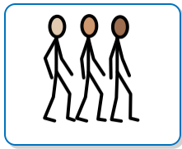  2. Lining up | • Move to the line promptly when directed.  • Stand in the expected order/position.  • Keep hands and feet to yourself.  • Use the expected voice level.  • Be ready to move when the adult directs.
3. Entering/leaving spaces | • Wait for adult direction.  • Enter and leave calmly.  • Greet staff when welcomed into a space.  • Move to the expected destination without unnecessary delay.  • Keep corridors, doorways and stairs safe for others.
4. Rehearsal | • Practise routes to key spaces early in Autumn 1.  • Practise classroom-to-assembly, classroom-to-playground and classroom-to-lunch transitions.  • Re-practise after holidays and whenever routines become less fluent.  • Adults praise pupils who model Pathfinder Walking.
Practice cycle for this unit: Explain why → adult model → pupil rehearsal → precise feedback → immediate re-practice → apply in the real context → retrieve and revisit later.
Values check: Adults explicitly name how Respect, Perseverance and Wisdom are demonstrated through the routines above.

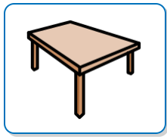
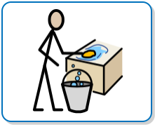
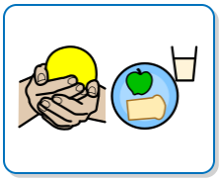
Unit 4 - Lunchtime
Teaching focus | Explicit knowledge, routines and expectations to teach and practise
1. Entering lunch | • Use Pathfinder Walking to reach the dining space.  • Queue calmly and respect personal space.  • Listen and respond to lunchtime staff.  • Use polite, respectful language.  • Be considerate of pupils who may find lunchtime challenging.
2. At the table | • Use an appropriate voice level.  • Eat safely and use cutlery appropriately.  • Be open to trying new foods.  • Remain considerate of the space and people around you.  • Ask for help appropriately.
3. Clearing and leaving | • Take responsibility for your place and rubbish.  • Care for the dining environment.  • Follow adult instructions for clearing/leaving.  • Leave calmly using Pathfinder Walking.
4. Values at lunch | • Respect: show care to staff, pupils and the environment.  • Perseverance: practise independence and new skills.  • Wisdom: recognise how noise, movement and choices affect others.
Practice cycle for this unit: Explain why → adult model → pupil rehearsal → precise feedback → immediate re-practice → apply in the real context → retrieve and revisit later.
Values check: Adults explicitly name how Respect, Perseverance and Wisdom are demonstrated through the routines above.

Unit 5 - Respectful Play
Teaching focus | Explicit knowledge, routines and expectations to teach and practise
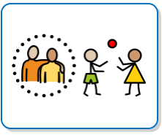  1. Safe and respectful play | • Treat others with kindness and curiosity.  • Respect personal space.  • Use equipment safely and for its intended purpose.  • Look after the environment.  • Recognise when play is becoming unsafe or unkind.
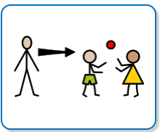  2. Joining and leaving play | • Ask to join appropriately.  • Accept that others may make different choices.  • Share and take turns where appropriate.  • Stop when someone asks you to stop.  • Walk away safely when a game is no longer successful.
  3. Friendship challenges | • Take ownership of your choices.  • Use calm words to explain a problem.  • Seek adult support when needed.  • Avoid drawing other pupils into a disagreement.  • Practise ways to navigate common friendship difficulties.
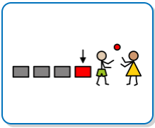  4. End of play | • Respond promptly to the signal/adult direction.  • Return equipment as expected.  • Move to the designated line/meeting point.  • Use Pathfinder Walking when returning to class.  • Reset so you are ready to learn.
Practice cycle for this unit: Explain why → adult model → pupil rehearsal → precise feedback → immediate re-practice → apply in the real context → retrieve and revisit later.
Values check: Adults explicitly name how Respect, Perseverance and Wisdom are demonstrated through the routines above.

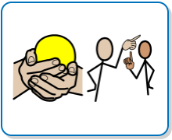
Unit 6 - Communication
Teaching focus | Explicit knowledge, routines and expectations to teach and practise
  1. Caring community | • Know that adults will respect your thoughts when you speak to them.  • Speak to adults and pupils respectfully.  • Listen without interrupting.  • Use an appropriate tone and volume.  • Contribute positively to the school community.
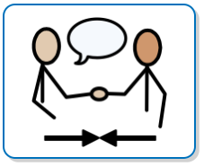  2. Manners and greetings | • Greet adults when appropriate.  • Use please and thank you.  • Face the person you are speaking to where appropriate.  • Ask for help clearly and respectfully.  • Show appreciation when someone helps you.
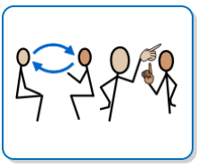  3. Discussion and disagreement | • Listen to another point of view.  • Disagree with the idea without being disrespectful to the person.  • Use calm words and positive body language.  • Persevere with a discussion when views differ.  • Know when adult help is needed.
4. Values in communication | • Respect: listen and respond with care.  • Perseverance: keep trying to communicate successfully.  • Wisdom: choose words, tone and timing thoughtfully.
Practice cycle for this unit: Explain why → adult model → pupil rehearsal → precise feedback → immediate re-practice → apply in the real context → retrieve and revisit later.
Values check: Adults explicitly name how Respect, Perseverance and Wisdom are demonstrated through the routines above.


Unit 7 - Regulate & Restore
Teaching focus | Explicit knowledge, routines and expectations to teach and practise
  1. Reset and Regulate | • Recognise when you are not ready to learn or play successfully.  • Accept an adult prompt to reset and regulate.  • Use an agreed calming space, movement break or other support when directed.  • Use the time to become calm enough to return successfully.  • Understand that regulation support is designed to help you learn a better way.
  2. Restoring after conflict | • Share what happened honestly.  • Listen to the other person's perspective.  • Consider feelings and impact.  • Reflect on which Pathfinder value can guide the next step.  • Identify what could be done differently next time.
  3. Taking responsibility | • Recognise your part in a problem without blaming others.  • Put right what can be put right.  • Use an apology where appropriate.  • Accept a logical consequence.  • Return to routines with a fresh start.
4. Adult language pupils will hear | • 'I need you to...'  • 'The expectation is...'  • A calm reminder of SHINE or another taught routine.  • A logical consequence connected to what happened.  • A restorative conversation when the pupil is ready.
Practice cycle for this unit: Explain why → adult model → pupil rehearsal → precise feedback → immediate re-practice → apply in the real context → retrieve and revisit later.
Values check: Adults explicitly name how Respect, Perseverance and Wisdom are demonstrated through the routines above.




Unit 8 - Consolidation
Teaching focus | Explicit knowledge, routines and expectations to teach and practise
1. Independent recall | • Name Respect, Perseverance and Wisdom.  • Recall SHINE.  • Explain Pathfinder Walking.  • Describe successful lunchtime and play routines.  • Explain how to reset and restore after difficulty.
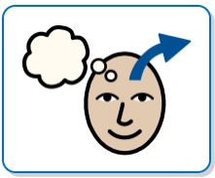  2. Apply in different contexts | • Show the same expectations with different adults.  • Apply routines in assemblies, visits and unfamiliar spaces.  • Transfer respectful communication to less structured times.  • Recognise that The Pathfinder Way applies throughout the school day.
3. Re-practise | • Return to a routine when an adult identifies it needs strengthening.  • Use demonstration, non-examples and immediate practice.  • Practise after breaks and holidays.  • Understand that needing more practice is part of learning.
4. Celebrate consistency | • Notice personal improvement.  • Recognise peers demonstrating the school values.  • Reflect on how routines make Pathfinder safer and calmer.  • Set a personal behaviour/routine goal for the next half term.
Practice cycle for this unit: Explain why → adult model → pupil rehearsal → precise feedback → immediate re-practice → apply in the real context → retrieve and revisit later.
Values check: Adults explicitly name how Respect, Perseverance and Wisdom are demonstrated through the routines above.

Autumn Implementation Map
When | Teaching and practice
Autumn 1 - Week 1 | Intensive teaching: Shared Culture and Values; SHINE; entering/leaving spaces; Pathfinder Walking; lining up; lunchtime and play expectations. Practise routines in the actual locations several times each day.
Autumn 1 - Week 2 | Re-teach all core routines. Introduce Active Learning, classroom organisation, communication and responding to correction. Identify routines/classes needing additional rehearsal.
Autumn 1 - Weeks 3-4 | Move from supported rehearsal to independent application. Teach respectful play and friendship scenarios explicitly. Continue daily retrieval of SHINE and Pathfinder Walking.
Autumn 1 - Weeks 5-7 | Teach regulation, Reset and Restore and taking responsibility. Use role-play and low-stakes scenarios. Re-practise any routine where consistency has reduced.
Autumn 2 - Weeks 1-2 | Full reset after the break: revisit all core routines as though teaching them, not merely reminding pupils. Re-establish values language and expectations.
Autumn 2 - Weeks 3-6 | Apply expectations across less familiar contexts. Use pupil modelling, scenario discussion and deliberate practice. Increase independence while maintaining precise feedback.
Autumn 2 - final weeks | Consolidate and assess recall. Celebrate consistency and improvement. Identify routines to revisit in Spring.

Non-negotiable staff approach: Do not assume that pupils 'should know' a routine. If an expectation is not secure, return to explicit teaching and practice. Use the least invasive correction possible, protect relationships, keep language concise and calm, and give the greatest attention to pupils demonstrating The Pathfinder Way.

