

*‘Our shared vision is that our students, colleagues and families will be part of a* ***FAIR*** *community.*

*We will support our school* ***Family*** *to* ***Achieve*** *their potential, and* ***Inspire*** *students to* ***Reach*** *the very best destinations.’*

 The Ridgeway School & Sixth Form College

*…Inspiring Learners For Their Future*

PSHE/RSE

Curriculum Overview 2024/25

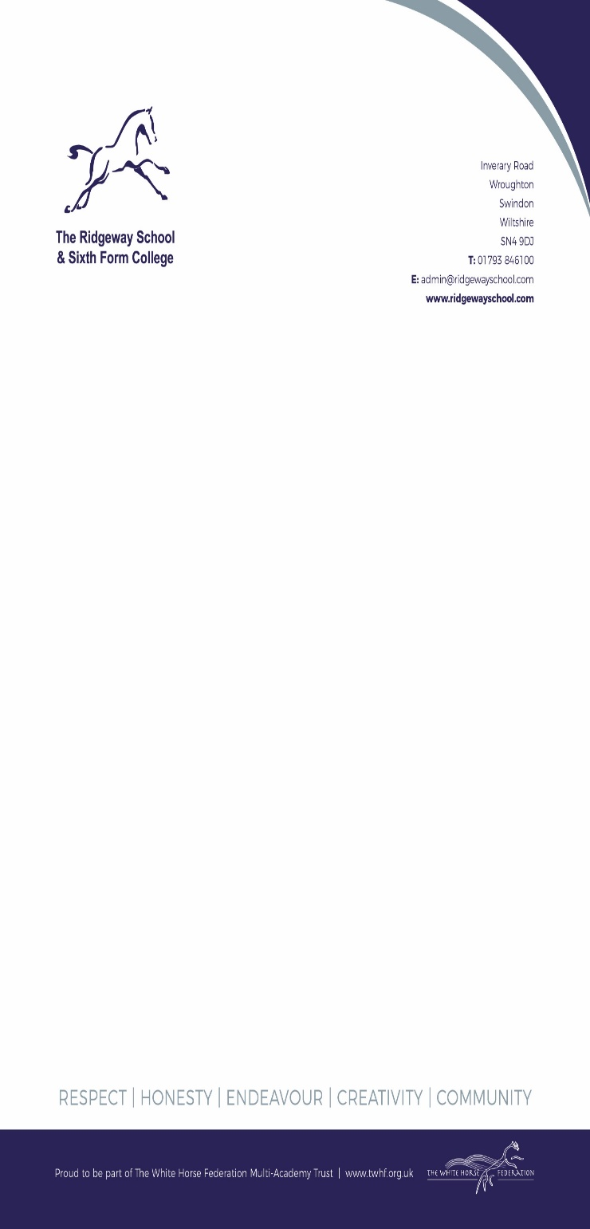

**Year 7 PSHE/RSE Curriculum Overview 2024/25**

|  |  |  |  |  |  |  |
| --- | --- | --- | --- | --- | --- | --- |
| **Year 7** | **Term 1** | **Term 2** | **Term 3** | **Term 4** | **Term 5** | **Term 6** |
| **Relationships** | **Health & Wellbeing** | **Living in the Wider World** | **Relationships** | **Health & Wellbeing** |  |
| **Respectful Relationships**   1. Bullying and Banta 2. Good Friendships 3. Positive and healthy friendships 4. Safe Relationships 5. Falling in love 6. Healthy lifestyle 7. Ending friendships and relationships | **Changing adolescent bodies**   1. Exploring puberty 2. Hygiene and dental health 3. Menstrual health 4. Menstrual health 5. First sexual feelings 6. Healthy Communication 7. Gender Identity and Sexuality | **Online and Media**  1.Oppurtunities Online  2.Digital Citizenship 1  3.Digital Citizenship 2  4.Digital Footprint  5.Cyberbullying  6.Social Media | **Citizens of a Wider World**   1. Prejudice 2. Discrimination 3. Hate Crimes 4. Radicalisation 5. Personal Identity 6. Anti-Racism | **Healthy Relationships in the family**   1. Families 2. Wider families 3. Respecting differences 4. Boundaries, privacy & consent 5. Family Conflict and Conflict and reconciliation | **Personal safety and boundaries**   1. Permissions 2. Sexting and dangers 3. Living Healthier 4. Healthy eating 5. Physical Health 6. Mental Wellbeing 7. Sun and water safety |

**Year 8 PSHE/RSE Curriculum Overview 2024/25**

|  |  |  |  |  |  |  |
| --- | --- | --- | --- | --- | --- | --- |
| **Year 8** | **Term 1** | **Term 2** | **Term 3** | **Term 4** | **Term 5** | **Term 6** |
| **Health & Wellbeing** | **Living in the Wider World** | **Health & Wellbeing** | **Relationships** | **Living in the Wider World** | **Relationships** |
| **Self-esteem and Confidence**  1. Self Esteem  2. Self Confidence  3. Body Image 1  4. Body Image 2  5. Body shaming  6. Personal Hygiene  7. Core Values and Attributes | **Online and Media**   1. Online risks 2. Screen time 3. Harmful material online 4. Risks of unknown people online 5. Unhealthy comparisons 6. Understanding online information 7. Explicit material online | **Drugs and Alcohol**   1. Drugs, the law and managing risk 2. Alcohol and Cannabis 3. Managing influence 4. Prescription drugs and legal highs 5. Caffeine consumption 6. Energy drinks 7. Vaping / smoking | **Families being safe and reporting concerns**   1. Safe family R/S 2. Trustworthy information 3. Recognising unsafe R/S 4. Recognising our own unsafe R/S 5. Communication Skills 6. FGM | **Human Rights and Crime**   1. Human Rights and Charity 2. Human Rights abused 3. Child Exploitation 4. Knife Crime 5. Law and Young Offenders | **Sexual health and Safety**   1. Sexual Consent 2. Harassment and Rape 3. Grooming 4. Contraception 5. STI’s 6. Choices in Pregnancy 7. First Aid |

**Year 9 PSHE/RSE Curriculum Overview 2024/25**

|  |  |  |  |  |  |  |
| --- | --- | --- | --- | --- | --- | --- |
| **Year 9** | **Term 1** | **Term 2** | **Term 3** | **Term 4** | **Term 5** | **Term 6** |
| **Living in the Wider World** | **Health & Wellbeing** | **Health & Wellbeing** | **Living in the Wider World** | **Relationships** | **Living in the Wider World** |
| **Safety off and online**   1. The Law 2. Issues and scenarios 3. Reporting and penalties 4. Sexualised material 5. Sexually explicit material 6. Social media and loneliness 7. Child sexual exploitation | **Seep and Healthy Routines**   1. Quality of sleep 2. Sleep strategies 3. Impact of poor sleep 4. Devices to sleep 5. Emotional Wellbeing 6. Mental Wellbeing 7. Physical health | **Drugs and Alcohol**  1. Substances  2. Alcohol Short Term  3. Alcohol Long Term  4. Tobacco  5. Drugs and the Law  6. Acid Attacks | **Extremism**   1. Anti Racism and tolerance 2. Prejudice and Discrimination 3. Extreme groups 4. Leaders of extreme groups 5. Extremism 6. Religion and Extreme groups | **Sexual health and Safety**   1. Delaying Sex 2. Healthy communication 3. Pornography 4. Revenge Porn 5. Harassment | **Preparing for Work**   1. Self attributes and goals 2. How to achieve 3. Workplace skills 4. Enterprises 5. Work skills 6. Employability 7. Navigating Financial Institutions |

**Year 10 PSHE/RSE Curriculum Overview 2024/25**

|  |  |  |  |  |  |  |
| --- | --- | --- | --- | --- | --- | --- |
| **Year 10** | **Term 1** | **Term 2** | **Term 3** | **Term 4** | **Term 5** | **Term 6** |
| **Relationships** | **Health & Wellbeing** | **Living in the Wider World** | **Living in the Wider World** | **Health & Wellbeing** | **Living in the Wider World** |
| **Harmful behaviours in relationships**   1. Sexual consent 2. Alcohol, drugs and sex 3. Issues of consent 4. Sexual coercion 5. Harassment, abuse and rape 6. Stalking 7. Domestic abuse | **Sexual relationships**   1. Contraception 2. Barrier methods 3. Hormonal devices and NFP 4. Introduction to STIs 5. The main STIs and HIV 6. Healthy communication 7. Forced marriage | **Finances**   1. Personal Budgets 2. Wants and Needs 3. Financial Products 4. Financial Transactions 5. Shop Ethically 6. Savings and Debt | **Preparing for Work**   1. Preparing for Work Experience 2. Rights and Responsibilities in the work place 3. Right career choice 4. Writing a CV 5. STEM 6. First Aid | **Healthy Relationships**   1. Sexism and gender prejudice 2. Conflict management 3. Same Sex R/S 4. Gender and trans Identity 5. Community Cohesion | **Social Dangers**   1. Fake News 2. Criminal Justice system 3. Anti-social behaviour 4. Gangs 5. Racism 6. Extremism 7. Money Laundering |

**Year 11 PSHE/RSE Curriculum Overview 2024/25**

|  |  |  |  |  |  |  |  |
| --- | --- | --- | --- | --- | --- | --- | --- |
| **Year 11** | **Term 1** | **Term 2** | **Term 3** | **Term 4** | **Term 5** | **Term 6** | |
| **Living in the Wider World** | **Health & Wellbeing** | **Health & Wellbeing** | **Relationships** | **Health & Wellbeing** | | N/A |
| **Internet safety and harms- online relationships and harmful behaviour**   1. Online grooming 2. Obsessive online behaviours 3. Catfishing 4. Honour-based violence 5. FGM 6. County lines and Gangs 7. Pornography | **Mental wellbeing- recognising problems and seeking support**   1. Coping with anxiety 2. Panic disorder and panic attacks 3. PTSD 4. Suicidal thoughts 5. SAD 6. Maintaining positive mental health into adulthood 7. First Aid | **Exam Preparation**   1. Exam Stress 2. Importance of sleep 3. Perseverance 4. Managing Time 5. Study Skills 6. Happiness | **Healthy Relationships**   1. Happiness in myself 2. Healthy relationships 3. Safe Sex 4. What is Good Sex 5. Consent 6. Healthy break ups | **Future Planning**   1. Fertility 2. Pregnancy and Miscarriage 3. Choices in Pregnancy 4. Long term commitments 5. Parenting | |  |