
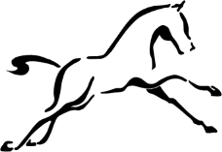

The Ridgeway School & Sixth Form College

UNIFORM GUIDE

2025 - 2026

RESPECT - HONESTY - ENDEAVOUR - CREATIVITY - COMMUNITY



The Ridgeway School & Sixth Form College

Uniform Guide

We believe that wearing a uniform creates a sense of community for our students, we want students to wear their uniform with pride and to share a sense of belonging to their school family.

- Our uniform is smart and appropriate for our school environment.
- Our uniform is inclusive and sensitive to students’ faiths and religions.
- It gives a clear sense of identity.
- Offensive lettering or suggestive logos/comments on clothing, school bags or books is prohibited.
- This Uniform guide includes pictures of acceptable uniform, shops are now promoting shoes and clothing as uniform that would not fit our Uniform Policy.
https://www.ridgewayschool.com/parents-students/school-uniform


We thank parents in advance for actively supporting our school uniform expectations and we ask that parents support this policy by ensuring that their children leave home in the morning correctly dressed with the correct equipment. Uniform is worn as a sign of commitment to The Ridgeway School and its ethos and values.

Equipment
Our equipment list ensures that students are ready and prepared to learn. When students take their assessments, including GCSE’s and A Levels they will require the following equipment;
  - A student planner
  - A reading book
  - A scientific calculator
  - A transparent pencil case containing:
    - A black pen
    - A spare black pen
    - A green pen
    - A pencil
    - A ruler
    - A rubber
    - A highlighter

Uniform
Our uniform supplier is Price and Buckland. They have an online website:
https://price-buckland.co.uk/ and a dedicated page to The Ridgeway School & Sixth Form College so you can purchase the appropriate uniform.

Our uniform:
  - A blazer with The Ridgeway School badge on the pocket - must be worn by all students in Year 7-
11. Students may choose to wear a Ridgeway School jumper/cardigan or a plain V neck black jumper or cardigan (so the tie is visible under their blazer), but not instead of their blazer. The jumper/ cardigan must not have any logos or slogans.
  - White school shirt/blouse (tucked in, sleeves unrolled and buttoned to the neck).
  - The Ridgeway School House tie.
  - Black regular length school trousers, ‘skinny’ or tight fitting in style is not permitted. Trousers should meet the shoe, and should not be rolled up at the hem.
  - Our school skirt can be purchased from The Price and Buckland website. No other skirts are permitted.
  - Large belts, buckles, zips, laces, pin stripes etc. should not be worn on either skirts or trousers.
  - Plain black school shoes suitable for wearing with formal attire should be worn. Shoes that are not permitted are black trainers/footwear that are trainer in style yet labelled as shoes, daps, sandals, shoes that look like trainers, shoes without backs, and heels higher than 3cm.
  - Natural or black colour tights, or plain black socks.
  - Cream apron for Technology.

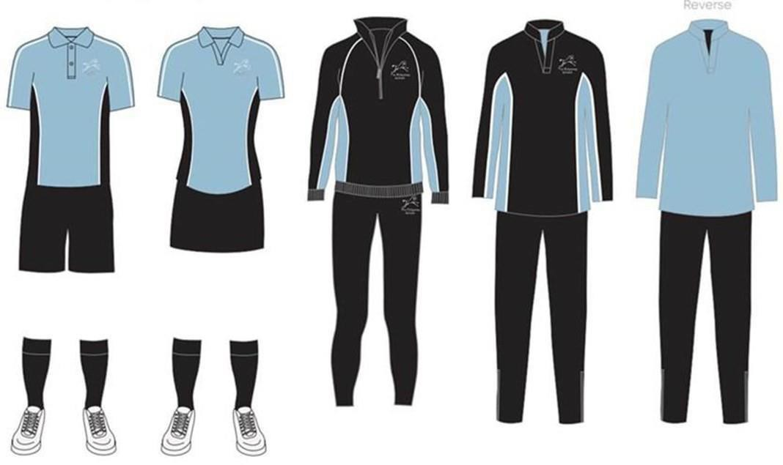
PE Kit...
 | Essential | Highly Recommended
Boys | - Ridgeway branded polo shirt  - Black underlayer  - Plain black shorts  - Plain black long socks (football socks)  - Trainers (supportive/sports not  fashion, not converse)  - Football boots  - For swimming - plain black  swimming trunks/shorts/speedos,  swimming cap, towel | - Ridgeway branded rugby shirt  - Plain black jogging trousers (for cold weather)  - Shin pads  - Gum shield (rugby and hockey)  - Plastic bag for dirty kit  - Goggles  - Spare socks on a PE day for hygiene
Girls | - Ridgeway branded polo shirt  - Black underlayer  - Plain black long socks (football socks)  - Trainers (supportive/sports not  fashion, not converse)  - Football boots  - Loose fitting, plain black PE shorts (not Nike-pro/cycling style)  - For swimming - Plain black all in  one swimming costume, swimming  cap, towel | - Ridgeway branded PE sweatshirt  - Plain black jogging trousers and/ or Ridgeway braded leggings (for cold weather)  - Shin pads  - Gum shield (rugby and hockey)  - Plastic bag for dirty kit  - Goggles  - Spare socks on a PE day for hygiene

Further Points...
  - Outdoor coats - should be “School Type” (not leather or denim coats/jackets) and must not have inappropriate logos, slogans. These should NOT be worn inside classrooms.

Hooded tops or tracksuits tops are also not permissible as an outdoor coat and should not be worn to school.
  - Trainers are NOT school uniform and should NOT be worn during the school day. Trainers can be worn when students are taking part in a sporting activity ONLY. Information on appropriate school shoes is shown in the table in this booklet.
  - Jewellery - the wearing of jewellery is not considered appropriate for school and is therefore not allowed. Students can only wear one small pair of discreet stud earrings in lower lobe. (These will need to be removed for PE lessons.) No other piercings allowed. Any jewellery worn will be confiscated and students who fail to remove jewellery will be isolated until it is removed.
  - Excessive make up, including extreme eye liner and false lashes are not permitted.

Coloured nail varnish, decorated and false nails are not permitted.
  - Extreme haircuts and styles are not acceptable. This includes dying the hair an unnatural colour.

Extreme Conditions
Uniform adjustments due to temperatures will only occur when the Department for Education issues guidance stating that there is an extreme weather warning and schools need to take action.

In all matters of uniform and dress, the decision of the Principal is final.

Purchasing
All items can be purchased from Price and Buckland online; The Ridgeway School & Sixth Form College (pbuniform-online.co.uk)
A school uniform sale is held annually where second-hand uniform can be purchased at a cheaper price. We also swap uniform for alternative sizes if we have availability in the uniform office.
If there are any concerns regarding the purchasing of uniform, please contact the school so we can offer our support.

Uniform Office
The school runs a uniform office open from 8.20am every morning. If a student has the incorrect uniform or has forgotten a piece of equipment, they may borrow this item for the remainder of the day. If a student attends the uniform office prior to the start of school at 8.45am they will not be issued with a uniform consequence.

Uniform Consequences
The member of staff on duty before school and the mentor during roll call will ensure that all students are wearing appropriate uniform. Where this is not the case, students should attend the uniform office where they may borrow items to ensure that they are meeting the uniform expectations.
Where uniform does not meet the expectations and students refuse to correct the infringement, they will not be able to attend lessons.
If a student has a medical requirement which impacts on the wearing of any part of the school uniform, medical evidence must be provided clearly stipulating the uniform adjustment that needs to take place and the date this will cease. In these circumstances, the student will be given a medical card and where possible we ask that plain black trainers are worn.
Item | Acceptable | Not Acceptable | Additional Information
Blazers | - School range blazer  - School badge  - Black in colour  - Full length body  - Full length sleeves  - Button up front  - Collar | - Colour trims  - ¾ length, rolled up sleeves  - Short waisted jackets  - Fashion blazers  - Tight fitting  - No other logo/badge, other than school. | We encourage them to be removed for practical lessons to avoid damage.  School blazers are “easy care” polyester  Black blazers may be purchased from other retailers in conjunction with a school badge available from Reception for £4.95
Ties | - The Ridgeway School tie worn correctly  - Proper knot by the top button of the shirt  - Waist length and showing 5 stripes | - Untied  - Large loose knots  - Shorter than waist length
Sweatshirt/ Cardigan (Optional) | - Plain black v neck so the tie can be seen | - No logos or slogans - must be plain black. | Can be worn underneath blazer if desired. Cannot be worn without a blazer.
Shirt | - School range  - Plain white  - Tucked in  - Must button to the neck  - Designed to take a tie | - Untucked  - Coloured  - Embroidery  - Capped sleeves  - Patterned  - Midriff on show | No logos or slogans – must be plain black.

Item | Acceptable | Examples of Acceptable | Not Acceptable | Examples of Not Acceptable | Additional Information
Trousers | - School range  - Plain black  - Flat or pleated front  - Bootleg or straight style  - Regular length to meet the shoe | 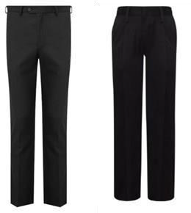 | - Cropped/rolled – the ankle must not be on show  - Skinny or flared leg  - Jeans or denim  - Leggings  - Zips that show  - Large belts  - Buckles/ laces  - Tight fitting  - Pin stripes | Trousers Trousers  Fitted Cropped Trousers Trousers
Skirts | - Black skirt available from Price and Buckland | 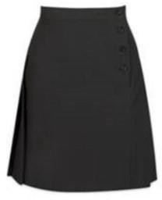 | - No other skirts are permitted
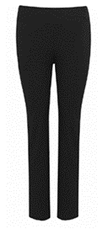
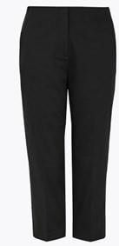

Item | Acceptable | Examples of Acceptable | Not Acceptable | Examples of Not Acceptable | Additional Information
Shoes | - Suitable plain black school shoes or ankle boots suitable for wearing with formal attire (blazer/formal trousers). | 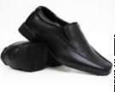  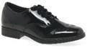  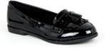  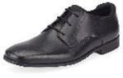 | - Knee /thigh high boots  - Trainers (including black and/or those that pose as trainers)  - Daps  - Flip flops/backless  - Open toes  - Heels over 3cm | 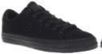  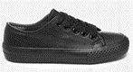  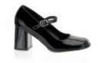  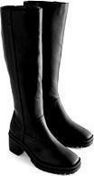
RESPECT - HONESTY - ENDEAVOUR - CREATIVITY - COMMUNITY

NOTES

NOTES



The Ridgeway School & Sixth Form College

Inverary Road
Wroughton
Swindon
Wiltshire
SN4 9DJ
Tel: 01793 846100
www.ridgewayschool.com

Principal: Adrian Cush

Proud to be part of The White Horse Federation Multi-Academy Trust

