Year 1 | Term 1 |  | Term 2 |  |  | Term 3 |  | Term 4 |  | Term 5 |  | Term 6
Genre | Fiction  Poetry  Story setting | Non-fiction  Recount | Fiction  Narrative: Character description | Non- Fiction-Recount | Fiction  Narrative: |  | Non-fiction  Non chronological report | Fiction  Narrative: short story writing | Non-fiction  Non- Fiction- Diary | Fiction  Narrative: story setting / description | Non-fiction  Instructions | Fiction  Narrative: Story writing | Non-fiction  Recount- Letter
Recommended Text/ Stimulus | Leaf  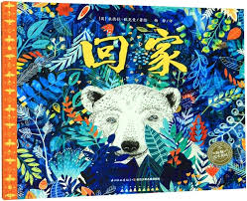 | Stuck  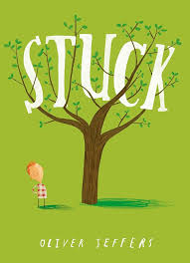 | Bog Baby  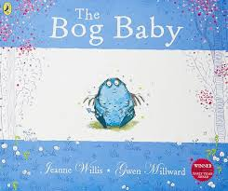 | Zog  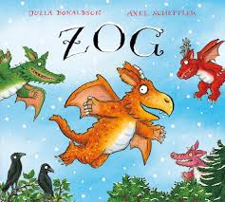 | Poles Apart  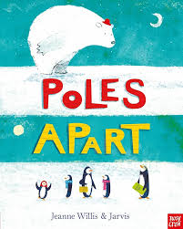 |  | Dear Greenpeace  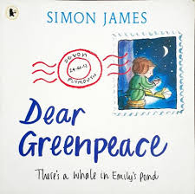 | Beegu  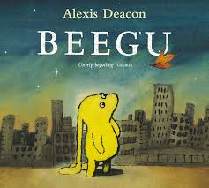 | Paddington  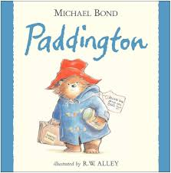 | Lost in the Toy Museum  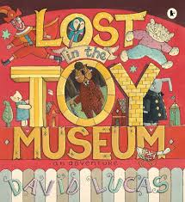 | Tidy   | Look Up  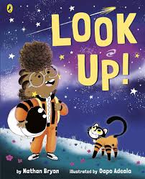 | 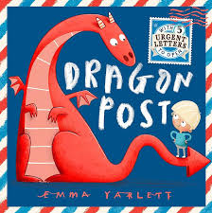  Dragon Post
Outcome/ form | To write a setting description  Sequence sentences to form short narratives Orally rehearse and write a simple sentence.  Re-read your sentence. | To write a recount  Sequence sentences to form short narratives (recount) Orally rehearse and write a simple sentence.  Re-read your sentence. | To write a character description  Sequence sentences to form short narratives (character description).  Orally rehearse and write a simple sentence.  Re-read your sentence. | To write a recount  Sequence sentences to form short narratives (recount). | Retelling of story / part of story  Sequence sentences to form short narratives |  | To write a non-chronological report  Sequence sentences to form short narratives (a non-chronological report) | To write a story  Sequence sentences to form short narratives | To write a diary  Sequence sentences to form short narratives (a diary). | To write a story including setting description  Sequence sentences to form short narratives (description/ setting). | To write a set of instructions  Sequence sentences to form short narratives (a set of instructions). | To write a story  Sequence sentences to form short narratives | To write a recount letter  Sequence sentences to form short narratives (recount letter)
Writing Purpose | Writing to entertain | Writing to inform (recount) | Writing to entertain | Writing to inform (recount) | Writing to entertain |  | Writing to inform (report) | Writing to entertain | To inform (recount) | Writing to entertain | Writing to inform | Writing to entertain | To Inform
Text Features | 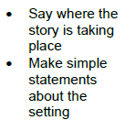 | 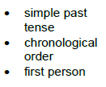 | 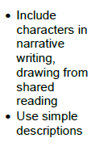 |  | 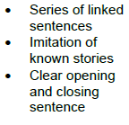 |  | 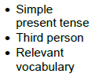 |  |  |  | 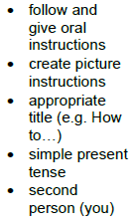
Grammatical structures |  |  |  | Join words using ‘and ' | Join words using ‘and ' |  | Join words using ‘and '  Join clauses using ‘and ' | Join words and clauses using ‘and ' |  |  | Join words and clauses using ‘and’
Descriptive language | Use adjectives in their writing- colour. E.g. The leaves are red | Use adjectives in their writing- size. E.g. big boat, large house | Use adjectives in their writing- texture. E.g. soft, bumpy.  Recap colour and size from Term 1. | Use adjectives in their writing- emotions E.g. proud, excited, scared, disappointed | Use adjectives in their writing.  senses. E.g.  feel – rain  see – big red bus |  | Use adjectives in their writing- choose an appropriate adjective
Tense/ verb forms |  |  |  |  |  |  |  | Use past tense with some accuracy. (Accurate and consistent use of the simple past tense  -ed ending) |  | Use past tense with some accuracy. (Accurate and consistent use of the simple past tense  -ed ending) |  |  | To use past the tense with some accuracy- irregular verbs
Paragraphing/ cohesion

Punctuation | Use finger spaces consistently.  Begin punctuating sentences using a full stop. | Begin punctuating sentences using a capital letter.  Consistently use capital letter for ‘I’. |  |  | To punctuate sentences with a capital letter and a full stop. |  | Begin punctuating sentences using a question mark. |  | Consistently use capital letter for ‘I’.  Some use of capital letters for proper nouns.  Begin to punctuate sentences using question marks. | Begin punctuating sentences using an exclamation mark. | To use question marks correctly. | Begin punctuating sentences using a question mark.  To begin punctuating sentences using an exclamation mark. | To begin to use a capital letter for proper nouns Consistently use capital letter for their own name.
Handwriting | Write recognisable letters most of which are formed correctly.  Form most lower-case and capital letters in the correct direction, starting and finishing in the right place. | Form most capital letters correctly. | Write recognisable letters most of which are formed correctly.
Spelling | Spell words by identifying sounds in them and representing the sounds with a letter or letters | Spell words containing each of the 40+ phonemes already taught.  Spell many Year 1 common exception words accurately. | Spell words containing each of the 40+ phonemes already taught. | Spell the days of the week correctly |  |  |  |  |  | Show some accurate use of –er –est where no change is needed in the spelling of root words.
GDS objective |  |  |  |  | To punctuate a sentence using an exclamation mark. |  | To use ‘because’ to extend sentences. | To begin to use capital letters, full stops, question marks and exclamation marks. | Write effectively and coherently for different purposes e.g. diaries- simple reflections. | To write effectively and coherently for different purposes (including stories- noun phrases to develop setting descriptions) | To write a series of sentences that are cohesive using first, after that, next, finally.  Use a variety of conjunctions in writing (e.g. and, but, so, because) | Use a variety of conjunctions in writing (e.g. and, but, so, because) | Write a series of sentences that are cohesive (e.g. using simple time adverbs: first, next, after that, finally).
Colour code
Black = new learning to this year group
Green = previous year group learning re-visited

